新北市立溪崑國民中學113學年度第二學期三次定期評量 英語科 試題卷
八年級 班 座號 姓名
第一部分: 聽力測驗 30%
- 辨識句意：每題均有三張圖片，請依據所聽到的句子，選出符合描述的圖片
1. (A)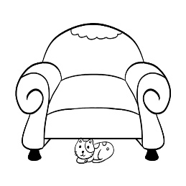 (B)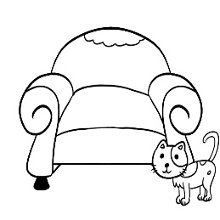 (C)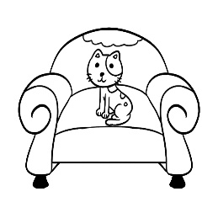
2. (A)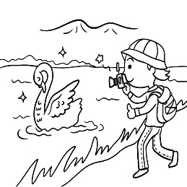 (B)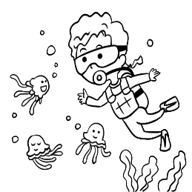 (C)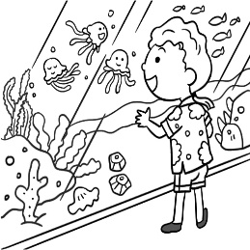
3. (A)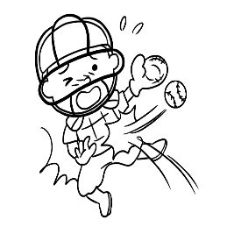 (B)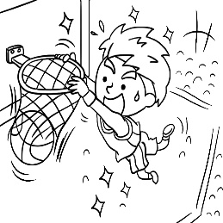 (C)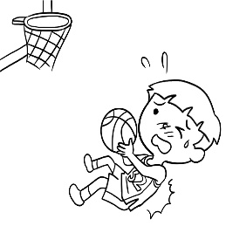
4. (A)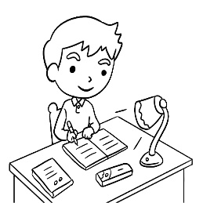 (B)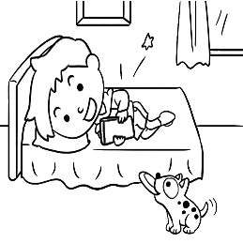 (C)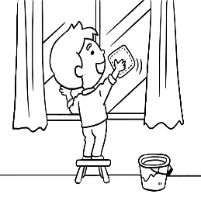
5. (A)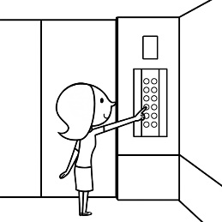 (B)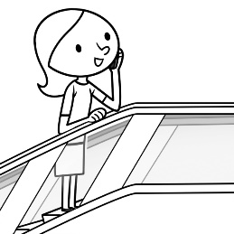 (C)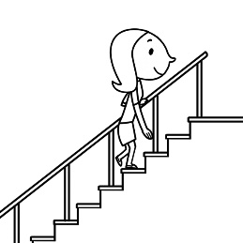

- 基本問答：每題均有三個選項，請依據所聽到的內容，選出一個最適合的回應
6. (A) Yes, I hid it outside the house.
(B) No, nothing is in the house.
(C) Yes, someone is singing.
7. (A) Twelve players make up a team.
(B) There are five teams in the race.
(C) This kind of event takes place every month.
8. (A) I bring my own chopsticks to eat noodles.
(B) Can I have the pizza instead?
(C) Thank you. I need some spoons.
9. (A) Correct. He’s the most famous writer in my country.
(B) That’s true. Though he isn’t very famous, I enjoy reading his books.
(C) You’re right. He is popular with teenagers.
10. (A) Don’t worry. It will end up in my brother’s stomach.
(B) Luckily, we can have steak instead.
(C) Why bother? Let’s use the forks and take a bite.

- 言談理解：每題均有三個選項，請依據所聽到的對話與問題，選出一個最適當的答案
11. (A) It got hurt badly.
(B) It got out of the animal hospital.
(C) The man hit it in its head.
12. (A) He finished nothing but the soup.
(B) He suddenly left without saying anything.
(C) Someone would buy food for Paul.
13. (A) The man fell off the bed when he slept.
(B) It wasn’t so cold, so the man didn’t need to sleep under blankets.
(C) The man’s blankets fell off his bed.
14. (A) The milk to feed her baby.
(B) Her husband’s help to buy some milk.
(C) Her bottles to fill up cold water and hot water.
15. (A) He didn’t want to wash his hands before eating.
(B) He wanted to keep his hands clean.
(C) He could put them on to throw the chicken away.

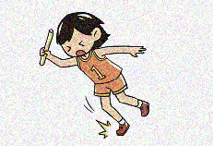
第二部分: 綜合測驗 40%
16. Look at the picture. The girl _____________.
(A) tripped herself in the race (B) cut herself in the art class
(C) is taking out the trash (D) saw someone cry
17. Jill tried to speak in a(n) _______ voice, but we all heard every word she said.
(A) loud (B) low (C) scary (D) lucky
18. People around the world come here for the music and arts festival. It’s the biggest _______ of the year.
(A) shelf (B) cover (C) event (D) land
19. In summer, swimming in Taiwan’s rivers and sea can be ________ for students, as many drowning accidents occur each year.
(A) dangerous (B) helpful (C) unhappy (D) deep
20. I forgot to _______ a shopping bag, so I have to hold everything in my hands.
(A) feed (B) hide (C) rub (D) carry
21. If you are interested in our winter vacation camp, _______ this number and ask for Mr. Chen. He’ll answer your questions.
(A) call (B) calling (C) called (D) to call
22. Sally has a twin sister. Can you _____ one ______ the other?
(A) tell; from (B) tell; to (C) stop; from (D) keep; from
23. When you see jellyfish in the sea, ____________ them if you don’t know their species.
(A) get close to (B) break down (C) keep in touch with (D) keep away from
24. Nkiambi has learned to use _______ well and can eat rice dumpling the way most Taiwanese people do.
(A) forks (B) chopsticks (C) knives (D) spoons
25. _________ apple juice in the fridge. You can have ________
(A) They’re; many (B) It’s; many (C) There are; some (D) There’s; some
26. We will go on a picnic_____________________.
(A) if it will be fine on Saturday (B) if there will be more fun
(C) if Alex visited us last night (D) if it is sunny this weekend
27. ________ of my brothers are younger than I am. I’m the oldest of the three in my family.
(A) Most (B) Some (C) Both (D) Few
28. Sara looked out of the office window and saw a man get in her car ________ away.
(A) drive (B) drove (C) and drive (D) and driving
29. There are ten children on the playground. Four of them play basketball well, and the others _________.
(A) don’t (B) aren’t (C) isn’t (D) didn’t

30. Welcome to my new house, Mary and Jerry. Please make _________ at home.
(A) herself (B) themselves (C) yourself (D) yourselves
31. Jack: Rose, I bought some food.
Rose: OK. Let me see. You have beef, pork, and chicken. Why ___ all of the food meat? ____ there any vegetables at the market?
(A) is; Weren’t (B) are; Wasn’t (C) have; Have (D) has; Has
32. Doris ended up finishing her studies in Taiwan _______ she had the chance to study abroad.
(A) so (B) until (C) although (D) because
33. I don’t think Jimmy will wear any one of the T-shirts you’ve picked out for him. ________ look(s) too bright.
(A) They (B) It (C) One (D) Some
34. Not only my parents but also my brother _______ to have a cup of coffee for breakfast every day.
(A) like (B)liking (C) don’t like (D) likes
35. Daisy didn’t understand what “point” meant in the conversation below:
Kevin: Some of our single-use plastic straws may be found in the ocean or in a turtle’s nose.
Tina: I see your point. Perhaps we should use fewer plastic straws to save our ocean.
She looked it up in the dictionary. Which sentence has the same meaning as “point”?
- Our team is four points behind. (B) You made an interesting point in your report.
(C) My teachers point out my mistakes. (D) The baseball team won the game by one point

第三部分: 題組(36~50) 30%
(36~38)
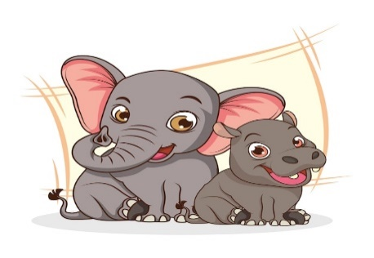
Do you like hippos and elephants? To most people, 36. . They usually stay quietly in the water or on land and do not look dangerous.
In fact, there are many records of these animals’ dangerous actions. When people get too close to them, hippos and elephants can become extremely dangerous animals. 37. , a few years ago, a Taiwanese visitor to Kenya died because a hippo bit him when he was trying to take a photo of it. There are also many news reports about elephants getting really angry and attacking their keepers.
If you think these animals are always friendly, you are wrong. That is only one side of the story. Next time, before trying to get close to animals, you should remember the saying: “ 38. .”
36. (A) they can bring us luck (B) they can be seen at a zoo
(C) they look friendly and nice (D) they need care and love
37. (A) Also (B) As a result
(C) On the other hand (D) For example
38. (A) Let the cat out of the bag (B) An elephant never forgets
(C) Actions speak louder than words (D) Never judge a book by its cover

(39~41)
Scott: 39. when the earthquake hit last night?
Bella: I was home. My house kept shaking, and all of the plates 40. the shelves. It was scary. What about you?
Scott: I just left the bookstore and was walking down the street near Showtime Live Sulin Store. I felt the ground shaking and I saw the lights go out and people running out of the buildings.
Bella: That was terrible. 41. , like most earthquakes, it stopped quickly.
39. (A) Where were you (B) Were you having breakfast
(C) Where did it happen (D) What were you doing
40. (A) went out (B) turned on
(C) fell off (D) gave back
41. (A) Suddenly (B) Luckily
(C) Comfortably (D) Probably

(42~44)
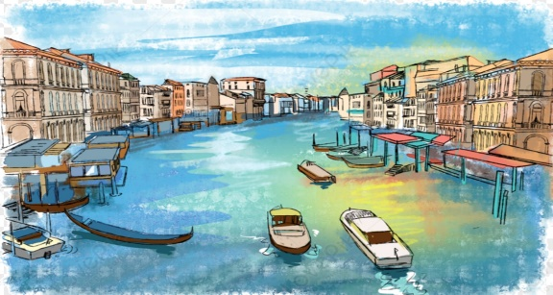
Venice is a special city in Italy. It is called the “City of Water” because it has more than 100 islands, over 170 canals, and 400 bridges. People move around the city by boat or on foot, instead of cars.
On November 12, 2019, Venice had its worst flood in 50 years. The water rose to 187 cm, the second highest in history. The worst flood happened in 1966. When the water reached 194 cm, many parts of the city were underwater. A famous place, St. Mark’s Square, was badly flooded. St. Mark’s Basilica, a famous church, was also destroyed. It was the fourth time in 20 years that the church had been flooded.
Since 2003, Venice has been building a system called MOSE. It includes 78 sea gates that can stop high water from coming into the city. Although MOSE was tested in 2013, it is still not finished. People in Venice hope it will be completed by the end of 2025. But some people are worried. A shopkeeper in Venice said, “I’m afraid MOSE will never work, but I hope it will. If not, I may have to sell my home and store.” 📖 destroy 毀壞

42. Why is Venice called the “ City of Water”?
(A) It has tall buildings and many highways. (B) It rains a lot there.
(C) It has many canals and islands. (D) It is underwater.
43. What do we know about MOSE?
(A) A famous church in Venice. (B) A sea gate system to stop floods.
(C) A museum in St. Mark’s Square. (D) A bridge destroyed by the flood.
44. Below are the ideas that are talked about in the reading.
① What made Venice special.
② What people in Venice expect.
③ What the flood did to Venice.
In what order does the writer put his ideas?
(A) ①→②→③ (B) ②→①→③ (C) ③→②→① (D) ①→③→②

(45~47)

Minecraft is one of the most popular video games in the world. It was created in 2009 by Markus Persson and later bought by Microsoft in 2014. Many young people enjoy playing Minecraft because it is fun and creative.
In Minecraft, players can build anything they want by using blocks. They can make houses, castles, farms, or even whole cities. There are no limits to what you can build. The game has different modes. In Creative Mode, you have all the blocks and can fly to build easily. In Survival Mode, you must collect materials, fight monsters, and stay alive.
One reason why Minecraft is popular among teenagers is that they can play with their friends. They can join the same world and build together. Some students even use Minecraft to learn about science, history, or math in a fun way. Also, Minecraft helps develop important skills like problem-solving, teamwork, and creativity. Many players also enjoy sharing their worlds on YouTube or watching others play the game online.
Today, Minecraft is more than just a game. It is a way for young people to express their ideas and have fun at the same time. That’s why Minecraft is still loved by millions of players around the world.
📖 limit 限制 mode 模式 survival 生存 material材料 express 表達

45. What is Minecraft mainly about?
(A) Cooking food. (B) Building with blocks. (C) Driving cars. (D) Playing sports.
46. Why do many teenagers like Minecraft?
(A) It is scary. (B) It is only for adults. (C) It is fun and creative. (D) It has many rules.
47. What can you do in Creative Mode?
(A) Fight monsters. (B) Build with all blocks and fly. (C) Run from the police. (D) Study for exams.

(48~50)
Beneath the skies so vast and blue,
The Earth awaits a kinder you.
Its forests breathe, its oceans sigh,
As smoke and plastic float on by.
The rivers once so pure and clear,
Now carry mankind’s waste and fear.
The polar caps begin to weep,
Their frozen secrets lost in sleep.
But hope still lives in every tree,
In winds that whisper, wild and free.
With every seed the children sow,
A greener future starts to grow.
So take a stand, embrace the day,
Let Earth Day guide our better way.
Protect the land, the air, the sea—
This world belongs to you and me.
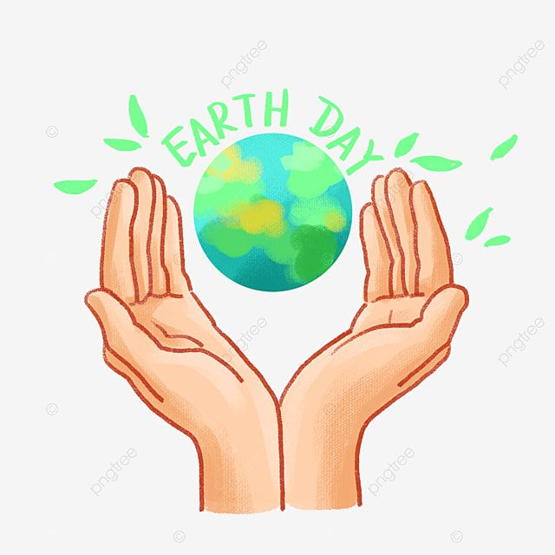
📖 mankind 人類 cap 冰帽
48. What is the message of the poem?
(A) The power of technology. (B) Environmental protection and hope.
(C) The beauty of the sky. (D) The mystery of space.
49. What do the lines “Its forests breathe, its oceans sigh” suggest?
(A) Forests and oceans are full of people. (B) The Earth is silent and unchanging.
(C) Forests and oceans are home to animals. (D) Nature is alive and reacting to human actions.
50. What does the poem imply about children planting seeds?
(A) It is a fun outdoor activity. (B) It has no real impact on the planet.
(C) It is needed by schools on Earth Day. (D) It stands for hope and a better future.

113-2-3 八年級英語科----解答
每題2分
01~10 AACBC CABBA
11~20 ABCCB ABCAD
21~30 AADBD DCCAD
31~40 ACADB CDDAC
41~50 BCBDB CBBDD

溪崑國中 英語科 考試卷 ___年___班
一、辨識句意：每題均有三張圖片，請依據所聽到的句子，選出符合描述的圖片。
- CD: A cat is hiding itself under the sofa.
(A) (B) (C)
答案：A

- CD: The boy felt happy when he saw the animal swimming in the lake, and then he took a picture of it.
(A) (B) (C)
答案：A
- CD: The boy was about to throw the ball, but he hurt himself and fell down.
(A) (B) (C)
答案：C
- CD: Although John had a lot of homework to do, he chose to have fun instead.
(A) (B) (C)
答案：B
- CD: Grace always takes the stairs to her office though it is on the 8th floor.
(A) (B) (C)
答案：C

二、基本問答：每題均有三個選項，請依據所聽到的內容，選出一個最適合的回應。
- CD: Do you hear anything from outside the house?
(A) Yes, I hid it outside the house.
(B) No, nothing is in the house.
(C) Yes, someone is singing.
答案：C
- CD: How many players do we need on a team?
(A) Twelve players make up a team.
(B) There are five teams in the race.
(C) This kind（種類）of event takes place every month.
答案：A
- CD: If you’re hungry, you can have some bread.
(A) I bring my own chopsticks to eat noodles.
(B) Can I have the pizza instead?
(C) Thank you. I need some spoons.
答案：B
- CD: Very few people know the writer, right?
(A) Correct. He’s the most famous writer in my country.
(B) That’s true. Though he isn’t very famous, I enjoy reading his books.
(C) You’re right. He is popular with teenagers.
答案：B
- CD: You cooked too much food. I don’t think you can finish it yourself.
(A) Don’t worry. It will end up in my brother’s stomach.
(B) Luckily, we can have steak instead.
(C) Why bother? Let’s use the forks and take a bite.
答案：A
三、言談理解：每題均有三個選項，請依據所聽到的對話與問題，選出一個最適當的答案。
- CD: M: What’s that sound?
W: Something hit the window.
M: Let me see... Oh, it’s a bird.
W: Oh my! Is it OK?
M: I don’t think so. Let’s take it to an animal doctor.
Q: What happened to the bird?
(A) It got hurt badly.
(B) It got out of the animal hospital.
(C) The man hit it in its head.
答案：A
- CD: M: Here comes the soup. Where’s Paul?
W: He left right after he got a phone call.
M: He didn’t even have a bite of anything.
W: Don’t worry. He’ll buy something to eat by himself. Let’s sit down and dig in.
Q: What happened to Paul?
(A) He finished nothing but the soup.
(B) He suddenly left without saying anything.
(C) Someone would buy food for Paul.
答案：B
- CD: W: You have a runny nose. Are you feeling sick?
M: Yes. It was cold last night.
W: Don’t you have any blankets?
M: I do, and I used two to cover my body when I slept. But they all fell onto the floor in the late night.
Q: What went wrong last night?
(A) The man fell off the bed when he slept.
(B) It wasn’t so cold, so the man didn’t need to sleep under blankets.
(C) The man’s blankets fell off his bed.
答案：C
- CD: M: Honey, are you ready to go?
W: I’m still looking for my water bottles, one for cold water and the other for hot water.
M: Can’t you just bring one bottle for warm water?
W: No. I have to make milk for our baby.
M: I see. Hey, I found them in the bag.
W: Thanks!
Q: What does the woman need?
(A) The milk to feed her baby.
(B) Her husband’s help to buy some milk.
(C) Her bottles to fill up cold water and hot water.
答案：C
- CD: M: Look! I bought some fried chicken. Let’s enjoy it together.
W: Great!
M: Do we have any disposable gloves at home?
W: No, we don’t.
M: But I need them to eat fried chicken because I don’t want to get my hands dirty.
W: Just eat it with your hands. You can wash them after you finish it. Besides, disposable gloves are bad for the Earth.
M: OK. I think you’re right.
Q: Why did the man want disposable gloves?
(A) He didn’t want to wash his hands before eating.
(B) He wanted to keep his hands clean.
(C) He could put them on to throw the chicken away.
答案：B

