新北市立溪崑國民中學113學年度第二學期第二次定期評量 英語科 試題卷
考試範圍: Unit 3-4 Review 2 （p1-p4劃卡題、p5手寫題） 八年級 班 座號 姓名
（一）、聽力測驗 30% (每題2分)
一、辨識句意：每題均有三張圖片，請依據所聽到的句子，選出符合描述的圖片。
（ ）1. (A) 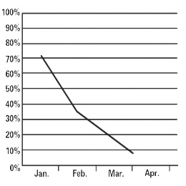 (B) 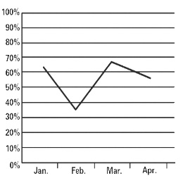 (C) 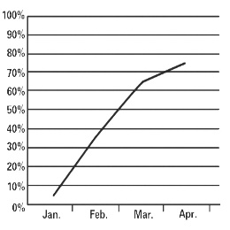
（ ）2. (A) 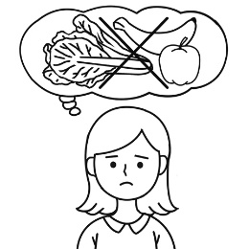 (B) 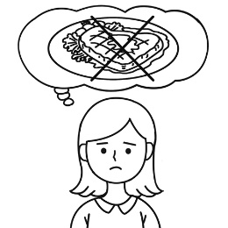 (C) 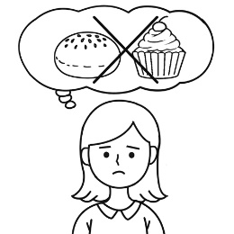
（ ）3. (A) 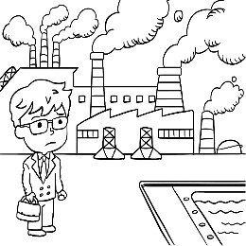 (B) 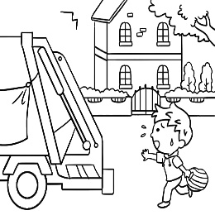 (C) 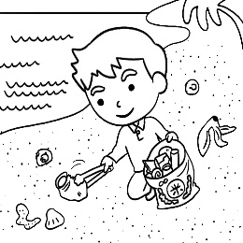
（ ）4. (A) 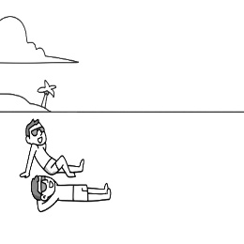 (B) 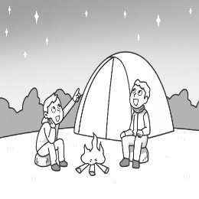 (C) 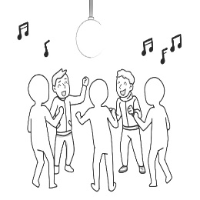
（ ）5. (A) 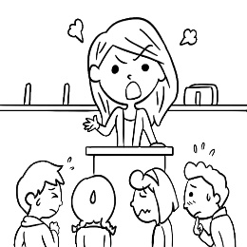 (B) 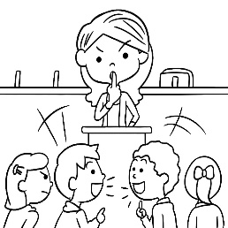 (C) 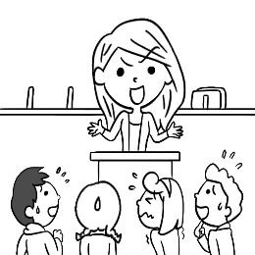
二、基本問答：每題均有三個選項，請依據所聽到的內容，選出一個最適合的回應。
（ ）6. (A) It’s the poorest restaurant around here. (B) Let’s start using the batter to make pancakes.
(C) Great. I keep healthy by always eating right.
（ ）7. (A) My son, of course. He matters more than anyone else in the world to me.
(B) My son, of course. To him, everything matters more than me.
(C) My son, of course. He doesn’t care about anything.
（ ）8. (A) At the end of the show. (B) On the ground over there. (C) You must put them down slowly.
（ ）9. (A) Oh, we must run to the station quickly then. (B) Actually, we are in the train station now.
(C) We will not be able to arrive there ten minutes earlier.
（ ）10. (A) You can put on more pairs of socks. (B) Take off the wet socks and hang them out to dry.
(C) That’s because you don’t keep your toes warm first.
三、言談理解：每題均有三個選項，請依據所聽到的對話與問題，選出一個最適當的答案。
（ ）11. (A) She worked for Delicious Chicken. (B) She wanted to order some food.
(C) She wanted to invite the man to dinner.
（ ）12. (A) They left trash by the wall. (B) They put a sign up on the wall. (C) They drew pictures on the wall.
（ ）13. (A) Dig in his dinner. (B) Go inside his room. (C) Go buy some bread.
（ ）14. (A) She won’t stop practicing. (B) She fell down and hurt her head. (C) She is going on a trip next week.
（ ）15. (A) He will go on a camping trip with Mrs. Lin’s family this weekend.
(B) He will probably buy as much food as possible in the supermarket.
(C) He was walking slowly to the supermarket when his wife saw him. （背面尚有試題）
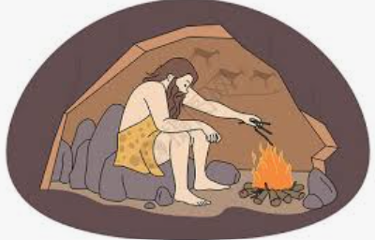
（二）、綜合測驗 34% (每題2分)
( ) 16. Look at the picture. What is the man doing? He is _____.
(A) making a fire (B) hanging out socks (C) lying on the ground (D) setting up camp
( ) 17. The song is not _____ to the kids. In fact, they listen to something like that every day at school.
(A) dark (B) friendly (C) perfect (D) fresh
( ) 18. A big dog once _____ my brother on the leg. Now he is afraid of dogs after that.
(A) dug (B) bit (C) put (D) stood
( ) 19. When David won the volleyball game, all of his classmates _____ for him yesterday.
(A) noticed (B) boiled (C) cheered (D) collected
( ) 20. We learned a lot about Grandma’s stories from reading her _____. We were all sad.
(A) campsites (B) diaries (C) leaves (D) strings
( ) 21. They decided to take a walk in the park because they had a really big _____ at the restaurant.
(A) meal (B) wall (C) weight (D) shape
( ) 22. Didn’t you see the sign over there? It says, ”Don’t park your motorcycle on the _____.” It’s for people to walk on.
(A) sidewalk (B) grass (C) moon (D) sugar
( ) 23. After years of hard work, Mary finally _____ a writer and is now popular in her country.
(A) looked (B) felt (C) got (D) became
( ) 24. Johnny started to play the piano because of his mother. She _____ him to practice every day.
(A) makes (B) helps (C) lets (D) has
( ) 25. Kevin: _____ did the cake taste _____? Judy: A strawberry. It was so soft and yummy.
(A) What; X (B) How; like (C) What; like (D) How; X
( ) 26. The smell of the food made all my family _____ hungrier. We couldn’t wait to eat.
(A) feel (B) feeling (C) to feel (D) felt
( ) 27. Yvonne arrived at the train station _____ than her classmates. She was excited about the class trip.
(A) early (B) earlier (C) earliest (D) more early
( ) 28. Vicky cleans the windows _____ in her class. She is hard-working.
(A) more careful (B) more carefully (C) the most careful (D) the most carefully
( ) 29. Raymond often goes to school _____, but he always studies _____.
(A) late; hardly (B) lately; hard (C) late; hard (D) lately; hardly
( ) 30. Kate plays the violin _____, but her sister plays it even _____.
(A) good; better (B) well; best (C) good; best (D) well; better
( ) 31. The little girl looked _____ at the party, and her father also looked at her _____.
(A) happily; happily (B) happy; happily (C) happy; happy (D) happily; happy
( ) 32. Jason is good at running. He runs _____ fastest on the school team.
(A) X (B) the most (C) more (D) very
（三）、閱讀測驗 16% (每題2分)
(33~35)
The Dajia Mazu Pilgrimage is one of Taiwan’s biggest events. It happens in late spring and lasts for nine days and eight nights every year. Some people even take some days off to walk more than 300 km to honor Mazu, the goddess of the sea. It’s a time of traditions, fun shows, and lots of good food. People along the way give out food to those people in Mazu Pilgrimage to show their love for Mazu.
Now we need helpers for this big event. You can help us:
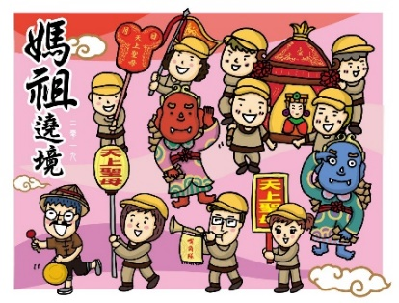

Give free food like buns, wheel pies, egg cakes, and pan cakes……
Help people who get hurt.
Keep the streets clean.
Show people where to go or what to do. （請翻至p3繼續作答）
Make sure everyone is safe.
Take photos of pilgrims.
This year, we’re looking for more young people to join us. Love cooking? Great! Good at planning things? Even better! Or maybe you just like chatting with people – we need you, too!
At the event, you can see cool lion dances and hear loud drums. Firecrackers with colorful smoke are amazing, too. It’s very exciting! You can also help everyone stay green by offering free food in paper containers.
Want to have fun and make new friends? Join us as a volunteer! Let’s make this year’s trip special together!
Dajia Mazu Pilgrimage大甲媽祖遶境 volunteer志工 event盛事 honor致敬 tradition傳統 offer提供
container容器 firecracker鞭炮 (文章改寫自”Eat, Pray, Enjoy”康軒)
( ) 33. What is this reading mainly about?
(A) It tells a story about a sea goddess.
(B) It shows how to travel around Taiwan.
(C) It asks for people to help at a special event.
(D) It talks about different kinds of Taiwanese food.
( ) 34. What does the reading say about being “green”?
(A) Growing plants.
(B) Using less plastic.
(C) Wearing green clothes.
(D) Painting streets green.
( ) 35. Who was probably a volunteer at the Dajia Mazu Pilgrimage last year?
(A) Lisa says: I played the drums on the street. It was very loud and exciting.
(B) Ken says: I gave out water and rice balls to people. It was tiring but fun.
(C) Gina says: I walked with people for two days. The free food was very good.
(D) Ian says: I felt safe and didn’t get hurt. Everyone knew where to go and what to do.
(36~38)
Gina: | Hey, isn’t it wonderful to be camping out here in Japan? The outback is so beautiful unlike the city view.  It’s far away from cities and the sea, especially the ALPS, which is famous for its clean water and bright  green mountains.
Ken | You can say that again. I really enjoy its fresh air and clear night sky with shining stars. They are simply breathtaking.
Gina: | And the wildlife! Did you know Japan has some unique animals in the world?
Ken: | Yeah. I saw on TV that Japanese macaques will take a hot spring bath in winter and they become Internet celebrity. Another is the thunderbird. You can hear their loud, low and rough sounds even from far away.
Gina: | And Japanese serows with fluffy hair and cute faces! I’m hoping we’ll be lucky enough to see one tomorrow though it’s a slim chance.
Ken: | Me too. I also want to see a thunderbird up close in the nature.
Gina: | We’d better rest or we might not get up early for the cultural tour early tomorrow morning.
Ken: | It’s important to know more about the land we are visiting.
Gina: | I just can’t wait!
breathtaking令人窒息的 wildlife野生動物 unique獨特的 macaque獼猴 celebrity名人 rough粗糙的
serow鬛羚 fluffy蓬鬆的 tour遊覽
( ) 36. What is the best title of the reading?
(A) An amazing cultural tour.
(B) Cities in the ALPS.
(C) A camp trip in Japan.
(D) Wild animals in Japan.
（背面尚有試題）

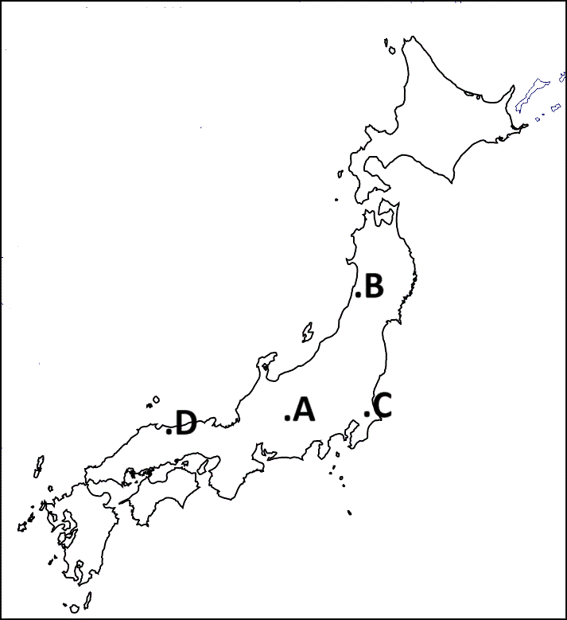
( ) 37. Look at the picture. Which is an outback?
(A) A
(B) B
(C) C
(D) D
( ) 38. Which is true according to the reading?
(A) Japanese macaques take a hot spring bath all year round.
(B) People can find shining stars in the clear dark night in the cities.
(C) Japanese serows are not easy for people to find even in Japan.
(D) Ken didn’t agree with Gina on the cultural tour the next morning.
(39~40)
- News 2024-04-03 Hit Count：6217
The Big Earthquake in East Taiwan Caused Damage to Hualien on
April 3, 2024
A strong earthquake hit Hualien on the morning of April 3, 2024. It caused rocks to fall down the mountains in Taroko National Park. The rockfalls hurt many visitors and took away many lives. To keep visitors and hikers safe, Taroko National Park is closed to the public and will open again when it is safe for visitors and hikers. rockfall落石
- News 04-18-2025 Hit Count：1064
Central Cross-Island Highway (Highway  ) is open, but the
Trails in Taroko National Park Are Still Closed. trail步道
May: | The earthquake was the strongest one in my life. I wasn’t in Hualien, but I could feel the shake. I was sleeping, and my bed was shaking terribly.
Ted: | I heard my little brother crying loudly when the shaking started. We all hurried outside the house. My pet cat hid under the bed and wouldn’t come out long after the shaking stopped.
John: | I’m sad the earthquake made Taroko Park not a beautiful place anymore. I went there from Canada five years ago. Visitors from other countries all love this wonderful park.
Jane: | When the ground shook, I was studying in the classroom. We quickly hid under the desks. I wasn’t afraid because of the earthquake drills we had at school.
Ian: | My friends in Taiwan told me they are used to earthquakes, but the quake this time was a really strong one.
Eva: | I felt like I was standing on a giant rolling ball. After the shaking, I hugged my family and felt thankful that we were all safe.
Jenny: | Oh, I heard about that big earthquake in Taiwan. I feel sorry and hope you can get over it soon.
Mina: | I was driving and saw the traffic light moving back and forth like they were dancing. That was terrible!
drill演練 giant巨大的 hug擁抱 forth向前地
( ) 39. Who didn’t experience the big earthquake on April 3, 2024?
(A) Mina, John, and Ted. (B) Ian, Jane, and John.
(C) Jenny, Eva, and May. (D) John, Ian, and Jenny.
( ) 40. What can we know from the reading?
(A) Fewer people read the news The Big Earthquake in East Taiwan Caused Damage to Hualien on April 3, 2024 than the other one.
(B) Students in Taiwan didn’t know what they should do when an earthquake happened.
(C) Many people got hurt badly but luckily no people died from the rockfalls in the quake.
(D) The whole Taroko National Park was closed on April 3, 2024 and the trails are still not open to the public now.
（劃卡試題結束，請翻至手寫卷作答）

新北市立溪崑國民中學113學年度第二學期第二次定期評量 英語科 答案卷
考試範圍: Unit 3-4 Review 2 八年級 班 座號 姓名
請用藍或黑色筆作答 (20%)
得分
依提示作答4%
41. During the break time, some students like to read. _______________ students like to talk. _________________ students like to go to the student store. （空格填「…其他…還有…」）2%
42. Sara ate less than Helen. Helen ate less than Judy. （用最高級合併句子）1%
_____________________________________________________________________________
43. Sandy is gentle. Sandy is reading to her child. （用gentle的副詞合併句子）1%
_____________________________________________________________________________
翻譯16%
44. | 例如，許多速食餐廳在它們的招牌上運用黃色和紅色，因為黃色使人感到快樂，而紅色則傳遞出邀請客人進入店裡的感覺。
45. | 在晚餐時間，我們做飯、和我們的老師們分享食物，並把盤子上的所有食物都吃光。
46. | 我們必須認真練習，否則我們將無法在大家面前跳得好。
47. | 當你跳舞時，移動要更緩慢，輕柔地踮起腳指頭旋轉，而且不要忘記微笑。
48 | 我們可以點任何東西而不用擔心體重增加。

44. 4%
________________________________________________________________________________________________________________________________________________________________________
45. 3%
________________________________________________________________________________________________________________________________________________________________________
46. 3%
________________________________________________________________________________________________________________________________________________________________________
47. 4%
________________________________________________________________________________________________________________________________________________________________________
48. 2%
________________________________________________________________________________________________________________________________________________________________________
試題結束，請仔細檢查。
113-2-2 八年級 英語科－解答
1-40每題2分
1 | 2 | 3 | 4 | 5 | 6 | 7 | 8 | 9 | 10
C | C | A | B | B | C | A | B | A | A
11 | 12 | 13 | 14 | 15 | 16 | 17 | 18 | 19 | 20
B | C | C | A | B | A | D | B | C | B
21 | 22 | 23 | 24 | 25 | 26 | 27 | 28 | 29 | 30
A | A | D | B | C | A | B | D | C | D
31 | 32 | 33 | 34 | 35 | 36 | 37 | 38 | 39 | 40
B | A | C | B | B | C | A | C | D | D

41. Other Still other 2%
42. Sara ate (the) least (of the three). 1%
43. Sandy is reading to her child gently. 1%
44. For example, many fast food restaurants use yellow and red in their signs because yellow makes people feel happy and red invites people into the stores. 4%
45. At dinnertime, we cooked, shared the food with our teachers, and ate up everything on our plates. 3%
46. We have to practice hard, or we won’t be able to dance well in front of everyone. 3%
47. When you dance, move more slowly, turn on your toes gently, and don’t forget to smile. 4%
48. We can order anything and don’t have to worry about putting on weight. 2%

八年級第二次段考聽力稿
- 辨識句意：每題均有三張圖片，請依據所聽到的句子，選出符合描述的圖片。
- The company’s business is getting better and better.
- Mary wanted to lose some weight, so she decided not to eat anything sweet.
- The man is sad about the change of the city. The air is getting much dirtier.
- My brother and I had a very good time under the starry sky.
- Mrs. White asked the students to speak as gently as possible. However, they still talked loudly.
- 基本問答：每題均有三個選項，請依據所聽到的內容，選出一個最適合的回應。
- The restaurant uses less oil, salt, and sugar in their food.
- Who is the most important person in your life?
- Where do you want me to put down these boxes?
- W: When will the train arrive at the station?
M: Let me see. In about ten minutes.
- My feet are cold because the socks are too thin.
- 言談理解：每題均有三個選項，請依據所聽到的對話與問題，選出一個最適當的答案。
- [Phone ringing...]
M: Hello, this is Delicious Chicken. How may I help you?
W: Hi, I’d like a family fried chicken and a large fries.
M: Anything else?
W: Yes, one vegetable soup.
M: Sorry. We don’t have vegetable soup today. What about bean soup?
W: Nope. That’s all. How much are they?
M: It’s three hundred and eighty dollars. The meal will be ready in thirty minutes.
W: OK. Thank you.
Q: Why did the woman make the phone call?
- W: I can’t believe it. Those kids drew on the wall again.
M: They call it art.
W: It’s not art to me. It only makes the wall look dirty. Some people even leave trash by
the wall because of those pictures.
M: Maybe you should put a sign on it.
W: I did, but they just keep drawing.
Q: What did the kids do?
- B: Mom, I’m home. When will dinner be ready?
W: Soon.
B: OK. I’ll be in my room. Call me when it’s ready.
W: Wait. I need you to buy some bread for breakfast tomorrow.
B: Right now?
W: Yes. Dinner will be ready when you come back.
Q: What will the boy do next?
- B: Why are you sitting here? Are you OK?
G: I just tripped and fell down.
B: Poor you. Let me help you up.
G: Thank you. I’m going to practice more today.
B: Why don’t you take a rest?
G: I want to win first place at the show next week.
Q: What do we know about the girl?
- M: Hi, Mrs. Lin. Where are you hurrying to?
W: The bread and the meat in the supermarket are on sale now.
M: All the meat and the bread?
W: Mr. Chen told me so. He came back home with lots of food from there.
M: Great. I’ll give my wife a call. We need lots of meat for the family camping trip this
weekend.
W: But the sale will end at twelve. We only have... let me see, twenty minutes.
M: Oh, forget about the call. I’ll go with you.
Q: Which is true about the man?

