新北市立溪崑國民中學112學年度第一學期第二次定期評量 英語科 試題卷
七年級 班 座號 姓名
一、聽力測驗 30%
(一) 辨識句意：請依據所聽到的句子，選出符合描述的圖片10%

1. ( ) (A) 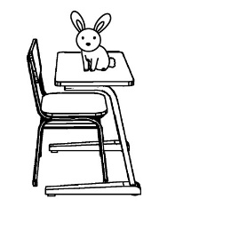 (B) 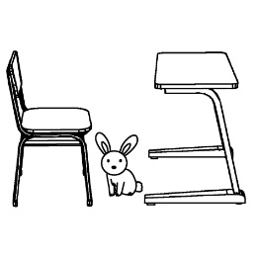 (C) 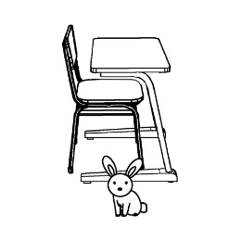
2. ( ) (A) 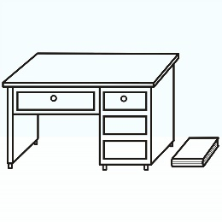 (B) 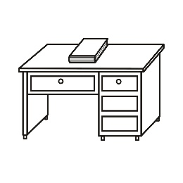 (C) 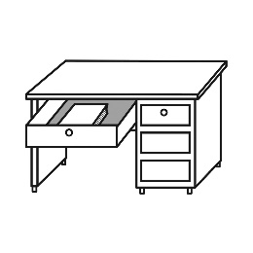

3. ( ) (A) 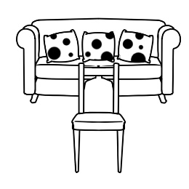 (B)  (C) 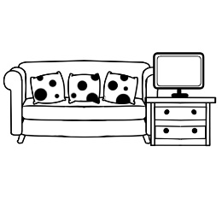

4. ( ) (A) 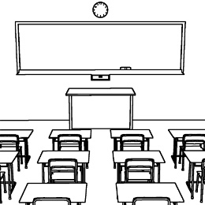 (B) 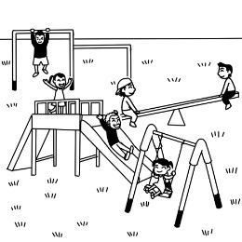 (C) 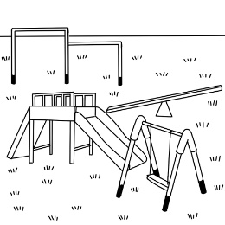

5. ( ) (A) 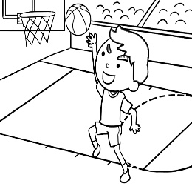 (B) 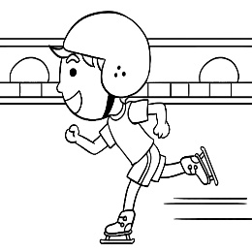 (C) 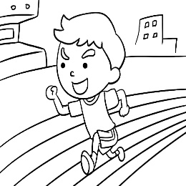

(二) 基本問答：請依據所聽到的內容，選出一個最適合的回應10%
6. ( ) (A) It’s from Taiwan. (B) It’s under your desk. (C) Is it in your blue bag?

7. ( ) (A) It’s different. (B) It’s my blanket. (C) It’s a magic school.

8. ( ) (A) Yes, it’s behind these mountains.
(B) There are some schools around here.
(C) Yes, there is a junior high school.

9. ( ) (A) Yes, it is fun. (B) No, she is in the library. (C) Yes, they are on the swings.

10. ( ) (A) There are about thirty. (B) Yes, it’s big and beautiful. (C) It’s behind the mountains.

(三) 言談理解：請依據所聽到的對話與問題，選出一個最適當的答案10%

11. ( ) (A) Yes, it’s a yellow blanket. (B) No, it isn’t. (C) Yes, it’s small and hard.

12. ( ) (A) She’s in the dining room. (B) She’s in the living room. (C) She’s in the kitchen.

13. ( ) (A) A blanket. (B) A cellphone. (C) A newspaper.

14. ( ) (A) It’s behind the sports field. (B) It’s beside the playground. (C) It’s in front of the playground.
15. ( ) (A) A mouse. (B) A cat. (C) A sheep.

二、 綜合測驗 (每題2分) 34%
16.( ) Many students at our school love basketball so much. After school there are a lot of students on the basketball _______ .
(A) field (B) ground (C) playground (D) court

17.( ) A:Isn’t your school next to the post office? B: No, It’s ________ the restaurant and the police station.
(A) on (B) between (C) in (D) over

18.( ) You don’t like to eat the same food for dinner for one month. Do you want something ________ for a change?
(A) soft (B) hard (C) same (D) different

19.( ) Harry is _________ boy. He is so happy in a magic school.
(A) an eleven years old (B)a eleven years old (C) an eleven-year-old (D) a eleven-year-old

20. ( ) Bella lives _______ her school, so she walks to her school every day.(A) near (B) over (C) on (D) under

21. ( ) The businessman comes to the city for business, not for _______. He needs to buy something cheap for his company.
(A) minute (B) later (C) fun (D) gate

22. ( ) A：Where are my storybooks? B: They’re ________. (A) on the bed (B) in the bed (C) in bed (D) on bed

23. ( ) Look! My father is ______ the bus. He drives a bus every day. He is a bus driver.
(A) in front of (B) in the front of (C) in back of (D) in the back of

24. ( ) A: Your mom is a nice housewife. She does the housework every day. B: No, she is not a housewife. ______ she is a nurse in a famous hospital.
(A) In fact (B) That’s right (C) So (D) No wonder

25.( ) Simon is happy that he got a good _______ on his English test. He prepared for it for 2 weeks.
(A) class (B) storybook (C) grade (D) question

26( ) A：________ under the sofa? B: An old cellphone. (A) Are there (B) Is there (C) What’s there (D) Where’s

27.( ) The Kaos do not have a ________ in their small house, so they always have dinner in the living room.
(A) restroom (B) dining room (C) bathroom (D) bedroom

28.( ) A: Is there a pig in your home? B: Yes, ___________. Everyone in my house loves the pet pig so much.
(A) they are (B) there are (C) it is (D) there is

29.( ) A: Look! My favorite singer is _________. B: I also like her. I know she is from Korea.
(A) on TV (B) in TV (C) on the TV (D) in the TV

30.( ) The school in the mountains ________ different. Its sport field is so big. I like it. (A) are (B) am (C) is (D) be

31.( ) Cindy loves flowers, but she does not have much money to buy many beautiful flowers. She is happy that there is a public _______ right next to her home. (A) classroom (B) library (C) garden (D) gym
32. ( ) A: _____ your new English teacher from? B: He is from Philadelphia.
(A) Where does (B) What does (C) What’s (D) Where’s

三、閱讀測驗 (每題2分) 12%
(一)
Hello, my name is Nick. Welcome to my house! My house has two floors and eight rooms. On the first floor you can find the living room. We love to watch TV and listen to music there. Next to it, you see the kitchen. Sometimes I cook dinner for my parents and my two sisters. Between the kitchen and the bathroom, you find the study room. On the second floor, there are three bedrooms. My bedroom is between my parents’ and my sisters’ bedrooms. In front of my bedroom, you can see a big bathroom, and I love taking a shower there every morning. Finally, I want to tell you about my bedroom. I have a bed and a bedside table with a lamp on it. In front of my bed , I have a TV on a table, and under the table there is a box full of magazines. There are also two posters on the wall under a small window in front of the TV. This is my favorite place because I can relax, listen to music and sleep! poster海報; relax放鬆
33.( ) What is Nick’s favorite place?
(A) The living room. (B) The bathroom (C) The study room. (D) The bedroom.
34.( ) What is NOT on the second floor in Nick’s house ?
(A) The TV. (B) The kitchen. (C) The bathroom. (D) The bedroom.

(二)
All around the world people live in different types of homes. Many people live in apartment buildings reaching high to the
sky. In Spain many people live in villas with big swimming pools. Eskimos live in igloos. Igloos are made of huge blocks of ice. In
some hot countries people live in huts with no windows or doors, made of mud, straw and leaves. Some Indians still live in teepees
made of animal skins. In many countries people live in houseboats, which are houses on the water.
teepee圓錐狀帳篷; villa別墅; huts小屋; mud泥土; straw稻草; skin皮膚
35.( ) What is the reading mainly (主要地) about ?
(A) Homes in the water. (B) Homes in the sky. (C) Homes around the world. (D) Home in the houseboats.
36.( ) Which (哪一個) is true (真實的)?
(A) Indians live in teepees.
(B) Houseboats are on the land.
(C) Everyone lives in the same type of the house.
(D) Huts are made from blocks of ice.

(三)
I think home schooling is great. I hope my parents will do this. The idea of never going to school sounds too good to be
true. My name is Ken and I am 19 years old. I hate school. I want to stay at home every day. I really don’ t mind staying at home
and studying. Of course, you need to be careful not to forget studying. One thing about home schooling I like is visiting museums
or watching films to learn more. I think my learning at school is bad because there are many kids who don’t want to learn.
I can get better grades if I stay at home. Maybe there’ll be more schooling in the future because of the Internet.
mind介意; film影片;future未來
37.( ) What is the reading mainly (主要地) about ?
(A) School life. (B) Doing homework. (C) School life at home. (D) Learning at school.
38.( ) Which (哪一個) is true (真實的)?
(A) Ken loves school.
(B) Ken doesn’t like to stay at home.
(C) Ken hates going to museums.
(D) Internet can make home schooling easier in the future.
~以下題目，請在答案卷上作答，否則不予計分~
四、配合題 (每題1分) 8%:
選擇下列代號A,B,C,D,E,F,G,H,依下列文章的意思，填入各題的空格中，以完成下列文章
例: (I)There are (A) they are (B) there is (C) there isn’t (D) there aren’t (E) some (F) a (G) an (H) the

Tokyo, Japan is 1 exciting place to live, but in the city, 2 a big problem. 例 millions of people, but 3 any space for many big homes. But now there is 4 clever answer to the problem: the Cell Brick Micro-Home. These beautiful homes are tall and narrow, and 5 very small. There is only one big room inside them. During the day the room is a living room, and the beds are inside 6 walls. The bathroom and kitchen areas get some shelves and cupboards, but 7 any walls between them. There are 8 curtains around the toilet and the shower, so people can’t look inside.
millions of 數以百萬計; shelf架子; cupboard櫥櫃;curtain窗簾

五、依提示改寫句子 (每題2分) 4%
1.The restroom is in back of the living room.（依畫線部分造原問句）
_____________________________________________

2.Is there an egg on the table? (改為複數問句）
_____________________________________________

六、翻譯：(每題3分) 12%
1. 我的學校有不同的課程，它們都很有趣。

__________________________________________________

2. 螢幕上的這相片是什麼地方？

__________________________________________________

3. Jason的床是一張在桌子旁邊又小又舊的毛毯。

__________________________________________________

4. 你的床又大又柔，或者又小又硬？

__________________________________________________

~試題完~

新北市立溪崑國民中學112學年度第一學期第二次定期評量 英語科 答案卷
七年級 班 座號 姓名
四、配合題(每題1分) 8%
例 | I | 1 |  | 2 |  | 3 |  | 4
 |  | 5 |  | 6 |  | 7 |  | 8

五、依提示改寫句子4% (每題2分)
1.
2.

六、翻譯12% (每題3分)
1.
2.
3
4

112-1-2 七年級 英語科－解答
一、聽力測驗 30%
1~5 BABCA 6~10 BCCBA 11~15 BACBA
二、綜合測驗34%
16~20 DBDCA 21~25 CABAC 26~30 CBDAC 31~32 CD

三、閱讀測驗12%
33~38DBCACD

四、配合題8%
1~8 GBCF AHDE
五、依提示改寫句子4%
1.Where is the restroom?

2. Are there any eggs on the table?

六、翻譯：(每題 3分) 12 %
1. There are different classes at my school, and they are fun.
2. What’s the place in this photo on the screen?
3. Jason’s bed is a small and old blanket next to the table.
4. Is your bed big and soft, or is it small and hard?

新北市立溪崑國民中學112學年度第一學期第二次定期評量
七年級 英語科 聽力測驗稿
聽力測驗 30%
(一) 辨識句意：請依據所聽到的句子，選出符合描述的圖片10%
1. (B:) Where is your pet rabbit? (G:) It’s between the chair and the table.
2. The book is not under the desk. It’s next to it.
3. There is a television in the living room. It is behind the sofa.
4. It’s cold today. There aren’t any children in the playground.
5. Jerry isn’t on the sports field. He’s on the basketball court.
(二) 基本問答：請依據所聽到的內容，選出一個最適合的回應10%
6. Where is my blue bag?
7. What is this place in the picture?
8. Is there a school in the mountains?
9. Is your daughter in the playground?
10. My school is very big. There are sixty classes. What about your school?
(三) 言談理解：請依據所聽到的對話與問題，選出一個最適當的答案10%
11. M: I like this red blanket. It’s thin and soft.
W: What about the yellow one?
M: It’s small and hard.
Q: Is the yellow blanket thin and soft?
12. B: Mom, I’m home. Where are you?
W: In the dining room. It’s time for lunch.
B: Great! Mom, can I have lunch in the living room?
W: No. Don’t eat and watch TV at the same time.
Q: Where is the woman?

13. M: Good morning.
W: Good morning. Today’s newspaper is on the dining table.
M: Thank you. Where is my cellphone?
W: It’s on the small table near the door.
Q: What is on the dining table?
14. M: Are there any restrooms around here?
W: Not around here. Go to the playground. There is one next to it.
M: Where is the playground?
W: It’s in front of the sports field.
Q: Where is the restroom?
15. M: There is a mouse in the kitchen. Is it Sandy’s pet?
W: Yes, it’s her favorite pet mouse.
M: Isn’t her favorite animal a cat or a sheep?
W: Those are not her favorites now.
Q: What is Sandy’s favorite animal now?

