新北市立溪崑國民中學112學年度第一學期第一次定期評量 英語科 試題卷
八年級 班 座號 姓名
第一大題 聽力測驗(1-15題，共25分)

第一部分 根據聽到的內容，選出正確的圖片(1-5題，每題2分)
( ) 1. | (A)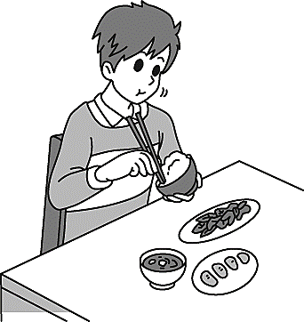 |   (B) | 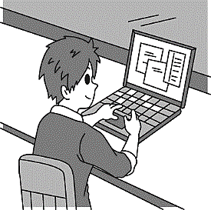  (C)
( ) 2. | (A) 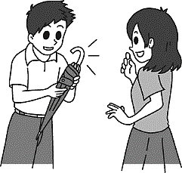 | (B) 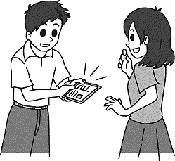 | (C) 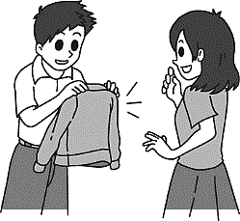
( ) 3. | (A) 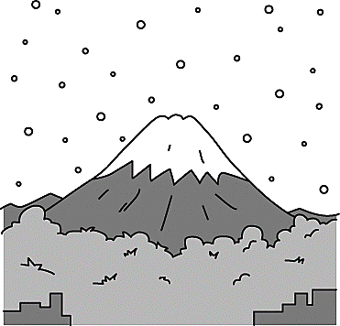 | (B) 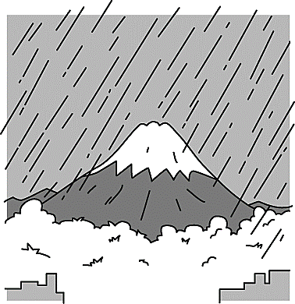 | (C) 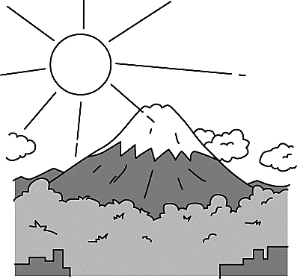
( ) 4. | (A) 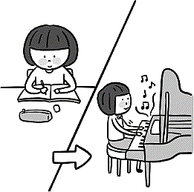 | (B) 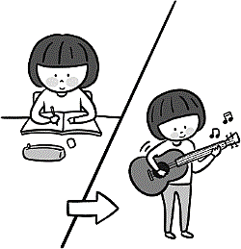 | (C) 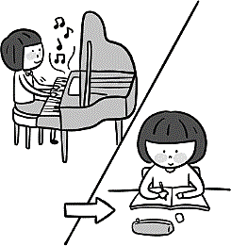
( ) 5. | (A) 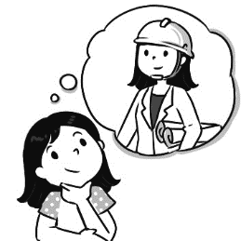 | (B) 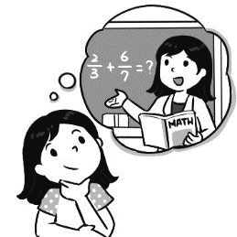 | (C) 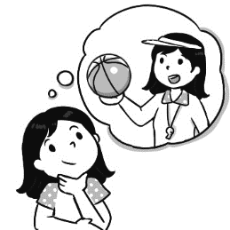

第二部分 基本問答：根據聽到的內容，選出一個最適合的回應或最適合的問句。 (6-10題，每題2分)
( ) 6. (A) There is a lot of rain in Taiwan. (B) I love summer a lot. (C) It is not easy to see flowers.
( ) 7. (A) That bag is not very cheap. (B) It is Judy’s. (C) I like your red bag.
( ) 8. (A) Sure! No problem. (B) Yes, he called Sharon five minutes ago. (C) I don’t think so.
( ) 9. (A) Yes, I am in the violin club and the magic club. (Ｂ) Yes, once a week.
(C) No, I don’t need to go to school on Sunday.
( ) 10. (A) It is a very interesting club. (B) I like to listen to music. (C) I learn how to play the violin.
第三部分 言談理解：根據聽到的內容，選出一個最適合的答案。 (11-15題，每題1分)
( ) 11. (A) She has to visit a friend first. (B) The beach is very clean. (C) She really wants to go there.
( ) 12. (A) The magic club. (B) The video game design club. (C) The English club.
( ) 13. (A) Three o’clock. (B) Two thirty. (C) Three forty.
( ) 14. (A) Talk to Mr. Wang. (B) Have lunch with Cindy. (C) Do the report.
( ) 15. (A) He is the girl’s teacher. (B) He is the girl’s father. (C) He is the girl’s boyfriend.
第二大題 綜合測驗 (16-34題，每題2分，共38分)
( )16. English, History, and Math are my favorite ________. I study them every day.
(A) languages (B) subjects (C) stories (D) clubs
( ) 17. Maggie is very happy because she can have her ______ room now. She doesn’t have to share a room with her sister
anymore.
(A) bed (B) free (C) self (D) own
( ) 18. It’s pouring outside. I’ve never seen such ______ rain before.
(A) big (B) lots of (C) heavy (D) strong
( ) 19. Poe looks like a grandpa, but _______, he’s only 28 years old.
(A) how strange (B) in fact (C) at the end (D) in a fun way
( ) 20. Hey, guys, go back to your seats and stop talking. Mr. Chen is coming ________. If you are still so noisy, he will get mad.
(A) quickly (B) fast (C) short (D) soon
( ) 21. Before you go to the classes, you have to _______ for them on the school website(校網).
(A) learn (B) sign up (C) sing out (D) check out
( ) 22. A: ________ iPad is this? B: Maybe it’s Jordan’s. I saw him using one yesterday.
(A) Who’s (B) What (C) Whose (D) Where
( ) 23. I don’t know anything about the robot design club. Can you ______ me something about it before I join it?
(A) tell (B) speak (C) talk to (D) say to
( ) 24. My dad is still working in his office now, but I think he’ll be back home _______ about an hour.
(A) for (B) by (C) at (D) in
( ) 25. A: May I speak to Jake, please? B: ________ A: Thanks.
(A) Please hold on. . (B) Speaking. (C) You are welcome (D) You have the wrong number.
( ) 26. John wants to study in St. Marie High, but he can’t, because that is a _______ school.
(A) girl (B) girl’s (C) girls’ (D) girls
( ) 27. Usually ______ a lot of snow here in July, but it’s very different this year.
(A) it is (B) they have (C) it has (D) there is
( ) 28. I am very happy because my mom bought ______ a cellphone for my birthday.
(A) I (B) mine (C) me (D) my
( ) 29. Terry ______ a lovely thank-you card to the man that helped him.
(A) bought (B) made (C) had (D) wrote
( ) 30. The postcards on the table are for _______; _______ are on your desk in your room.
(A) me ; you (B) me ; yours (C) mine ; yours (D) mine ; you
( ) 31. ________ a lot in New York last winter, but ________ any this December.
(A) We had snow ; it doesn’t snow (B) It snowed ; there isn’t
(C) There was snow ; it doesn’t (D) There snowed ; we don’t have
( ) 32. It’s getting cloudy, and I heard a clap of thunder(雷). Let’s go home ______ it rains. I don’t want to get wet.
(A) before (B) when (C) after (D) because
( ) 33. When I thought ______ how to help the poor family, I thought ______ Mr. Wealth, the kind and rich businessman.
(A) of ; about (B) about ; of (C) for ; of (D) about ; for
( ) 34. John: I don’t know how to swim, so last week I joined the swimming club to learn.
Ted: Good for you. Maybe you can go swimming with me in the sea this Saturday. John: _________ No way!
(A) What’s up? (B) Can I have a look? (C) Are you pulling my leg? (D) You swim like a fish.

第三大題 克漏字測驗 (35-39題，每題2分，共10分)
(35-39)
Jake : Hey, May. Why are you in such a hurry? Where are you going?
May: Oh, honey. Sorry, I didn’t see you. I have to go to Tim’s school and pick him up.
Jake: Why? He’s already 15 years old. He can go home by himself.
May: Of course. But he called me 35 , but I didn’t get it. I was on my way home and didn’t hear my cellphone ring. Then I
saw his message on my phone. He 36 to me that he didn’t have an umbrella with him, so he can’t go home.
Jake: Oh, I stay in the house all day. 37 the weather like outside now?
May: It 38 and terribly cold.
Jake: The weather is too bad. You just stay home. Let me go pick him up.
May: Oh, honey! 39 ! Thank you.

( ) 35. (A) 10 minutes ago (B) for 30 minutes (C) right now (D) in an hour
( ) 36. (A) told (B) said (C) spoke (D) talked
( ) 37. (A) How’s (B) Does (C) Is (D) What’s
( ) 38. (A) rains (B) rainy (C) is raining (D) is rain
( ) 39. (A) What sweet a husband you are (B) How very sweet of you
(C) It’s so kind for you (D) That’s sweet of me
第四大題 閱讀測驗 (40-44題，每題1分，共5分)
(40-42)
The Ghost Festival comes every year on the fifteenth day of the seventh month in the lunar calendar. It's a special time for people in Taiwan. They believe that during the first day of this month, the gate to the underworld or "Hell" opens up. So, to make sure the spirits of dead people feel welcome and respected, they do some rituals. One thing they do is let go of lanterns, like little glowing lights, to help guide the spirits. They also prepare yummy food as offerings to feed these spirits because they might be hungry. Lighting incense and burning spirit money are other ways to show respect to the spirits.
But there's a rule during this ghost month: Don't go swimming in rivers or the sea! Why? Well, some ghosts might be out there, and they could try to find someone to take their place. That's why people stay away from swimming during this time.

gate 大門 spirit 靈魂 lantern 燈籠 glowing 發亮的 offering 供品 incense 香

( ) 40. Which of the following is a ritual?
(A) People celebrate a birthday with cake and candles.
(B) Students go to school in uniforms (制服).
(C) People in the old times lit up (點亮) a lantern when they were in the dark.
(D) People prepare yummy food when they are hungry.

( ) 41. What do people in Taiwan do on the Ghost Festival?
(A) They buy yummy food and incense with spirit money. (B) They find someone to take their place at work.
(C) They open the gate to the underworld. (D) They stay away from waters.
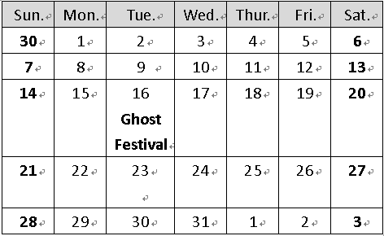
( ) 42. Otani: Let’s go swimming at the beach this weekend.
Darvish: But is it safe to go swimming this weekend?
Otani: Sure. I know what you’re worried about. I’ve checked the calendar.

Question: When are Otani and Darvish going to swim?
(A) On July 7. (B) On July 13.
(C) On July 28. (D) On August 3

(43-44)
In Japan, there are not enough people to work, so the government is letting more people from other countries, like Vietnam and the Philippines, come and work there. But it's not easy for them because they need to learn Japanese and might not get paid as much as they would in their own countries.
In the past, people from other countries came to Japan to work, but they had different problems. For example, some Japanese-Brazilians had trouble because they didn't speak Japanese well. When there were fewer jobs, some of them had to leave. There are also Korean people who have been living in Japan for a long time, but they aren't considered Japanese citizens. Some of them faced discrimination before, but things are getting better for some.
Japan doesn't usually take in many refugees, but they made an exception for some Ukrainian people who had to leave because of a war. These Ukrainian refugees have to go back to Ukraine when the war is over.
Japan wants more workers with skills from other countries to help with their work shortage. But some people think it will be difficult because of the language and culture differences. The government is also making it harder for immigrants by raising the language requirements.
Still, some people think having more immigrants in Japan is a good thing because it can make the job competition better and help the economy. Although there are challenges, some immigrants like living in Japan because most people there treat them with respect, no matter what kind of job they have.
government政府 Vietnam 越南 the Philippines菲律賓 get paid 得到薪水 Japanese-Brazilians 日裔巴西人 consider認為 citizen 公民discrimination 歧視 refugee 難民 Ukraine烏克蘭
immigrant 移民 raise提高 requirement要求competition 競爭 economy 經濟 although 雖然

( ) 43. Which of the following is an example of exception?
(A) John always goes to a doctor when he is sick.
(B) Japan lets foreigners with skills work for its people.
(C) Every Ukrainian has to go back to Ukraine after the war.
(D) Everyone in this class has to take an English class, but Peter doesn’t, because he is an American.

( ) 44. Which of the following is TRUE?
(A) Many foreigners don’t like to work in Japan because Japanese are bad to them.
(B) Japan wants more foreigners to come to work for them because of a war.
(C) The problems foreigners face are always the same when they work in Japan.
(D) Working in Japan is not easy for foreigners.

第五大題 翻譯 (22%)
1. A: 台北冬天的天氣如何? B:很冷，但是不會下雪。(4%)
2. 我的夾克不夠溫暖，所以我阿姨把她的給了我。(4%)
3. 我無法下定決心，因為所有的社團都很有趣。(4%)
4. 英文一點也不難，而且老師們教學的方式很有趣。(English…, and …way.) (4%)
5. 我從那位3屆機器人設計大賽的贏家身上學到很多。(6%)

新北市立溪崑國民中學112學年度第一學期第一次定期評量 英語科 答案卷
八年級 班 座號 姓名
第五大題 翻譯 (22%)
1. A: 台北冬天的天氣如何? B:很冷，但是不會下雪。(4%)
________________________________________________________________________________
2. 我的夾克不夠溫暖，所以我阿姨把她的給了我。(4%)
________________________________________________________________________________
3. 我無法下定決心，因為所有的社團都很有趣。(4%) ________________________________________________________________________________
4. 英文一點也不難，而且老師們教學的方式很有趣。(English…, and …way.) (4%) ________________________________________________________________________________
5. 我從那位3屆機器人設計大賽的贏家身上學到很多。(6%) ________________________________________________________________________________

112-1-1 八年級 英語科－解答
1 | 2 | 3 | 4 | 5 | 6 | 7 | 8 | 9 | 10
B | C | A | A | A | B | B | A | A | C
11 | 12 | 13 | 14 | 15 | 16 | 17 | 18 | 19 | 20
C | B | C | C | A | B | D | C | B | D
21 | 22 | 23 | 24 | 25 | 26 | 27 | 28 | 29 | 30
B | C | A | D | A | C | D | C | D | B
31 | 32 | 33 | 34 | 35 | 36 | 37 | 38 | 39 | 40
B | A | B | C | A | B | D | C | B | A
41 | 42 | 43 | 44
D | D | D | D

翻譯 (22%)
- A: How is the weather in Taipei in winter? B: It’s cold, but it doesn’t snow.
- My jacket is not warm enough, so my aunt gave hers to me.
- I can’t make up my mind because all the clubs are interesting.
- English is not difficult at all, and the teachers teach in a fun way.
- I learned a lot from the three-time winner of the robot design contest.

新北市立溪崑國民中學112學年度第一學期第一次定期評量
八年級 英語科 聽力測驗稿
第一部分辨識句意：根據聽到的內容，選出符合描述的圖片或符合圖片的描述。
- My uncle made some cookies this morning.
- Kevin gave a jacket to me three days ago.
- It snows a lot in Japan in winter.
- Amy played the piano after doing her homework last night.
- Gina wants to become an engineer in the future.
第二部分 基本問答：根據聽到的內容，選出一個最適合的回應或最適合的問句。
- What is your favorite season in Taiwan?
- There is a red bag on the sofa. Whose is it?
- Can I think about that and call you back?
- Are you in any school clubs?
- After you join the music club, what do you learn?
言談理解：根據聽到的內容，選出一個最適合的答案。
11. W: How is the weather in Hawaii?
M: It is very nice. We can lie on the beach or play in the water every day.
W: I can’t wait to visit there with my husband next year.
Q: What does the woman mean?
12. M: There are many clubs in our school. I don’t know how to choose. Do you have any ideas, Nancy?
W: I joined the video game design club last year. It was really interesting. We made a lot of video games by ourselves. Maybe you can think about it.
M: Okay! Sounds great!
Q: What club did the woman join last year?
13. M: Hello.
W: Hi, can I speak to Luke?
M: Sorry! Luke isn’t home right now. He went to the shop to buy some food at three.
W: When can I call back?
M: Maybe in thirty minutes.
Q: What time may the woman call again?
14. W: Ken, it’s time for lunch now.
M: Oh Cindy, I am sorry I can’t have lunch with you today.
W: Why not?
M: I have to finish my science report before I hand it in today, or Mr. Wang will be very angry with me.
Q: What is Ken going to do next?
15. M: Why are you at home on such a sunny day? Dennis and I are going picnicking this afternoon.
W: I’d really love to go, but I have to do my science homework.
M: Come on. Forget about the homework. Let’s go on a picnic.
W: No. Mr. Chen will be angry if I don’t hand in my homework next Monday.
Q: Who is Mr. Chen?

