新北市立溪崑國民中學112學年度第一學期第一次定期評量 英語科 試題卷
七年級 班 座號 姓名
壹 聽力測驗 30%
一、辨識句意：每題均有三張圖片，請依據所聽到的句子，選出符合描述的圖片。10%
- (A)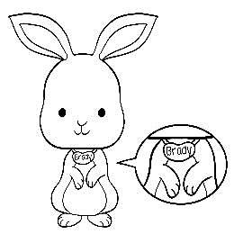 (B)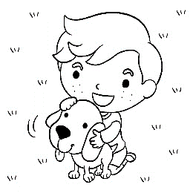 (C)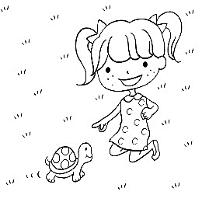
- (A)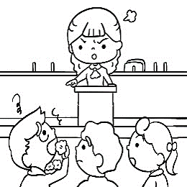 (B)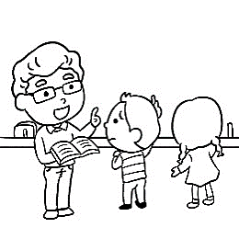 (C)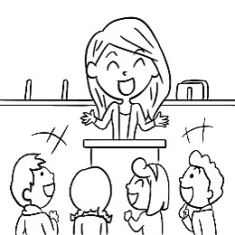
- (A)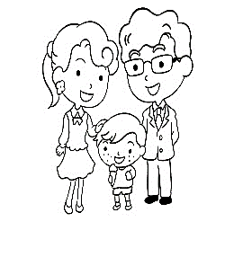 (B)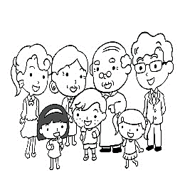 (C)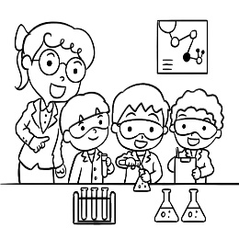
- (A)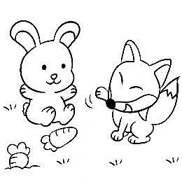 (B) 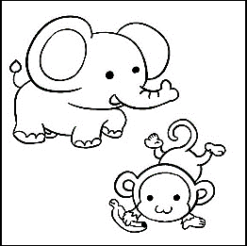 (C)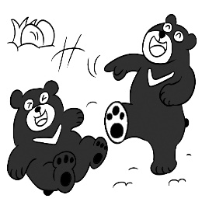
- (A)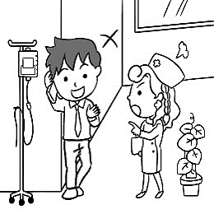 (B)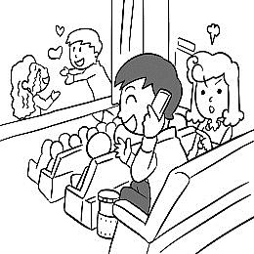 (C)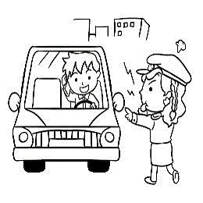
二、基本問答：每題均有三個選項，請依據所聽到的內容，選出一個最適合的回應。10%
- (A) It is a ruler. (B) No, it isn’t. (C) Yes, it’s a ruler.
- (A) No, she’s a nurse. (B) No, she’s my daughter. (C) Yes, she’s a nice nurse.
- (A) Thank you. (B) You’re welcome. (C) I’m fine. Thanks.
- (A) I’m five. (B) I’m good. (C) I’m at home.
- (A) It is 1985. (B) I’m a horse. (C) I’m thirty.

三、言談理解：每題均有三個選項，請依據所聽到的對話與問題，選出一個最適當的答案。10%
- (A) She’s the man’s new doctor. (B) She’s the doctor’s daughter. (C) She’s Bruce’s new doctor.
- (A) No, it’s for the man. (B) No, it’s for the woman’s father. (C) Yes, it’s for the woman.
- (A) Tony and Enid. (B) Tony. (C) Enid.
- (A) In a zoo. (B) At a school. (C) In a movie theater.
- (A) No, it’s cute. (B) No, it isn’t. (C) Yes, it is.

貳 綜合測驗 38%

16. A: Is his name Rick? B: Yes, Rick. (Ａ) I’m (Ｂ) you’re (Ｃ) he’s (Ｄ) she’s
17. Mrs. Wang’s daughter, Elsa, a singer. (Ａ) is (Ｂ) am (Ｃ) are (Ｄ) be
- 選出正確的句子。 (Ａ) Is that black old bear good? (Ｂ) These are white mice. (Ｃ) Are those rhinoes?
(D) Is this small monkey?
- Your family big, and your family really nice. (Ａ) is ; are (Ｂ) is ; is (Ｃ) are ; is (Ｄ) are ; are
- ＿＿＿ are good students. We all（全部）have good teachers.
(Ａ) He, I and you (Ｂ) I, you and he (Ｃ) She, you and I (Ｄ) You, he and I
- This is my pig. name is Rocky. a good name.
(Ａ) Your ; You’re (Ｂ) My ; I’m (Ｃ) His ; It’s (Ｄ) It’s ; He’s
- Their dad a firefighter, and our dad , too. (Ａ) is ; is (Ｂ) are ; are (Ｃ) isn’t ; isn’t (Ｄ) aren’t ; aren’t
- A: Isn’t Mr. Lin a farmer? B: He is a writer.
(Ａ) Yes, he is. (Ｂ) No, he isn’t. (Ｃ) Yes, he is Mr. Lin. (Ｄ) No, he is not a nurse.
- A: What is this? B: That’s . (Ａ) pencils (Ｂ) not a ruler (Ｃ) your picture books (Ｄ) a brush
- A: your phone number? B: 2686-9727.
(Ａ) Is ; It’s (Ｂ) Is ; My phone number is (Ｃ) What’s ; x (Ｄ) What is ; It
- That’s new desk, not old chair. (Ａ) an ; a (Ｂ) a ; an (Ｃ) a ; a (Ｄ) an ; an
- A: ____ is this shirt? B: It’s OK, the color isn’t good.(Ａ) How ; but (Ｂ) What ; and (Ｃ) Who ; but (Ｄ) How ; and
28. A：What are these? B：＿＿＿ are cute _____.
(A) You ; dragons (B) They ; foxes (C) It ; bus (D) Those ; sheeps
29. A：Those red apples on the table ＿＿＿ you. B：Thank you. I like apples.
(A) is to (B) are from (C) isn’t for (D) are for
30. A：The women ＿＿＿ beautiful. ＿＿＿ hair is long. Who are they? B：That is Candy, and that is Rita. They’re sisters.
(A) is; Their (B) are; Their (C) is; Her (D) are; Her
31. A：Who are ＿＿＿ ＿＿＿? B：They’re the boys’ fathers.
(A) this; men (B) these; men (C) this; man (D) these; man
32. Leo and Tom are brothers. _____ are Mr. and Mrs. Lin’s _____.
(A) These ; sons (B) Those ; child (C) They ; children (D) They ; daughters
33. A：Mr. Fisher and Mr. Smith _____ tall and handsome. Their ＿＿ are pretty.
(A) is ; cousin (B) isn’t ; uncle (C) are ; wives (D) aren’t ; wife
34. My grandparents are 70 years old, but they are still（仍然）_____.
(A) dead (B) energetic (C) long (D) sorry

參 克漏字選擇 6%

A: Nice to see you, Jay. How are you?
B: Not bad. 35 you?
A: Fine, thanks. 36 that beautiful girl next to you? Is she your girlfriend?
B: No, she is my mother. She’s 40 37.
A: Wow! She looks young.
next to 在……旁邊

35. (A) How (B) What about (C) Who (D) How old
36. (Ａ) Who’s (Ｂ) What’s (Ｃ) How’s (Ｄ) Who are
37. (A) year old (B) years old (C) year-old (D) years-old

肆 閱讀測驗 8%

Guess what we are. We are tall, but we are not giraffes. We are strong, but we are not lions. Our feet are big and we have big ears and long noses. What are we?
giraffe 長頸鹿 strong強壯的 feet 腳

38. What are we? (A) We are tigers. (B) We are elephants. (C) We are lions. (D) We are rabbits.
39. Which(哪一個) is true?
(A) Our ears are long. (B) Our feet are small. (C) We are tall animals. (D) Our noses are short.

Hi, everyone. My name is Ted, a thirteen-year-old student. Leo is my father. Do you know him? He's a baseball player. In my eyes, Dad plays better than any other baseball player. My mom is Angel. She is a dancer. She's nice and kind to her friends. I have two sisters. They are Tracy and Karen. Tracy is fourteen and Karen is fifteen. They look like each other. My grandpa is Paul. He is a farmer. My grandma is Lily. She is a cook. They are nice to us. Abby is our pet dog. She’s cute. They are my family, and I love them very much.
any other任何其他 look like 看起來像

40. Which is true? (A) Karen is 14. (B) Lily is a cooker. (C) Abby is Ted’s sister. (D) Angel’s husband is a baseball player.
41. Who is Paul? (A) He’s Ted’s father. (B) He’s Karen’s brother. (C) He’s Leo’s grandson. (D) He’s Tracy’s grandfather.

伍 將大、小寫字母互換3% (每題1分)
42. news 43. daughter 44. QUICKLY

陸. 翻譯 15% (每題3分)
45.這年輕的男人是誰啊？
46.您是一位國中生嗎？
47.它們不是中國的十二生肖嗎？(…zodiac…)
48.難怪你人緣好。
49.大象 Bubbles 和小狗 Bella 的尺寸不一樣，但牠們都是很棒的游泳者。

試題結束

新北市立溪崑國民中學112學年度第一學期第一次定期評量 英語科 答案卷
七年級 班 座號 姓名
五 將大、小寫字母互換3% (每題1分)
42. | 43. | 44.

六. 翻譯 15% (每題3分)
45.
46.
47.
48.
49.

112-1-1 七年級 英語科－解答
1-5 B C B C B 6-10 A C A B A 11-15 B A C A C 16-20 C A B A D 21-25 C A B D C
26-30 B A B D B 31-35 B C C B B 36-40 A B B C D 41.D
五 將大、小寫字母互換3% (每題1分)
42. NEWS 43. DAUGHTER 44. quickly

六. 翻譯 15% (每題3分)
45. Who’s this young man?
46. Are you a junior high school student?
47. Aren’t they the Chinese zodiac animal signs?
48. No wonder you are a people person.
49. Bubbles the elephant and Bella the dog are not the same size, but they are great swimmers.

新北市立溪崑國民中學112學年度第一學期第一次定期評量
七年級 英語科 聽力測驗稿
- 辨識句意：每題均有三張圖片，請依據所聽到的句子，選出符合描述的圖片。10%
  - This is our pet, Brady. It’s a good dog.
  - Mrs. Lin is Bill’s aunt, and she is our teacher. She’s nice to us.
  - Frank is a father of three children. They are a happy family.
  - The animals in the picture are the same.
  - Those people are in a movie theater, and the woman is not happy with the man.
- 基本問答：每題均有三個選項，請依據所聽到的內容，選出一個最適合的回應。10%
6. What is it?
7. Isn’t Nina a nurse?
8. You’re a nice and beautiful woman.
9. Hi, Irene, how are you today?
10. What’s your birth year?
三、言談理解：每題均有三個選項，請依據所聽到的對話與問題，選出一個最適當的答案。10%
11. M: Vicky, who is this Bruce Wang?
W: He’s your new doctor, and he’s my father, too.
M: Cool!
Q: Who is Vicky?

12. M: What is in the box?
W: It’s a tea cup.
M: Is it for your father?
W: No, honey, it’s for you.
Q: Is the tea cup for the woman?

13. M: Who are those people?
W: They are Tony and Enid. They are our new teachers.
M: Are they Chinese teachers?
W: No. Tony is a PE teacher, and Enid is an English teacher.
Q: Who is the new English teacher?
14. G: I like these white rabbits. They’re cute. What about you?
B: I like these rhinos. Look! They’re eating grass.
Q: Where are the boy and the girl?

15. G: What’s that under the bed?
B: It’s my pet mouse.
G: A mouse! That’s scary!
B: No, it’s cute. It’s smart, too.
Q: Is the boy’s mouse under the bed?

