新北市立溪崑國民中學112學年度第一學期第三次定期評量 英語科 試題卷
八年級 班 座號 姓名
- 聽力測驗: 30% 每題2分
- 辨識句意: 根據聽到的內容，選出符合描述的圖片。
- (A) 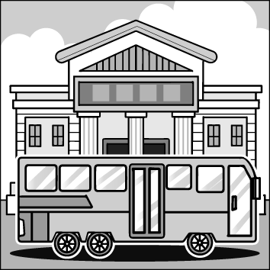 (B) 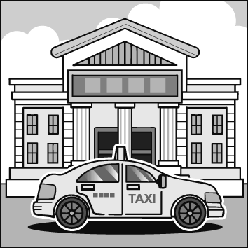 (C) 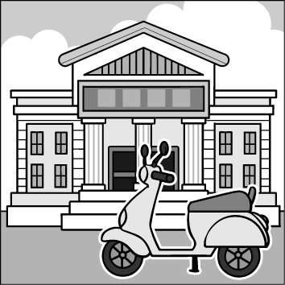

- (A) 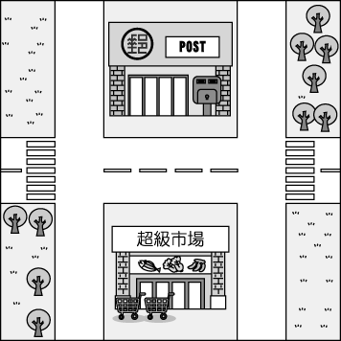 (B) 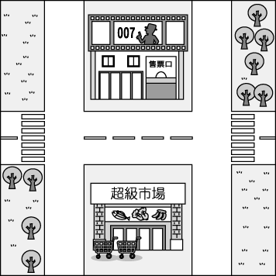 (C) 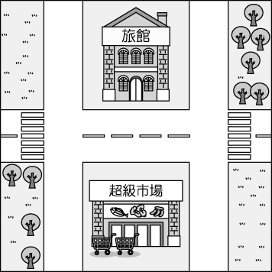
- (A) 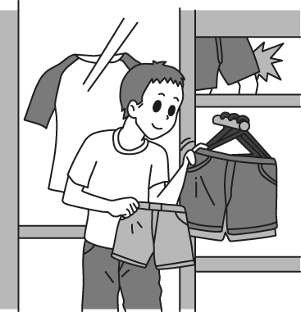 (B) 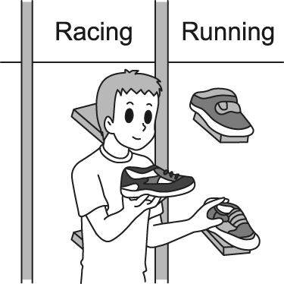 (C) 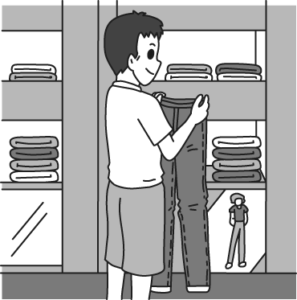
- (A) 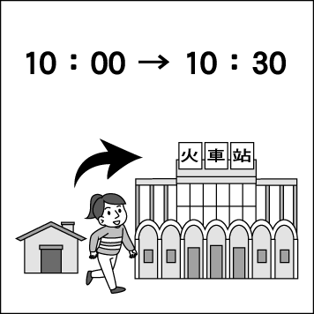 (B) 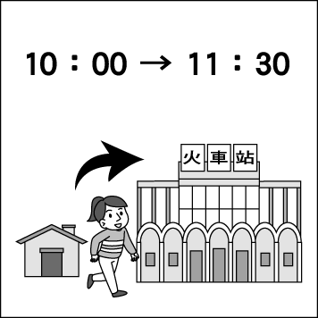 (C) 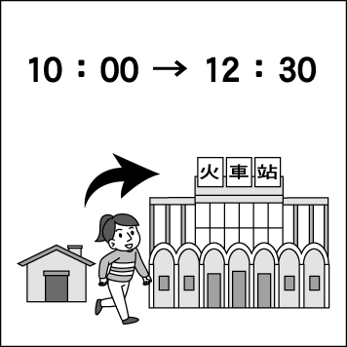
- (A) 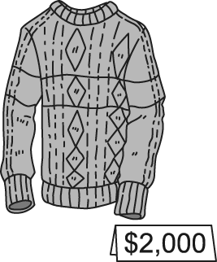 (B) 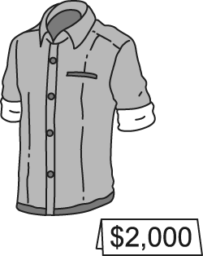 (C) 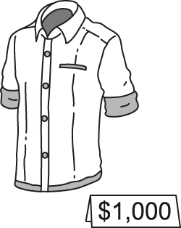
- 基本問答: 根據聽到的內容，選出一個最合適的回應句。
- (A) I am sorry. I am lost. (B) Do you see the fire station? The school is on the left. (C) It is not very far from here.
- (A) They went there by taxi. (B) They liked the museum very much. (C) They visited there many times.
- (A) Well, he has much time. (B) He went jogging last night. (C) He likes to go swimming a lot.
- (A) Around 10 minutes on foot. (B) It is so wonderful. (C) You can take the MRT there.
- (A) I am going to Tokyo. (B) I was in Japan last week, too. (C) In two days.
- 言談理解: 根據聽到的內容，選出一個最合適的答案。
- (A) On the bus. (B) In the school. (C) In the hospital.
- (A) She has to help her mom at home. (B) She is going sailing with her friends. (C) She is going shopping with her mom.
- (A) He wants to find a new shirt for his dad. (B) The department store will have a sale. (C) He needs a new pair of shoes.
- (A) 10 minutes. (B) One hour. (C) 30 minutes.
- (A) NT 1,000. (B) NT 590. (C) NT 410.
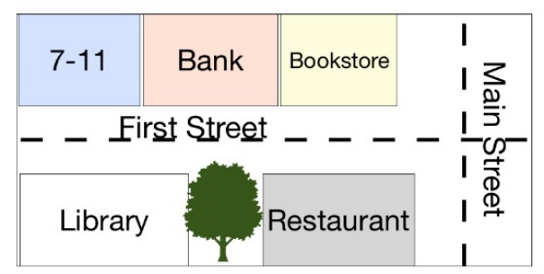
- 單題: 選擇正確或最佳的答案 36% 每題2分
- Look at the map! Where is the bank?
- It is next to a library.
- It’s on Main Street.
- It’s between a convenience store and a bookstore.
- It’s behind a restaurant.
- The man was using his phone when his car ____ the tree.
(A) flew (B) hit (C) rang (D) fed
- Let’s not walk there. We can _____ time by taking the bus.
(A) save (B) order (C) wear (D) build
- Betty: Hey, listen! What’s that strange _____?
Ben: Maybe there’s something wrong with your car. Let me check.
(A) lesson (B) picnic (C) truth (D) sound
- I care about my hands, so I usually put on rubber _____ when I wash dishes.
(A) socks (B) belts (C) earrings (D) gloves
- The sweater is too _____. I don’t have that much money.
(A) terrible (B) expensive (C) impossible (D) lovely
- My father is in the _____ because he hurt his leg, but luckily, he can go back home next week.
(A) museum (B) library (C) hospital (D) factory
- ______ right at the police station, go past a park and you’ll see it next to a school.
(A) Pull (B) Turn (C) Join (D) Hold
- Please _____ your shoes before you go into the house.
(A) take off (B) get on (C) leave for (D) set up
- Kyle enjoys ______ in his free time. He thinks that it doesn’t cost much money, just a good pair of sneakers.
(A) going shopping (B) going fishing (C) going jogging (D) going swimming
- Eric: How long does it _____ to drive to your grandpa’s farm?
Alex: About three hours.
(A) cost (B) wear (C) stay (D) take
- My sister is coming to my home today. She _____ with me for a week.
(A) stayed (B) will stay (C) was staying (D) staying
- These poor workers in this company work for long hours for very low _____.
(A) pay (B) truth (C) cash (D) ride
- Hurry up! We have to run. The train ____ in five minutes.
(A) left (B) was leaving (C) is leaving (D) leave
- Yuki: ______ do we get to our hotel, Dad?
Dad: Let’s go by taxi.
(A) What (B) How (C) Why (D) When
- It _____ Dave a lot of money to study in London. That’s why he sold his house.
(A) took (B) spent (C) made (D) cost
- My parents will take a trip to Japan. I ______ go with them because I need to practice the piano for the concert.
(A) am not (B) didn’t (C) won’t (D) aren’t
- Visitors pay NT$150 for the One-Day Pass card. With the card, visitors can ______ to any station in Taipei.
(A) on foot (B) ride a bike (C) drive (D) take the metro
- 閱讀題組測驗: 34% 每題2分
  - Jamie: Kim needs a sweater because 34 an ugly Christmas sweater party next weekend. 35 ?
Cody: What a funny sweater! She’ll be like a walking Christmas tree. 36 ?
Jamie: It is one thousand NT dollars. Hmm, that’s a little expensive.
Cody: Don’t 37 that much money on this sweater. I have one at home. You can save some money.
Jamie: How nice of you. Thanks.
34. (A) there was (B) there are (C) there will be (D) there will have
35. (A) Do you have one? (B) What do you think of this one? (C) How was the party? (D) Are you going with me?
36. (A) How much do you like it? (B) How often do you wear a sweater?
(C) How would you like to pay? (D) How much does it cost?
37. (A) cost (B) spend (C) pay (D) take
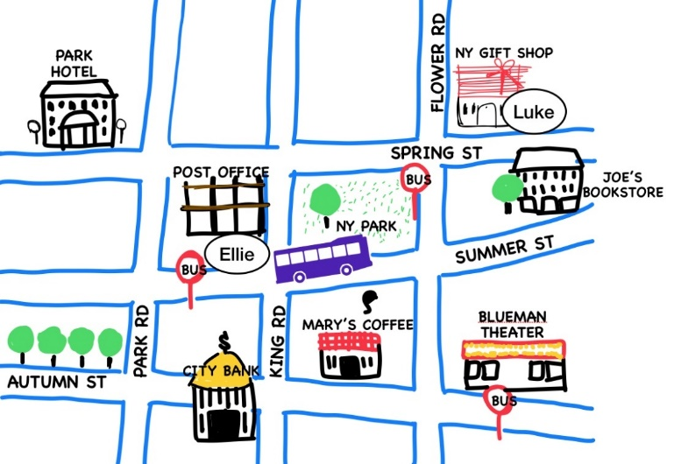
(B) Two people asked Alex for directions.
Ellie: Excuse me. How do I get to City Bank?
Alex: Just 38 King Road for one 39 .
It’s 40 King Road and Autumn Street.

Luke: Excuse me. Is there a 41 around here?
Alex: Go along Flower Road and turn right on Autmn Street.
You can see it on the right.

38. (A) Turn left (B) Look around (C) Go through (D) Walk down
39. (A) stair (B) ground (C) block (D) office
40. (A) across from (B) on the corner of (C) between (D) in front of
41. (A) coffee shop (B) post office (C) movie theater (D) bus station

(C)

deck=floor passenger 乘客 crew member全體船員 book 預定

- Who might book the trip?
(A) Jack likes to go mountain climbing. (B) Jamie and Cody plan to go camping by the sea.
(C) Becky always feels sick when taking a boat. (D) Shirley would like to travel by ship.
- Which is true about the ad?
(A) The ship can carry 7,960 people. (B) It costs $1,790 to book the trip on Dec. 10.
(C) KingTrip doesn’t have a website. (D) The tour starts on January 1, 2024.

(D) Online Shopping
My name is Sara, and I love shopping online. I like using mobile phone apps, but sometimes I use my computer. I almost buy everything online, like food, electronics, books, and accessories. I even bought my sofa and my bed online. But I learned a lesson that it’s better to get clothes from a store because I can try them on to be sure they fit me fine. Yesterday I bought a birthday present for my mother, and it arrived today. That saved me a lot of time. I am busy so I think it’s wonderful to buy something when I think of it.
Some of my friends don’t like shopping online because they think it can be dangerous. Of course, bad things sometimes happen, but I am very careful with my personal information. I think most people fear that someone will copy their credit card number. We need to be careful when using credit cards. It’s important to be sure that the web page is safe.
electronics 電子產品 accessory 飾品配件
- Wat is “it” in line 4?
(A) Shopping online. (B) Her mother’s birthday. (C) A present. (D) A credit card.
- According to the reading, which of the following is true?
(A) Sara buys everything online, like books, sofas, shoes, and dresses.
(B) Shopping online is safe and cheap.
(C) Sara loves shopping online because of low price.
(D) Not all of Sara’s friends like shopping online.

(E) The London Eye - A Giant Wheel in the Sky!

The London Eye is not a real eye, but it's something super cool in the sky in London. The London Eye is a 135-meter-high giant wheel that goes really high up in the air. Passengers sit or stand in a big, round capsule, and slowly go up and up. Each of the 32 capsules can hold up to 25 people. From the top of the London Eye, you can see the whole city of London. The buildings look like tiny toys, and the River Thames looks like a wiggly snake. The London Eye is so big that it takes about 30 minutes to go all the way around. That's enough time to spot lots of interesting things and even take some pictures! People from all over the world come to London to ride the London Eye and see the city from the sky. Enjoy the 360∘view when it goes up and up! wheel 輪子 capsule 膠囊座艙 wiggly 彎曲的
Ticket Type | Price

Standard
Child (3-15years) | ￡22.5
Adult (16+) | ￡25.5

Fast Track (No Waiting)
Child (3-15 years) | ￡44
Adult (16+) | ￡48

- How long does it take to go all the way around the London Eye?

(A) Half an hour. (B) 15 minutes. (C) ￡25.5 (D) ￡48
- What can we learn from the reading?

(A) People can see the whole world from the top of the Lonon Eye. (B) People in a hurry can buy fast track tickets.

(C) The London Eye is a big round capsule. (D) Fast track tickets are only for adults.

(F) On Vacation
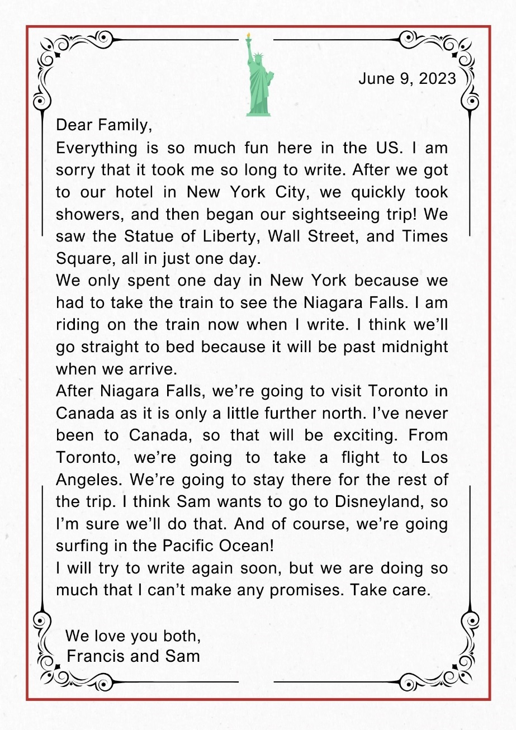
- What famous landmarks did Francis and Sam visit in New
York?
(A) The Niagara Falls. (B) Museum of Modern Art.
(C) The CN Tower. (D) The Statue of Liberty.
- Which is true about the reading?
(A) Francis and Sam only stayed one day in New York.
(B) Francis will stay in Toronto till the last day of the trip.
(C) They will get off the train early and look around.
(D) Francis and Sam are going to visit only one country.
- What activity does Francis plan to do in Los Angles?
(A) Surf the Net every day. (B) Take a train ride.
(C) Go to Disneyland. (D) Play games on the beach.

falls 瀑布 further 較遠的 rest剩餘的 promise 承諾

112-1-3 八年級 英語科－解答
1. B B C A A B A C A C
11. A B B C C
16. C B A D D B C B A C
26. D B A C B D C D
34. C B D B D C B A
42. D A C D A B D A C

新北市立溪崑國民中學112學年度第一學期第三次定期評量
八年級 英語科 聽力測驗稿
- 辨識句意: 根據聽到的內容，選出符合描述的圖片。
- They went to the restaurant by taxi.
- The movie theater is across from the supermarket.
- Kevin will buy a new pair of jeans. He won’t buy shorts.
- It takes Teresa 30 minutes to get to the train station.
- It cost William 2,000 dollars to buy the sweater last month.
- 基本問答: 根據聽到的內容，選出一個最合適的回應句。
- Excuse me. How can I get to Xin Yi Elementary School?
- How did they go to the museum this morning?
- What does William like to do in his free time?
- How long does it take to get to the hospital?
- When will you be back from Japan, Robert?
- 言談理解: 根據聽到的內容，選出一個最合適的答案。
- W: Excuse me. I want to go to National Taiwan University Hospital. Where should I get off?
M: You should get off at the next stop. And you just walk straight for about 3 minutes. There are some tall buildings, and you can see it on the left.
W: Thank you for your help.
Q: Where is the woman?
- W: Do you have any plans for the next holiday?
M: Not yet. Any ideas?
W: My friends and I are going sailing in Kenting. Would you like to join us?
M: Sounds great. But I have to ask my mom first.
Q: What is the woman going to do for the next holiday?
- M: When will the department store have a big sale? I want to buy Dad a tie as his birthday gift.
W: It will have a sale next week because Father’s Day is coming.
M: That’s great. Let’s go shopping and find a nice tie for him.
W: That’s a good idea.
Q: Why will the man go shopping next week?
- M: How do you usually go to school?
W: I usually go to school by motorcycle.
M: How long does it usually take?
W: My house is close to school. It usually takes about half an hour.
Q: How long does it take the woman to get to school?
- W: Hello, sir. The total is NT 590. How would you like to pay, in cash or by credit card?
M: In cash, please. Here is one thousand dollars.
W: Okay. Here is your change. Have a good day.
M: You too.
Q: How much money will the man get back?

