新北市立溪崑國民中學112學年度第一學期第三次定期評量 英語科 試題卷
七年級 班 座號 姓名
- 聽力測驗30%

(一)辨識句意:每題均有三張圖片，請依據所聽到的句子，選出符合描述的圖片
1.
(A) 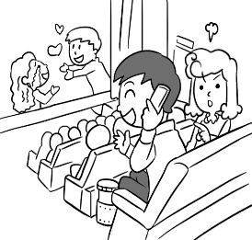 (B) 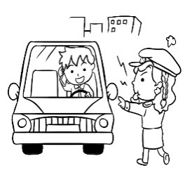 (C) 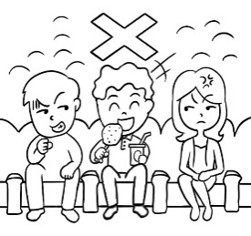
2.
(A) 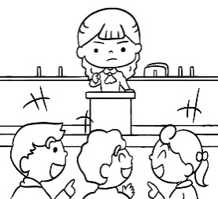 (B) 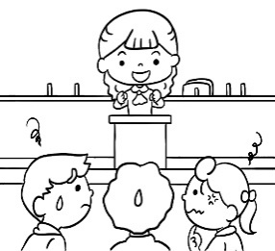 (C) 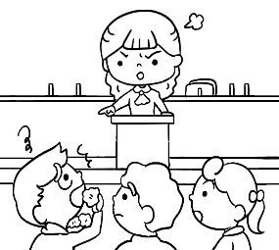

3. (A) 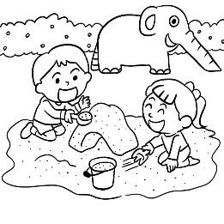 (B)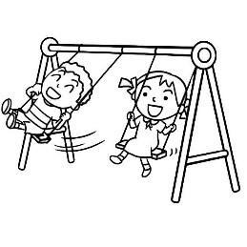 (C) 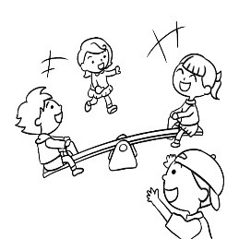

4. (A) 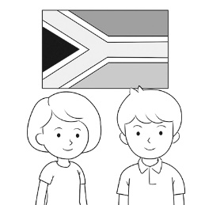 (B) 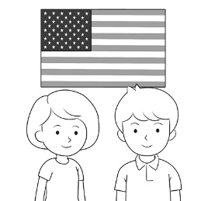 (C) 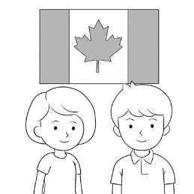

5. (A) 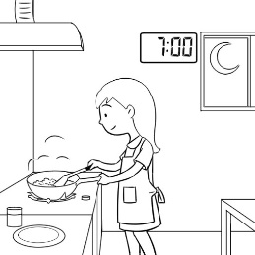 (B) 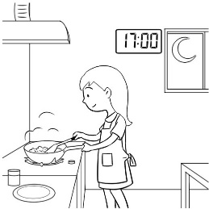 (C) 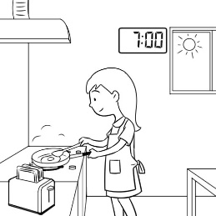

(二)基本問答: 每題均有三個選項，請依據所聽到的內容，選出一個最適合的回應
6. (A) Thank you. (B) Don’t wait in line. (C) Let’s follow the rules.
7. (A) It’s time for bed. (B) Today is not Sunday. (C) OK, Mom.
8. (A) I’m watching TV. (B) I’m looking for my watch. (C) I’m preparing lunch for my son.
9. (A) Let’s sit down. (B) Let’s wait in line. (C) Let’s give our seats to them.
10. (A) Yes, let’s hurry up! (B) Yes, the movie is on. (C) Yes, there’s a group chat today.
(三)言談理解：每題均有三個選項，請依據所聽到的對話與問題，選出一個最適當的答案
11. (A) In a zoo. (B) In a museum. (C) In a playground.
12. (A) Yes, he is. (B) No, he isn’t. (C) No, he’s in his room.
13. (A) It is a smart cat. (B) It is the boy’s toy. (C) It is from Australia.
14. (A) He’s preparing dinner. (B) He’s playing with a toy. (C) He’s chatting with Jenny.
15. (A) They are at the same school. (B) They are in the same class. (C) They are in different cities.

- 綜合測驗42%
16. This is Judy, and I am cousin. (Ａ)she (Ｂ)her (Ｃ)his (Ｄ)my
17. David: Are these dolls, girls? Kelly: No, aren’t.
(Ａ) her; she (Ｂ) their; they (Ｃ) his; he (Ｄ) your; they
18. A: Grandpa is sleeping. Let’s make any noise. B: OK.
(A) isn’t (B) don’t (C) not (D) aren’t
19. George and Mary are busy（忙碌的）this . They have a lot of homework to do.
(A) week (B) chat (C) life (D) city
20. Kevin and Peter ＿＿＿ playing baseball now. Let’s join（加入）＿＿＿.
(A) is; him (B) are; them (C) is; them (D) are; him
21. A：I’m hungry. B：Me too. It’s time ＿＿＿ lunch.
A：Great. Let’s eat some hamburgers.
(A) for (B) to (C) on (D) at
22. A: The math class is at 10 o’clock. B: Oh, no. It’s 9:45 now.
(A) Let’s wait in line. (B) Be quiet. (C) Hurry up. (D) Let’s not run.
23. A: What are you doing? B:
(A)We are doing a report. (B) We are fine. (C) We are students. (D) We are in the bedroom.
24. A: Is Jenny ? B: No, she’s drawing.
(A) doing (B) drawing (C) sleep (D) reading
25. Sherry and Kenny are Christians（基督徒）. They go to church（做禮拜）on ______.
(A) noons (B) days (C) Sundays (D) weeks
26. A: ________ B: It’s on Sunday.
(A) Is it on Sunday? (B) What day is today? (C) Is today Monday? (D) What day is Dad’s birthday?
27. Dan: Where is John? Jill: In the kitchen. He ________ dinner. We’re going to have noodles tonight.
(A) cook (B) cooking (C) is cooking (D) was cooking
28. Everyone ________ happy in the zoo. (A) is (B) am (C) are (D) be
29. Listen! Mom ________ in the bathroom.
(A) sing (B) sings (C) singing (D) is singing
30. In the museum, be quiet . Please follow the rules here.
(A) or don’t run (B) and don’t run (C) or not run (D) and not run
31. Be . There is a big dog behind you.
(A) noisy (B) careful (C) happy (D) talk
32. Today is Mother’s Day. Let’s thank you to her.
(A) say (B) talk (C) tell (D) speak
33. A：What are your parents doing? B：They’re making dinner for in the kitchen.
(A) us (B) our (C) they (D) we
34. Please don’t eat ＿＿＿ drink on the school bus. That’s the rule.
(A) and (B) for (C) or (D) in
35. A：What time does the sun ______ here? B：At about 5:20 a.m.
(A) early (B) sit (C) rise (D) fun
36. on the bus. It’s dangerous（危險的）.
(A) Please, Jack, not run (B) Jack, please don’t run (C) Please don’t, Jack run (D) Please don’t run, Jack

三、克漏字選擇8%
(In the 37 )
Good morning, students. In today’s class, let’s make a “Thank-You Card” for your parents or friends. 38 There is an example—the card for my mother. Now, please come to the front and take a card. Write your 39 and your words of thankfulness on the card. Next, decorate the card with pictures and stickers. 40
 example 範例 words of thankfulness 感謝語 decorate... with 用……裝飾 sticker 貼紙
37. (A) station (B) PE class (C) restroom (D) classroom
38. (A) Look here. (B) Be nice to your friends. (C) Please listen to the teacher. (D) Let’s stand up.
39. (A) name (B) rules (C) problems (D) seat number
40. (A) Let’s go to the gym. (B) Let’s do it and have fun. (C) Let’s read the dos and don’ts.
(D) Make the card in the next class.

- 閱讀測驗20%
(一)
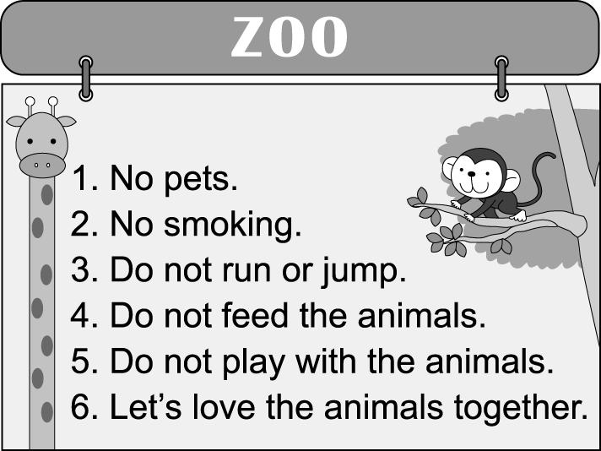
41. What can(可以) you do at the zoo? (Ａ) Play with the animals. (Ｂ) Smoke with the animals. (Ｃ) See the animals.
(Ｄ) Run with the animals.
42. Who is NOT welcome to the zoo? (Ａ) A cat. (Ｂ) A guy. (Ｃ) A boy. (Ｄ) A girl.
43. What can you do to the animals? (Ａ) Be bad. (Ｂ) Be nice. (Ｃ) Be sad. (Ｄ) Be hungry.
(二) Hi, I’m David. I am making tasty cookies in the kitchen. I am mixing the flour, sugar, and chocolate chips. The yummy smell is filling the room. My mom is helping me, and we are having a great time. Right now, the cookies are baking in the oven. I can't wait to taste them when they are ready!
44. What is the main idea of the article "Making Tasty Cookies"?
(A) David is baking in the oven now. (B) David is happy to taste the cookies.
(C) David's mom is helping him make cookies. (D) David is making cookies in the kitchen.
45. What ingredients are used to make the cookies in the article?  ingredients 食材
(A) salt, pepper, butter (B) eggs, milk, vanilla extract (C) flour, sugar, chocolate chips
(D) eggs, sugar, milk
46. What does the word "yummy" mean in the reading?
A. Bitter B. Spicy C. Tasteless D. Delicious
(三)
(Tom and his mom are in London.)
Mom：Tom, what are you doing? Tom：I am calling Dad.
Mom：At this time? Dad is already in bed in Taipei.
Tom：In bed? Look at the clock. It’s only seven o’clock in the evening here.
Mom：But for Dad, it is three o’clock in the morning. Tom：OK, let’s call Cousin Jenny.
Mom：It’s four o’clock in the morning in Tokyo. Call her later.
 London 倫敦 call 打電話 already 已經 Tokyo 東京
47. “At this time” means it’s _______ in Taipei.
(A) 5 p.m. (B) 4 a.m. (C) 3 a.m. (D) 7 p.m.
48. What might Tom’s cousin, Jenny, be doing?  might 可能
(A) 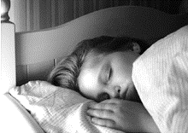 (B)  (C) 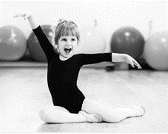 (D) 

(四)
Muslims in PE Class
Mr. Smith is showing this picture to his students.
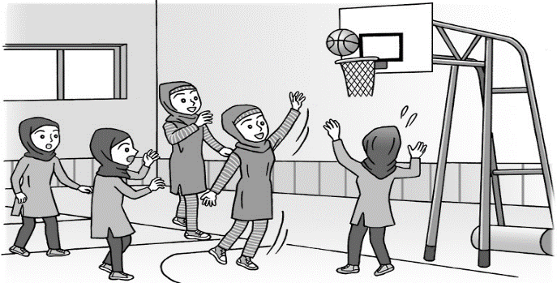
49. Mr. Brown is talking to the students about this picture.
... The girls are Muslims. They are all wearing（穿）hijabs. The hijabs can cover（覆蓋）their heads（頭）, ears, and necks(頸部)
According to（根據）the talk, what are hijabs?
(Ａ) 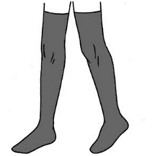 (Ｂ) 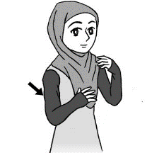 (Ｃ) 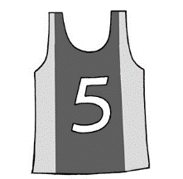 (Ｄ) 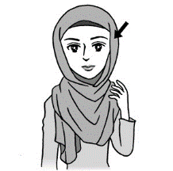
50. Which is NOT true in this picture?
(Ａ) They are in the gym. (Ｂ) They are studying English. (Ｃ) The players are all girls. (Ｄ) They are playing basketball.

May you have a great winter vacation!

112-1-3 七年級 英語科－解答
- 聽力測驗30%
1-15 AACBA ACBCA BBCBC
- 綜合測驗42%
16-36 BDCAB ACADC DCADB BAACCB
- 克漏字選擇8%
37-40 DAAB
- 閱讀測驗20%
41-50 CABDC DCADB

新北市立溪崑國民中學112學年度第一學期第三次定期評量
七年級 英語科 聽力測驗稿

溪崑國民中學112學年度第一學期第三次段考七年級聽力測驗，每題會念兩遍，共三大題，請仔細聽完題目後，細心作答。聽力測驗開始
- 辨識句意:每題均有三張圖片，請依據所聽到的句子，選出符合描述的圖片
1. CD: (W:) Please don’t make any noise in the movie theater.
2. CD: Mrs. Wang is not happy. Her students are not quiet.
3. CD: The boy and the girl are happy in the playground. They are playing on a seesaw.
4. CD: Wendy and Henry are not from South Africa. They’re from the USA.
5. CD: It’s 7 o’clock. The woman is making dinner.
- 基本問答: 每題均有三個選項，請依據所聽到的內容，選出一個最適合的回應
- CD: (W:) Take a seat, please.
7. CD: (W:) The sun is up. Rise and shine.
8. CD: What are you looking for?
9. CD: Look! There are two old ladies.
10. CD: What time is it? Are we late for the group chat?
- 言談理解：每題均有三個選項，請依據所聽到的對話與問題，選出一個最適當的答案
11. CD:
B: There are a lot of beautiful pictures here.
G: Yeah. Look at this picture. It’s my favorite picture.
M: Hey, students. Please be quiet and stand in line.
G: Sorry, Mr. Martin.
Q: Where are the boy and the girl?
12. CD:
W: It’s Sunday evening. Michelle is making dinner in the kitchen. Ted is there, too. He’s
hungry. He’s having some tea eggs.
Q: Is Ted making dinner in the kitchen?
13. CD:
G: This is my robot cat. Its name is Bobo.
B: It’s cool! Where is it from?
G: It’s from my uncle in Australia. Bobo, run! Good. Bobo, stand up! And listen. It
can talk, too.
B: Wow! It’s a smart robot!
G: It is.
Q: What can we say about Bobo?
- CD:
M: Jenny, I’m home. What are you doing?
W: I’m preparing dinner for Ryan. He’s hungry.
M: Okay. Hey, Ryan, don’t put the toy in your mouth.
Q: What is Ryan doing?
15. CD:
(B:) Hi, there. My name is Bill. I’m a junior high school student in Taipei. It’s 7 o’clock, and I’m ready for school. The girl in the photo is my friend, Sophie. She is a junior high school student in Paris. It is 12 a.m. in Paris.
Q: What is right about Sophie and Bill?
聽力測驗結束!

