新北市立溪崑國民中學112學年度第一學期第二次定期評量 英語科 試題卷
八年級 班 座號 姓名
一、聽力測驗: 30% (一題2分)
(一)、辨識句意：根據聽到的內容，選出符合描述的圖片。
- （ ）
(Ａ) 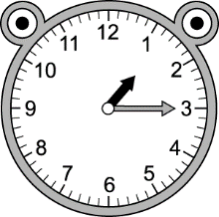 (Ｂ) 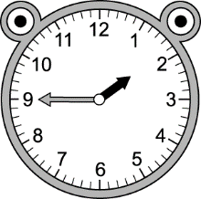 (Ｃ) 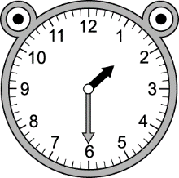
- （ ）
(Ａ) 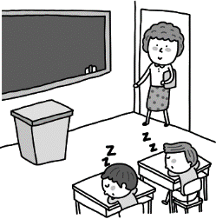 (Ｂ) 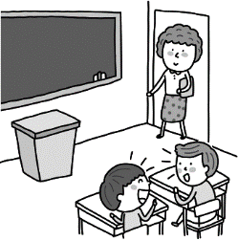 (Ｃ) 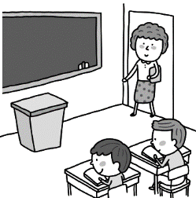
- （ ）
(Ａ) 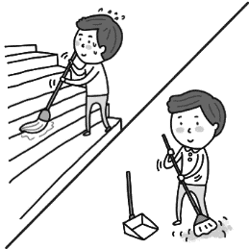 (Ｂ) 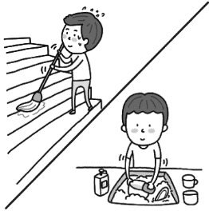 (Ｃ) 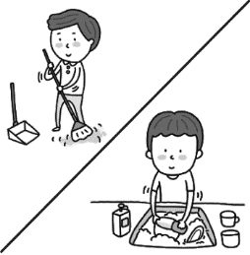
- （ ）
(Ａ) 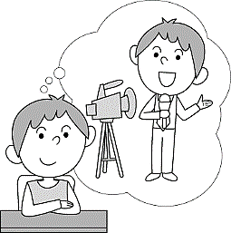 (Ｂ) 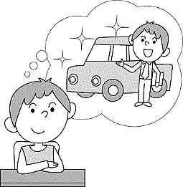 (Ｃ) 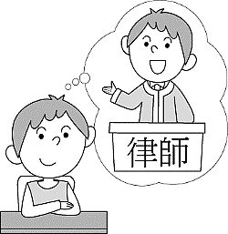
- （ ）
(Ａ) 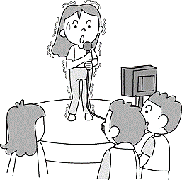 (Ｂ) 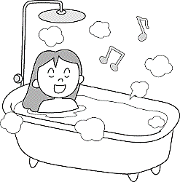 (Ｃ) 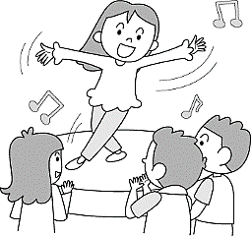
(二)、基本問答：根據聽到的內容，選出一個最適合的回應句。
- （ ）(Ａ) Yes, I am very busy.
(Ｂ) Sorry, I don’t know.
(Ｃ) Yes, I have time, so I can go with you.
- （ ）(Ａ) It was so exciting.
(Ｂ) I was taking a shower in the bathroom.
(Ｃ) I am watching a movie now.
- （ ）(Ａ) I want to go mountain climbing.
(Ｂ) I grow some vegetables on the farm.
(Ｃ) I want to be a lawyer.

(背面尚有試題)
- （ ）(Ａ) I don’t need to drink a lot of water.
(Ｂ) There are some plants over there.
(Ｃ) At a quarter to four, in the afternoon.
- （ ）(Ａ) Yes, I love traveling in the USA.
(Ｂ) Not really. I just practice speaking English for half an hour every day.
(Ｃ) I don’t like to stay at home. I like to go out.
(三)、言談理解：根據聽到的內容，選出一個最適合的答案。
- （ ）(Ａ) A singer. (Ｂ) A soldier. (Ｃ) A doctor.
- （ ）(Ａ) In the school. (Ｂ) In the park. (Ｃ) In the store.
- （ ）(Ａ) In the school. (Ｂ) On the website. (Ｃ) In the clothing store.
- （ ）(Ａ) He had to buy the lunch box. (Ｂ) He had to practice basketball. (Ｃ) He had to catch the bus.
- （ ）(Ａ) The woman saw Ted play the piano last month. (Ｂ) Ted practices the guitar twice a week.
(Ｃ) Ted started to learn the guitar three months ago.
二、綜合測驗: 38% (一題2分)
16.（ ）John moved around in bed and couldn’t find a right to sleep.
(Ａ) clothes (Ｂ) windows (Ｃ) nature calls (Ｄ) position
17.（ ）When you come into the room, please your coat and hat up on the rack(架子) over there.
(Ａ) wipe (Ｂ) feed (Ｃ) sweep (Ｄ) hang
18.（ ）Welcome to my new house. Please sit down and make yourself .
(Ａ) comfortable (Ｂ) popular (Ｃ) strange (Ｄ) close
19.（ ）It is raining cats and dogs outside. your raincoat, and don’t get wet.
(Ａ) Call up (Ｂ) Dream about (Ｃ) Give up (Ｄ) Put on
20.（ ）Mr. Smith had a headache last night, so he couldn’t fall asleep. After he took the medicine, he fell asleep in the end. (Ａ) close (Ｂ) terrible (Ｃ) right (Ｄ) future
21.（ ）Leo sat at the desk from 7:00 a.m. to 7:00 p.m. He tried to finished his work. , he still couldn’t make it.
(Ａ) Even (Ｂ) However (Ｃ) Finally (Ｄ) And
22.（ ）Somebody was singing in the classroom, and her was so beautiful.
(Ａ) position (Ｂ) tooth (Ｃ) voice (Ｄ) thing
23.（ ）Mark: Do you see my pencil case? I can’t find it! Billy: No, I didn’t. Maybe you it at home.
(Ａ) caught (Ｂ) changed (Ｃ) found (Ｄ) left
24.（ ）Nessy: I when the earthquake started. What about you? Tom: I in the bathroom.
(Ａ) swept the floor; was (Ｂ) sweep the floor; do (Ｃ) were sweeping the floor; did
(Ｄ) was sweeping the floor; was
25.（ ）Playing in the water lots of fun on a hot summer day, and also great to have some ice cream.
(Ａ) is; it’s (Ｂ) are; they’re (Ｃ) has; it does (Ｄ) have; they do
26.（ ）Eating healthy food and exercising more good for your health. (Ａ) is (Ｂ) was (Ｃ) did (Ｄ) are
27.（ ）Jenny was very happy today because her dad her a new MP3 player this morning.
(Ａ) gave (Ｂ) gives (Ｃ) was giving (Ｄ) to give
28.（ ）At this time yesterday evening, her dad the news on TV.
(Ａ) watches (Ｂ) watch (Ｃ) was watching (Ｄ) watched
29.（ ）Most students enjoy to music or video games in their free time.
(Ａ) listening; playing (Ｂ) to listen; play (Ｃ) listens; plays (Ｄ) listened; plays
30.（ ）May: Alex, you look tired. What’s wrong? Alex: I was busy my science report. I have to turn it in next Monday. May: It’s not good for your health. You need more.
(Ａ) doing; to sleep (Ｂ) to do; sleeps (Ｃ) do; sleeping (Ｄ) did; slept
(尚有試題)

31.（ ）A: It is already half one. I am really tired, and I want . Would you please be quiet?
B: Oh, I’m very sorry. (Ａ) of; sleeping (Ｂ) past; to sleep (Ｃ) in; to sleep (Ｄ) before; sleeping
32.（ ）A: I want to be a teacher like my father, but I’m still not good enough.
B: You work very hard. I’m sure you can be good at in the future.
(Ａ) teach (Ｂ) taught (Ｃ) to teach (Ｄ) teaching
33.（ ）Vanessa: remembering new words difficult for you? Alvin: Yes. I always have trouble new words.
(Ａ) Does; to remember (Ｂ) Is; remembering (Ｃ) Are; to remember (Ｄ) Is; remember
34.（ ）Nina: Where were you at 7:00 p.m. yesterday? I rang the doorbell, and you didn’t answer it.
Max: Sorry, I didn’t hear the doorbell rang.
(Ａ) I was making breakfast. (Ｂ) I was playing the violin in my bedroom. (Ｃ) I am walking in the street. (Ｄ) I am working at the desk in the office.
三、克漏字測驗: 4% (一題1分)
Please Help Us
Who was near Nana restaurant at 9 p.m. on August 24? We need your help. Last Sunday after dinner, my wife and I went to Nana's. We were walking out of the restaurant at 35 when a car suddenly 36 my wife. She fell on the street and 37 her body. The driver didn't get out of the car. He didn't even stop 38 her. He just drove away. I didn't get his plate number, so the police couldn't find him. Can someone please help us?
35.（ ）(A) five to ten (B) five to nine (C) half past eight (D) a quarter to nine
36.（ ）(A) hit (B) hitted (C) hits (D) was hitting
37.（ ）(A) can’t move (B) moved (C) didn’t move (D) couldn’t move
38.（ ）(A) look at (B) to look at (C) looking at (D) looked at
四、閱讀測驗: 6% (一題1分)
It is very common for children to be shy in new and different situations. They may feel afraid of doing new things or meeting new people. However, for some children, this fear can be very serious and affects their lives. Doctors called it “social phobia”. This problem can start when children are at the age of around seven. At that time, they may not want to be in social situations where they think other people are watching them.
They are shy when they have conversations with others or speak in front of their classmates. In fact, even thinking about doing these things may make some children feel very scared and nervous. As a result, they will start to avoid these activities. Some children may even end up not wanting to go to school at all.
Luckily, doctors can help children with social phobia get better by working with them to set goals and change both their behaviors and the way they think. Schools can also help students who fear social situations by letting them take breaks or visit a counselor when they feel very uncomfortable. With these supports, they can learn to deal with their fears and begin living better lives.
situation情況 affect 影響 avoid避免goal目標
behavior行為counselor輔導員support支持
39.（ ）Who would most likely have social phobia?
(A) John is afraid of snakes. (B) Ted doesn’t like to do his homework. (C) Emma likes to talk to her teacher.
(D) Anne is nervous when she talks to strangers.
40.（ ）Who can help children with social phobia?
(A) Doctors. (B) Teachers. (C) Counselors. (D) All of the three.
41.（ ）What is “WRONG” about the reading?
(A) Social phobia starts to develop in elementary school students.
(B) Social phobia affects people’s lives.
(C) Children with social phobia may even end up not wanting to go to school at all.
(D) Children with social phobia can never learn to deal with their fears and live better lives.

(背面尚有試題)
A Day at the Science Museum
Last Saturday, Lucy and her friends visited the Science Wonders Museum for an exciting day of learning. The museum was full of amazing things that made science fun and interesting.
Their first stop was the Space Adventure Zone, where they looked at models of planets and learned about the galaxies. Lucy's favorite part was the interactive rocket simulator that let them experience what it feels like to be an astronaut. She imagined herself flying through space and landing on the moon.
Next, they went into the Dinosaur Discovery Hall, where lifelike dinosaur replicas stood tall. Lucy was amazed by the gigantic T-Rex and the speedy Velociraptor. She and her friends even got to touch a real dinosaur bone. It felt like a puzzle waiting to be solved.
In the Ocean Exploration Room, Lucy and her friends saw colorful fish and lifelike sharks. They found the importance of protecting marine life and learned about the wonders under the sea.
As the day ended, Lucy and her friends left the museum with heads full of knowledge and excitement. The Science Wonders Museum turned learning into an adventure, and Lucy couldn't wait to share all the cool things she learned with her family.
model模型interactive rocket simulator互動火箭模擬器astronaut太空人
replicas複製品gigantic巨大的T-Rex暴龍Velociraptor迅猛龍puzzle謎marine海洋
42.（ ）When Lucy touched a real dinosaur bone, she felt it was like a puzzle. What does that really mean?
(A) Dinosaur discovery isn't about puzzles.
(B) Dinosaur hunters solve puzzles for bones.
(C) Dinosaurs are puzzles wanting you to solve.
(D) Bones are easy without puzzles.
43.（ ）Why is it important for kids to learn about ocean animals?
(A) Ocean animals aren't interesting.
(B) The ocean doesn't matter.
(C) Learning is only for scientists.
(D) Understanding helps protect the ocean.
44.（ ）What did Lucy and her friends leave the Science Wonders Museum with?
(A) Lifelike shark replicas.
(B) Empty heads.
(C) Excitement and knowledge.
(D) Real dinosaur bones.
五、翻譯:22%
45.我不記得向你借過任何書。(4分)
46.我喜歡畫畫，並且希望有一天成為一個有名的藝術家。(4分)
47.在我成為一個作家之後，我想為兒童們寫有趣的故事。(5分)
48.一點十五分的時候你在廚房做什麼。(4分)
49.因為Stefani平凡的外表，她要成為一個成功的歌星並不容易。(5分)

(試題結束)

新北市立溪崑國民中學112學年度第一學期第二次定期評量 英語科 答案卷
八年級 班 座號 姓名
五、翻譯: 22%
45.我不記得向你借過任何書。(4分)
46.我喜歡畫畫，並且希望有一天成為一個有名的藝術家。(4分)
47.在我成為一個作家之後，我想為兒童們寫有趣的故事。(5分)
48. 一點十五分的時候你在廚房做什麼。(4分)
49.因為Stefani平凡的外表，她要成為一個成功的歌星並不容易。(5分)

112-1-2 八年級 英語科－解答
一、聽力測驗
1-5 BBCCA 6-10 BBCCB 11-15 CCBCC
二、綜合測驗
16-20 DDADB 21-25 BCDDA 26-30 DACAA 31-34 BDBB
三、克漏字測驗
35-38 BADB
四、閱讀測驗
39-41 DDD 42-44 CDC
五、翻譯
45. I don’t (didn’t) remember borrowing any books from you.
46. I like painting, and I hope to be a famous artist one day.
47. After I become a writer, I want to write interesting stories
for children.
48. What were you doing in the kitchen at a quarter after one?
49. Because of Stefani’s ordinary looks, it is not easy for her
to become a successful singer.

新北市立溪崑國民中學112學年度第一學期第二次定期評量
八年級 英語科 聽力測驗稿
一、辨識句意：根據聽到的內容，選出符合描述的圖片。
1. It’s a quarter to two. We have to hurry up.
2. The students were talking when the teacher came into the classroom.
3. Bob is very busy today. He has to sweep the floor and do the dishes.
4. Jack wants to be a lawyer because he wants to help people in need and fight for their rights.
5. Gina hates singing in front of people because she always gets butterflies in her stomach.

二、基本問答：根據聽到的內容，選出一個最適合的回應句。
6. Helen, I didn’t bring my watch. Do you have the time?
7. Where were you when the earthquake happened last night?
8. What do you want to be when you grow up?
9. What time do you usually walk your dog?
10. Why is your English so good, Yuki? Did you stay in the USA for a long time?

三、言談理解：根據聽到的內容，選出一個最適合的答案。
11. M: It’s good to have a dream. If you have a dream, you will try your best to make your dream come true.
W: So Willy, what is your dream?
M: My dream is to be a doctor because I want to help people in need.
W: Wow... sounds great. I want to be a soldier in the future because of my dad.
Q: What does Willy want to be in the future?
12. M: Where is my cellphone? I can’t find it!
W: Cool down. Where did you go today?
M: I played basketball with my friends at school. And then I went to 7-11 to get some water. I was still holding my cellphone at that time because I used my cellphone to pay.
W: Maybe you left your cellphone there.
M: Oh, I put it on the counter and I left.
Q: Where did the man leave his cellphone?
13. W: I plan to buy a dress for my mom as her birthday gift.
M: Why don’t you buy it from the website?
W: That’s a good idea. Do you have any good websites? Maybe I can try to buy it there.
M: Oh, here you go. My sister just bought some dresses from this website.
Q: Where does the woman decide to buy the dress?
14. W: Tom, I saw you running this morning. What happened?
M: I was trying to catch the school bus then.
W: Did you catch the bus?
M: No, and I even lost my lunch box.
W: Oh no. Today wasn’t your day.
Q: Why was Tom running this morning?
15. W: Ted, I saw you play the guitar in the band last week. You looked so handsome.
M: Thanks.
W: When did you learn the guitar?
M: About three months ago. I just practice playing the guitar every day.
W: Only three months? That’s amazing.
Q: Which is true?

