新北市立溪崑國民中學112學年度第一學期第三次定期評量 英語科 試題卷
九年級 班 座號 姓名
壹、聽力測驗 (26 %)
一、辨識句意：每題均有三張圖片，請依據所聽到的句子，選出符合描述的圖片。
- (A)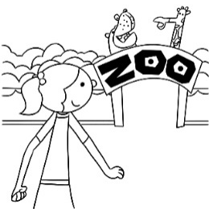 (B)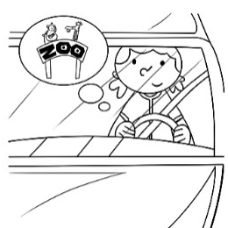 (C)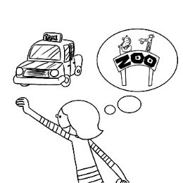
- (A)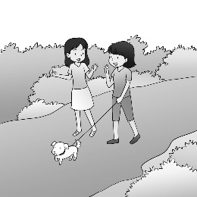 (B)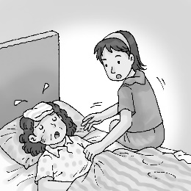 (C)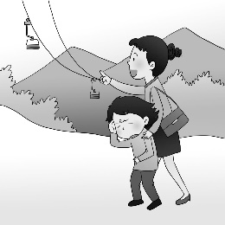
- (A)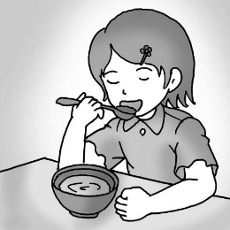 (B)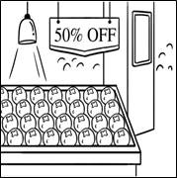 (C)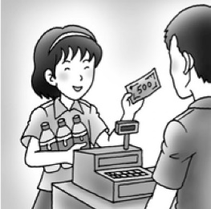
- (A)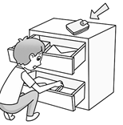 (B)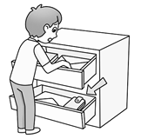 (C)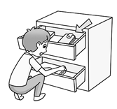
- (A)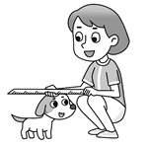 (B)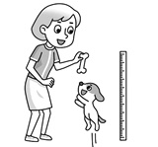 (C)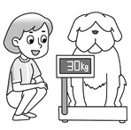
二、基本問答：每題均有三個選項，請依據所聽到的內容，選出一個最適合的回應。
- (A) You’re amazing.
(B) You should go to the dentist.
(C) You have to fulfill the plan.
- (A) The number of pizzas we sold is on the rise.
(B) No, you can’t. They don’t belong to you.
(C) You can have this one. It was made without flour.
- (A) Don’t let your eyes decide what to get. Make sure your money is spent wisely.
(B) Don’t be fooled by the sales promotion. It isn’t as good as it appears to be.
(C) Don’t pull out your wallet. It’s on me.
- (A) You cheated on the English test, didn’t you?
(B) I didn’t, either. The test was so difficult this time.
(C) That’s too bad. I failed the test, too.
- (A) Lucky her. She is a very good shopkeeper.
(B) Poor her. Maybe it’s because she doesn’t own the big company.
(C) Yeah. That’s why she has to give up her plan and find a job first.
三、言談理解：每題均有三個選項，請依據所聽到的對話與問題，選出一個最適當的答案。
11. (A) Because it’s a natural rock with a special shape.
(B) Because the clerk made it and asked her to buy it.
(C) Because it looked like the word "lucky" in Chinese. (請繼續作答)
12. (A) He is cooking in a restaurant.
(B) He is selling fried chicken at a school fair.
(C) He is eating fried chicken in a night market.
13. (A) One hundred fifteen dollars.
(B) One hundred fifty dollars.
(C) One hundred ninety-five dollars.

貳、綜合語法 (28%)
14. Keep away from the benches in the park. The sign says " Wet _____."
(A) Paint (B) Wallets (C) Pears (D) Grams
15. My parents have told me a million times not to waste money. I always spend every cent _____.
(A) secretly (B) successfully (C) surely (D) wisely
16. The party tonight at my grandparents’ house _____ the end of my winter vacation. I am going back home and getting
ready for school tomorrow.
(A) tricks (B) rises (C) packages (D) marks
17. There is some sugar at the _____ of the bowl. You need to stir it before you drink it.
(A) center (B) bottom (C) profit (D) level
18. It _____ that some companies try to cheat their customers. Therefore, those shopkeepers usually make big profits.
(A) wastes (B) fulfills (C) appears (D) fools
19. Basketball is Daniel’s favorite. He wishes he will be about the same _____ as the NBA players.
(A) product (B) sight (C) pound (D) height
20. Grace enjoys listening to her kids sing songs _____ at school.
(A) they learned (B) that has learned (C) they were learned (D) which learned
21. Many people are used to buying notebooks _____ in Taiwan. They are always the best products.
(A) that made (B) which have made (C) that are made (D) which be made
22. Maggie wasn't sure if the young man before her was _____ pulled her out of a car on fire.
(A) the one who (B) the one which (C) the one (D) who
23. These buildings near the department store _____ my boss. He has set up many companies on his own.
(A) belong to (B) that belongs to (C) which is belong to (D) X belongs to
24. The man _____ is a hard-working person and his voice always rises when he talks about his business.
(A) in big eyes (B) who with a cap (C) that is wearing a cap (D) whose long hair
25. Helen likes animals and she keeps many dogs at home. The dog _____ is black and white.
(A) Helen is playing (B) which playing with Helen (C) which with playing is Helen (D) that Helen is playing with
26. A: Look at this sign on the wall. It says if we buy five pieces, we can get one free!
B: _____. It's a great deal!
(A) The boss is fooling you
(B) Let's not pass up this chance
(C) Here's how it works
(D) It’s strange-sounding
27. ______. You can find him on the basketball court every day.
(A) Eric is the boy whose hobby is shopping.
(B) Rick is a person who loves fast fashion a lot.
(C) My classmate Daniel is someone who really loves sports.
(D) Matthew is the only person that doesn’t like sports.

參、克漏字選擇 (22%)
Sometimes when the rain falls hard and fast on you, it might hurt a little. But what happens when it hits a mosquito?
A study 28 when a raindrop falls on a mosquito, it’s like when a bus hits a person. 29 , the little insect is hit
by a raindrop about once every 20 seconds. So why don’t we see many dead mosquitoes after it rains? A mosquito is as
big as a raindrop, but it is much lighter - 0.002 g only. This saves its life in raindrop attacks. Because the mosquito is so
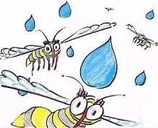
light, when it is hit by a raindrop, it won't experience a force that is strong enough to kill it. The study
also found that when a mosquito is hit by a raindrop, the insect is pushed by the raindrop and falls
together with it. But the mosquito doesn't get wet easily because it 30 with hairs which keep off
water. After dropping about 6 cm, it will roll off the raindrop and fly away. However, this trick isn't
always successful. If the mosquito flies too low when it is hit by the raindrop, it won’t have time to fly
off. Then it will hit the ground and 31 .
raindrop 雨滴mosquito 蚊子force 力量
(請繼續作答)
28. (A) speaks (B) says (C) pastes (D) talks
29. (A) Except (B) Therefore (C) However (D) Besides
30. (A) has covered (B) covers (C) is covered (D) has been covered
31. (A) die (B) dead (C) dying (D) died

Why does a bull run at a man 32 a bright red cape? Does the color make it mad? The reason is not the color. Some studies show that bulls are red-green color-blind. Things that move quickly make bulls scared and angry. Bulls feel that they are in danger, so they attack the moving things. If you wear 33 and just walk very slowly, the bulls won't attack you. Some studies show that cats are also red-green color-blind. However, cats can hunt fast-moving mice at night as easily as in the days. Because cats can see things clearly 34 little light. danger危險 bull 公牛cape 披風
32. (A) has (B) with (C) wears (D) is wearing
33. (A) some thing red (B) something red (C) some red thing (D) red something
34. (A) have (B) with (C) which with (D) that use

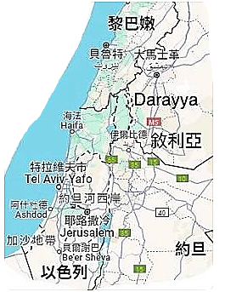
In Darayya, a city in Syria, there’s a library, and it has 15,000 books on almost every subject you can think of. However, it is different from any libraries you know. It is a secret underground library, and only people in Darayya know where it is. Over the years, wars have shaken Darayya badly. Every day, houses are bombed and people are killed. Stores are closed one after another, and so are schools. To help the kids in Darayya 35 their learning, Anas Ahmad, a 19-year-old student, and his friends decided to build a library. They built the library under the ground to keep it safe from bombing. But it is dangerous to collect books for the library. Often, Ahmad and his friends look for books in houses 36 were bombed. They need to be careful because they may be killed in another bombing. You may ask, “In a place like Darayya, would people be interested in books?” “Just like the body needs food, the mind needs books,” says one library user. In the library, people enjoy their time of reading and forget about the terrible world 37 , so their life doesn't seem so hard.
38 reading, they are able to dream of a better life after wars. war 戰爭 bomb轟炸
35. (A) with (B) to (C) for (D) without
36. (A) that (B) X (C) that they (D) whose houses
37. (A) with (B) up (C) about (D) above
38. (A) To (B) If (C) Because (D) Through

肆、閱讀測驗 ( 24% )
Super Bacteria for Methane
Methane is a gas that leads to global warming and climate change when released into the sky. Methane is released during human activities, such as using oil, factories, and farming. It's hard to stop completely.
Scientists have discovered tiny bacteria in nature that could deal with a big problem: greenhouse gases. Certain types of bacteria, known as methanotrophic bacteria, have the unique ability. These bacteria are like nature's superheroes that can eat up methane. Now scientists are teaching them and making them even better. The goal is that these tiny bacteria can help cool the Earth.
Scientists are excited about these tiny helpers and they are working hard to train them further. Maybe one day, they can play a big role in saving the Earth from getting too warm.
bacteria 細菌methane 甲烷release 釋放tiny 微小的completely 完全地 greenhouse gas 溫室氣體 ability 能力goal 目標
39. What is the main idea of the reading?
(A) All the superheroes are real.
(B) The Earth is getting cooler because of methane.
(C) Greenhouse gases make the Earth cool.
(D) Scientists have found special helpers in nature.
40. Where does methane come from?
(A) From the sky.
(B) From the ocean.
(C) From the supermarket.
(D) From factories and farms. (請繼續作答)

TikTok's Shopping Power: Buy or Bye?
TikTok is super popular now. Some people say that the name "TikTok" comes from Minnan language. When you pronounce "TikTok," it sounds similar to play in Minnan language, which means playing, having fun, and games. TikTok, with a vision to "inspire creativity and bring joy." has spread globally like wildfire.
TikTok is also super popular for shopping now! People use hashtags like #cleantok (for cleaning items) and #booktok (for books) to help choose what to buy. TikTok is good for books with #BookTok. This makes people buy more books. TikTok even gives awards for books. People who sell books say #BookTok helps sell a lot, especially books for young people and love stories.
TikTok, Instagram and YouTube, have totally changed our shopping habits. We like to watch interesting videos on TikTok and trust people who create videos too easily. Short videos, around 30 to 60 seconds, have been changing our thoughts on shopping. TikTok's system learns what we like and shows us more. TikTok is good at this.
However, experts say liking TikTok too much might lead to overspending. Experts worry we trust people too much on TikTok. Even if they aren't familiar with us, we feel a strong connection with them. This makes us buy things we may not really need. Therefore, this could result in overspending because it's hard to distinguish between real suggestions and ads.
pronounce發音expert 專家familiar with 熟悉 connection 連結 distinguish 分辨 award 頒獎
41. What is the main idea of the reading?
(A) Studying the differences between TikTok and YouTube.
(B) Explaining the history of TikTok for shopping.
(C) Studying the dangers of overspending on TikTok.
(D) Explaining how people watch videos on TikTok.
42. What role do short videos play in shopping habits on TikTok?
(A) They make viewers want to buy things.
(B) They show things in different languages on the Net.
(C) They are also one of the customers who fall in business tricks.
(D) They help us tell the real world from ads.
43. What could happen if customers trust TikTok too much for shopping ?
(A) They are better at picking what to buy.
(B) They pay less money for buying books.
(C) They spend too much money buying things they don’t really need.
(D) Promotions on TikTok always make larger profits for customers.

Keep Animals Away from The Tracks
Engineers in Japan use a speaker that barks like dogs and snorts like a deer in order to keep animals away from
tracks. People have been troubled by a problem with trains colliding with deer on its tracks. According to a report, there were 613 cases of train delayed for at least 30 minutes because of deer and other wild animals in 2016-2017.
Deer are attracted to tracks because of a need for iron in their diets. They lick the tracks to pick up iron caused by the action of wheels against tracks. This need has led to a battle to keep the deer away from tracks. In the past, flashing red lights and even lion faces have been unsuccessfully used to keep deer off the tracks.
This new device has been invented. These engineers explain that deer have a habit of repeatedly snorting short, sharp sounds to alert other deer when they perceive danger. The barking of dogs, which drives deer to scare. When the deer hear a 3-second-long recording of a deer’s snort and 20 seconds of a barking dog, they scare and flee quickly.

speaker 擴音器snorts鼻息(聲) tracks 軌道 deer 鹿collide 碰撞 attract吸引 iron 鐵質 diet 飲食
alert 警示 perceive察覺

(請繼續作答)
44. Why do deer like train tracks?
(A) They love to sleep near railways at night.
(B) They need iron from train tracks.
(C) They like to shout at the train tracks.
(D) They enjoy watching trains moving.
45. What device has NOT been used to solve the railway problem in Japan?
(A) Flashing lights.
(B) Barking speakers.
(C) Noisy train tracks.
(D) Lion face paintings.
46. What does “flee” mean in the reading?
(A) Run away.
(B) Pass up.
(C) Deal with.
(D) Blow away.

The New Stadium
Taipei Big Egg, located in the heart of Taipei, is a very big sports stadium. Shaped like a giant dome, it had earned the nickname "Big Egg" because of the unique structure. The stadium is not only a popular place for baseball but also hosts concerts, events, and sports competitions.
The World Baseball Championship is an international baseball tournament. This exciting event brings teams from different countries all over the world to join this championship. Players show their skills, teamwork, and sportsmanship as they compete for the honor of being the world's best baseball team.
Taipei Big Egg, also known as Taipei Dome, hosted the World Baseball Championship last year. In 2023, the tournament was held at Taipei Big Egg, making it an extra special and memorable occasion.

stadium 體育場nickname 綽號 championship冠軍 competition 競賽 dome圓屋頂 unique獨特的
tournament 錦標賽 sportsmanship 體育精神
47. What important event did Taipei Big Egg host in 2023?
(A) HBL (High School Basketball League) games.
(B) Yonex Taipei Open 2023.
(C) World Baseball Championship.
(D) NBA (National Basketball Association) games.
48. What is the shape of Taipei Big Egg called?
(A) Giant Tree.
(B) Giant Cake.
(C) Big Dome.
(D) Big Bowl.
49. Which activity will Not be held at Taipei Big Egg?
(A) Baseball Games.
(B) Concerts.
(C) Swimming.
(D) Events .
50. What does “structure” mean in line 2 ?
(A) A building.
(B) A game.
(C) A choice.
(D) A location.

(試題結束)

112-1-3 九年級 英語科－解答
1-5 CBCCC
6-10 BCCBC
11-15 ABBAD
16-20 DBCDA
21-25 CAACD
26-30 BCBDC
31-35 ABBBA
36-40 ADDDD
41-46 CACBC
47-50 ACCCA

新北市立溪崑國民中學112學年度第一學期第三次定期評量
九年級 英語科 聽力測驗稿
一、辨識句意：每題均有三張圖片，請依據所聽到的句子，選出符合描述的圖片。
- 《腳本區》
CD: Vicky is the girl whose car is broken, so she is going to take a taxi to the zoo.
《題目區》
(A)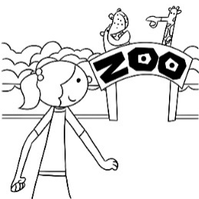 (B)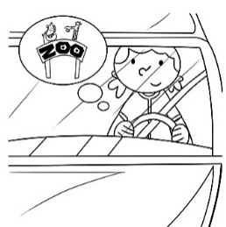 (C)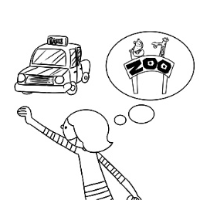
《答案區》
答案：C
題號：A05L6168
- 《腳本區》
CD: Tina is the girl whose mother is lying in bed.
《題目區》
(A)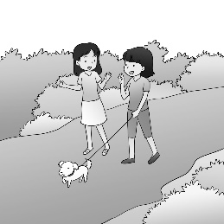 (B)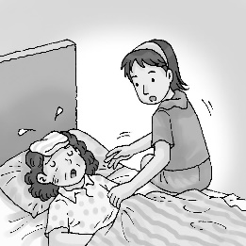 (C)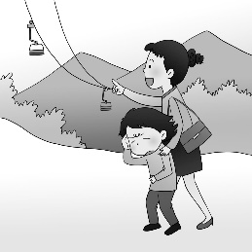
《答案區》
答案：B
題號：A05L6169
- 《腳本區》
CD: Sally doesn’t want to pass up the chance to buy her favorite drink because today she can buy two and get one free.
《題目區》
(A)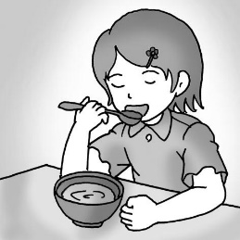 (B) (C)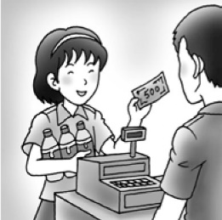
《答案區》
答案：C
題號：A05L6182
- 《腳本區》
CD: The wallet that Ben is looking for is in the top drawer, but he doesn’t notice that.
《題目區》
(A) (B) (C)
《答案區》
答案：C
題號：A05L6211
- 《腳本區》
CD: Helen’s dog grows quickly, so she wants to know how many kilograms it has put on.
《題目區》
(A) (B) (C)
《答案區》
答案：C
題號：A05L6214
二、基本問答：每題均有三個選項，請依據所聽到的內容，選出一個最適合的回應。
- 《腳本區》
CD: There is something wrong with my teeth.
《題目區》
(A) You’re amazing.
(B) You should go to the dentist.
(C) You have to fulfill the plan.
《答案區》
答案：B
題號：A05L5061
- 《腳本區》
CD: I can’t eat these pizzas because I don’t eat flour.
《題目區》
(A) The number of pizzas we sold is on the rise.
(B) No, you can’t. They don’t belong to you.
(C) You can have this one. It was made without flour.
《答案區》
答案：C
題號：A05L5064
- 《腳本區》
CD: How much do I need to pay for the meal?
《題目區》
(A) Don’t let your eyes decide what to get. Make sure your money is spent wisely.
(B) Don’t be fooled by the sales promotion. It isn’t as good as it appears to be.
(C) Don’t pull out your wallet. It’s on me.
《答案區》
答案：C
題號：A05L6077
- 《腳本區》
CD: I didn’t expect that I would pass the science test.
《題目區》
(A) You cheated on the English test, didn’t you?
(B) I didn’t, either. The test was so difficult this time.
(C) That’s too bad. I failed the test, too.
《答案區》
答案：B
題號：A05L6204
- 《腳本區》
CD: Jane can’t raise enough money to start her own business.
《題目區》
(A) Lucky her. She is a very good shopkeeper.
(B) Poor her. Maybe it’s because she doesn’t own the big company.
(C) Yeah. That’s why she has to give up her plan and find a job first.
《答案區》
答案：C
題號：A05L6205
三、言談理解：每題均有三個選項，請依據所聽到的對話與問題，選出一個最適當的答案。
- 《腳本區》
CD: M: Why is there a rock in the center of our living room?
W: I found it in a store that sells interesting rocks.
M: Well, what’s so special about it that you even carried it home?
W: If you look from this side, it looks like a bat which means “lucky” in Chinese. And it is natural, not man-made.
Q: Why did the woman buy the rock?
《題目區》
(A) Because it’s a natural rock with a special shape.
(B) Because the clerk made it and asked her to buy it.
(C) Because it looked like the word “lucky” in Chinese.
《答案區》
答案：A
題號：A05L5097
- 《腳本區》
CD: W: Hello, Frank. Here I am.
B: Hi, Mom. I’m so happy that you’re here.
W: Your class runs a successful business.
B: Yeah. Are you interested in trying our fried chicken? It’s my treat.
W: I’d love to try some, but I want to pay for it.
B: All right. It’s NT$50.
Q: What is the boy doing?
《題目區》
(A) He is cooking in a restaurant.
(B) He is selling fried chicken at a school fair.
(C) He is eating fried chicken in a night market.
《答案區》
答案：B
題號：A05L5102
- 《腳本區》
CD: M: Here is the pumpkin. It’s $80.
W: Thanks. It is bigger than I expected. By the way, how much do the pears cost?
M: $35 a kilogram.
W: I need two kilograms, thanks.
M: No problem.
Q: How much does the woman have to pay for the pumpkin and the pears she needs?
《題目區》
(A) One hundred fifteen dollars.
(B) One hundred fifty dollars.
(C) One hundred ninety-five dollars.
《答案區》
答案：B
題號：A05L6093

