新北市立溪崑國民中學112學年度第二學期第一次定期評量 英語科 試題卷
九年級 班 座號 姓名
第一部分-聽力測驗
一、辨識句意：每題均有三張圖片，請依據所聽到的句子，選出符合描述的圖片。
- (A)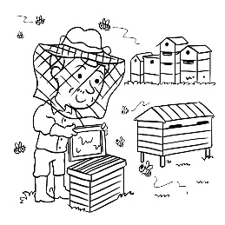 (B)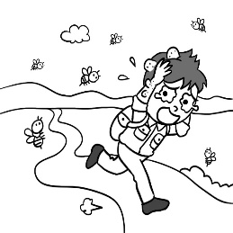 (C)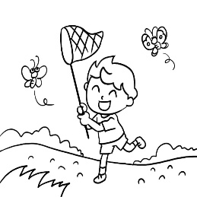
- (A)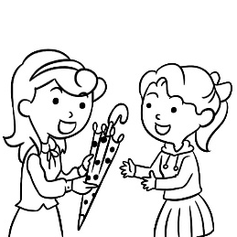 (B)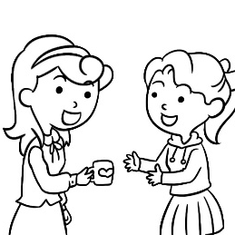 (C)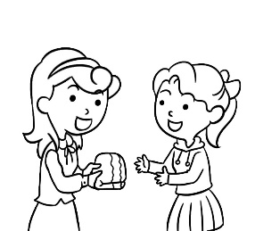
- (A)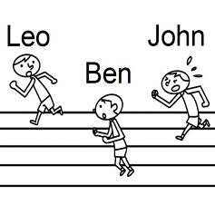 (B)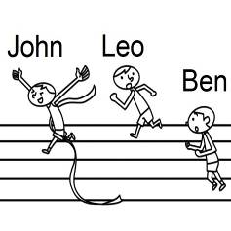 (C)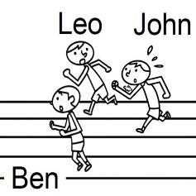
- (A)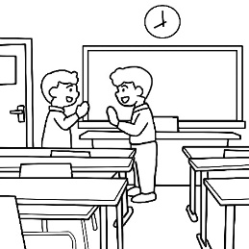 (B)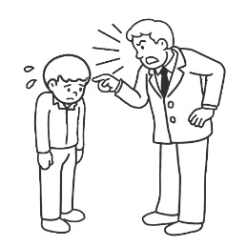 (C)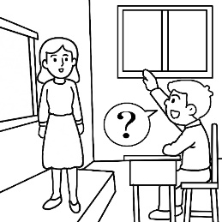
- (A)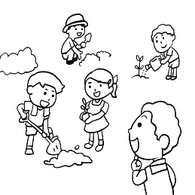 (B)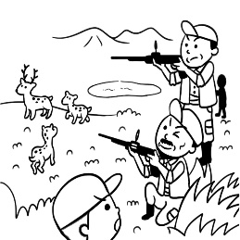 (C)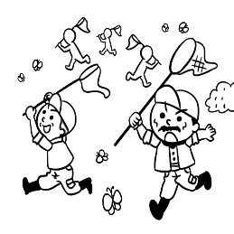
二、基本問答：每題均有三個選項，請依據所聽到的內容，選出一個最適合的回應。
- (A) He is a man with a kind heart. (B) That makes him less popular. (C) Neither does my neighbor, Jerry.
- (A) What’s your humor style? (B) He’s mean to people around him. (C) No wonder everyone enjoys talking to him.
- (A) So do I. (B) Neither do I. (C) I am, too.
- (A) He ran into heavy traffic near the airport.
(B) He is going to visit his relatives there.
(C) It takes fifty minutes to fly to Penghu.
- (A) The last bus is at 10 p.m.
(B) Then how did he get home?
(C) He is always late for work.
三、言談理解：每題均有三個選項，請依據所聽到的對話與問題，選出一個最適當的答案。
- (A) Because the teacher spotted many errors in the boy’s report.
(B) Because the information in the boy’s report wasn’t from a trusted source.
(C) Because the teacher found that the boy copied Ashely’s report.
- (A) The man will see it as soon as he turns right at the corner.
(B) The man will see it as soon as he crosses the bridge.
(C) The man will see it as soon as he walks along the sidewalk.
- (A) She laughed at the man by putting him down.
(B) She spent as little money as possible.
(C) She asked the man to lend her money.
- (A) The woman wants to eat ice cream. So does the man.
(B) Neither the woman nor the man wants to eat ice cream.
(C) The woman wants to eat ice cream, but the man doesn’t.
- (A) They have to get started soon.
(B) They failed to show up at a party.
(C) They need a ball for the birthday boy.
第二部分-綜合測驗
- Jessica dyed(染) her hair purple, so she could easily be ___ among a group of students.
(A)stopped (B)copied (C)trusted (D)spotted
- The beef is ___ meat. It’s actually made from beans, so those who don’t eat meat can have it.
(A)for (B)fake (C)nail (D)towel
- The house was so dirty before we moved in, and it took us a whole week to ___ it up.
(A)roll (B)copy (C)hunt (D)tidy
- The restaurant ___ sign is pink used to be my favorite.
(A)which (B) whose (C)that (D)with
- Tony has to go back home before 10 p.m., and so ___ his brothers.
(A)has (B)have (C)does (D)do
- Did something happen between you and Whitney? You guys used to hang out quite a lot, ___?
(A)didn’t you (B)haven’t you (C)would you (D)were you
- My roommate, Fiona, threw out all the gifts ___ her because she didn’t want to think of the past anymore.
(A)which was given (B)that gave to (C)the man gave (D) who the man gave
- The T-shirt is ___ small for Mike ___ wear. He needs a bigger one.
(A)so; that (B)too; to (C)enough; to (D)very; to
- I’ll join ___ the volleyball club ___ the film club. I haven’t decided which one to join yet.
(A)neither; nor (B)both; and (C)not only; but also (D)either; or
- We planned to study together but ended up ___ the whole afternoon.
(A)to chat (B)chatting (C)chat (D)being chatting
- Eric seldom went to the library when he was a student, and ___ Benson.
(A)so did (B)neither did (C)so was (D)neither didn’t
- The dog I saved the other day ___ a ball happily in our garden right now.
(A)that is playing (B)playing (C)is playing (D)play
- Justin: Haha! Joe’s jokes are all so funny. _____
Mark: you’re right, I love his jokes! He should be a comedian(喜劇演員)
(A)Ok, here it comes. (B)In that case, go ahead!
(C)Are you kidding? (D)He’s killing me!
- While Henry ___ the movie, his son was playing with the robots.
(A)watching (B)watched (C) has watched (D)was watching
- As long as Wilson ___ the report, he will drive us to Tainan.
(A)will finish (B)has finished (C)finished (D)finishes
第三部分-題組
克漏字選擇
This was not the first time Laura had gotten a hate message. In fact, this had been happening for over a week. And then the phone showed another message on her Facebook, “No one (31) to see you. You FAT girl!” While she was trying to delete the message, more messages (32) from different numbers. Even her friends at school were not talking to her. They laughed at her behind her back. Laura felt really sad and lonely. She had no idea how to stop this.
The next day, it was time for her computer class. There was only one computer left when she walked into the classroom, so she turned it on and saw a website, which was called “hatelaura.com” It showed so many photos of Laura, but (33) to make her look terrible. What was worse, the website got more than 100 likes. Just then, another message appeared on the screen of her phone and it said “I (34) you. Do you enjoy the website I made for you? Hahaha!” Laura was so scared that she ran out of the classroom at once and didn’t stop running until she got home.
- (A)wants (B)want (C)wanted (D)is wanting
- (A)kept coming (B)is keeping coming (C)would keep coming (D)keeps coming
- (A)they changed (B)they were changed (C)they are changed (D)it has been changed
- (A)watch (B)was watching (C)am watching (D)will watch

What should a slow police officer do when he has to catch a fast guy? A police officer in England set a strange but good example. He caught a bad guy who tried to run away by barking like a dog. In fact, he barked so realistically that everyone around thought that (35).
It all starts on the streets of southwest England. Four young people drove too fast and made it very dangerous for other cars to drive on the same street. The police were trying to stop them. Finally, they stopped the young men’s car by shooting at its tires. Those men didn’t stay in the car when the police car drove near. They tried to run away, but three of them failed. Only one man was running so fast that the police couldn’t catch him. However, one of the policemen (36). When he was about to lose the young guy, he started to bark like a dog. The running man stopped when he heard the barking (37). He was so afraid of being bitten that he didn’t move at all. When he found that there was no dog, it was already too late.
Since then, other people have made jokes about the police officer, (38). He thinks his quick thinking was helpful, and that was the most important thing.
realistically逼真的
- (A)he had a trained dog with him (B)he could be bitten by a dog
(C)he was running over to the bad guy (D)he was feeding a dog
- (A)was happy and healthy (B)was slow but smart
(C)didn’t think fast (D)wouldn’t get away
- (A)when he stopped the dog from biting him (B)after he found the police officer near the dog
(C)so he couldn’t find where the dog was (D)because he could never be faster than a dog
- (A)but he does not care at all (B)and he is good at telling jokes, too
(C)so he won’t be remembered (D)because he is not hard-working
閱讀測驗
Exam preparation tips
Studying for an exam can be extremely stressful. No matter how ready you are, there’s always a risk that something bad could happen on the exam day. Maybe you get surprised by a question, or you lose your cool and write a bad answer.
Luckily, there are ways to make sure this doesn’t happen. It just takes a careful and organized approach to exam preparation. Here are a few important tips to help you succeed:
- Practice on old exams to get the hang of the subject matter.
- Arrange study groups with your classmates to get their points of view.
- Eat foods that support your memory, like fish, fruits, and nuts.
- Use visual tools to study, like charts and pictures.
- Don’t always study in the same place.
- Study in a clean and quiet area.
- Take short breaks to give your mind a rest.
- Plan out your exam day so there are no surprises on the way to school.
approach方式
- Which of the following is not a study tip from the article?
(A)Use pictures to study. (B)Study in a quiet place.
(C)Practice on old exams. (D)Always study alone.
- What does it mean to “get the hang” of something?
(A)To fully understand it. (B)To say it out loud.
(C)To discuss it with a friend. (D)To forget it.
- Which would likely be another study tip from the writer?
(A)Study in front of the television. (B)Cheat on the exam if you’re not well prepared.
(C)Get a good sleep the night before the exam. (D)Drink lots of cola before taking an exam.
- What is “this”?
(A)Something bad happening on exam day. (B)An exam making you laugh.
(C)Being careful about an exam. (D)A new way to prepare for your exams.
How many students does the average teacher teach in a lifetime? Thousands, certainly. But tens of thousands? Millions? Probably not. Salman Khan is a teacher, too ── with over 25 million students.
But how can one man teach so many people? With the help of the Internet, of course. Salman Khan is the founder of the Khan Academy, an online organization dedicated to providing anyone, anywhere, with a free, world-class education.
The project began when Khan, who has degrees from both MIT and Harvard, began teaching his cousin mathematics over the Internet. Many of Khan’s other relatives wanted his help, too, so he decided to begin making educational videos and posting them online.
The academy’s website features links to over 2,400 courses, covering subjects from math to the history of art. The lessons take the form of YouTube videos followed by several practice exercises.
One of the most important things about these videos is that they’re available in languages other than English. At present, Khan’s lessons are available in 65 languages. This means that anyone can use the service, no matter where he or she is from, what language he or she speaks, or how much money he or she has.
academy學院 education教育 average平均、普通的 dedicate 致力 feature特色
- What is said about Salmon Khan?
(A)He’s American. (B)He has a good education.
(C)He’s a young man. (D)He speaks many languages.
- If I am the “founder” of an organization, what would I do?
(A)Buy it. (B)Start it. (C)Sell it. (D)Learn it.
- Who does the Khan Academy help most?
(A)People in poor countries. (B)People who have been to college.
(C)People who work in business. (D)People who don’t like studying.
- Who is “one man”?
(A)Khan’s cousin. (B)The average teacher. (C)One of Khan’s students. (D)Salman Khan.
Technology: Time to Disconnecting?
By Professor R. J. Howard
Over the past few years, technology has developed at an unbelievable speed. We are now at a point where we have a whole world of entertainment and communication at our fingertips at all times. But are these mini-computers that we always carry around in our pockets good for us? Do they make us more connected with each other? Or do they disconnect us from reality? The idea to write this book came from a study performed by a friend of mine, Professor T. M. Stark, in late 2013. Professor Stark wanted to examine his students’ ability to focus on a task. He found that students who checked Facebook often got lower grades and found it more difficult to focus on their work. Professor Stark’s study got me thinking: is technology changing us for the better, or for the worse? As a great lover of modern technology, I found this book difficult and sometimes painful to write. But here it is ── technology, warts and all. I hope that by reading this book you too will understand the damage that an addiction to technology can cause.
reality事實 perform表現 task課題 painful痛苦的 addiction上癮
- What is the writer trying to express to the reader?
(A)His love for technology. (B)His respect for his friend Professor Stark.
(C)His reasons for writing a book. (D)The speed at which technology is developing.
- What gave the writer the idea for his book?
(A)A bad experience he had with technology as a child.
(B)A study showing the negative(負面的) effects of technology on students.
(C)A conversation he had with a co-worker.
(D)A book about the wonderful things technology has done for us.
- Which of these describes something that’s “at one’s fingertips”?
(A)It’s hard to understand. (B)It’s difficult to use. (C)It’s cheap to buy. (D)It’s easy to get.
- If you asked Professor Howard what his opinion of technology was, what would he most likely say?
(A)“It’s great, but you can have too much of a good thing.” (B)“It’s the worst thing that has ever happened to us.”
(C)“It’s fun. The more you use it, the better!” (D)“I don’t think it affects us very much at all.”

試題共4頁,50題,每題2分

112-2-1 九年級 英語科－解答
1.ACBCC 6.ACABB 11.CBBCA 16.DBDBD 21.ACBDB
26.BCDDD 31.AABCA 36.BDADA 41.CABBA 46.DCBDA

新北市立溪崑國民中學112學年度第二學期第一次定期評量
九年級 英語科 聽力測驗稿

一、辨識句意：每題均有三張圖片，請依據所聽到的句子，選出符合描述的圖片。
- 《腳本區》
CD: My cousin followed in his father’s footsteps. He raised honeybees in the yard.
《題目區》
(A) (B) (C)
《答案區》
答案：A
題號：A06L1167
- 《腳本區》
CD: (W:) When I found out I forgot my bath towel, a friend kindly lent me one.
《題目區》
＿＿＿
(A) (B) (C)
《答案區》
答案：C
題號：A06L2214
- 《腳本區》
CD: Leo can run faster than Ben, and so can John.
《題目區》
＿＿＿
(A) (B) (C)
《答案區》
答案：B
題號：A06L2177
- 《腳本區》
CD: It is polite of Kenny to raise his hand before asking questions.
《題目區》
＿＿＿
(A) (B) (C)
《答案區》
答案：C
題號：A06L2174
- 《腳本區》
CD: These people tried to catch insects in the mountains.
《題目區》
(A) (B) (C)
《答案區》
答案：C
題號：A06L1213
二、基本問答：每題均有三個選項，請依據所聽到的內容，選出一個最適合的回應。
- 《腳本區》
CD: Peter gives away money to help those in need every year.
《題目區》
＿＿＿
(A) He is a man with a kind heart.
(B) That makes him less popular.
(C) Neither does my neighbor, Jerry.
《答案區》
答案：A
題號：A06L2078
- 《腳本區》
CD: The man who has a great sense of humor is Mr. Wang.
《題目區》
＿＿＿
(A) What’s your humor style?
(B) He’s mean to people around him.
(C) No wonder everyone enjoys talking to him.
《答案區》
答案：C
題號：A06L2065
- 《腳本區》
CD: I hope Joe can find joy in his new job.
《題目區》
＿＿＿
(A) So do I.
(B) Neither do I.
(C) I am, too.
《答案區》
答案：A
題號：A06L2062
- 《腳本區》
CD: Do you know why Lucas is flying to Penghu tomorrow?
《題目區》
＿＿＿
(A) He ran into heavy traffic near the airport.
(B) He is going to visit his relatives there.
(C) It takes fifty minutes to fly to Penghu.
《答案區》
答案：B
題號：A06L2204
- 《腳本區》
CD: Tony left the office too late to catch the last bus.
《題目區》
＿＿＿
(A) The last bus is at 10 p.m.
(B) Then how did he get home?
(C) He is always late for work.
《答案區》
答案：B
題號：A06L2072
三、言談理解：每題均有三個選項，請依據所聽到的對話與問題，選出一個最適當的答案。
- 《腳本區》
CD: B: What’s wrong, Mom?
W: I got a call from your teacher. She said that your Chinese report was almost the same as Ashley’s. Why is that?
B: I guess that’s because the information we found was from the same sources.
W: I don’t think that’s the truth. Do your report again by yourself and stop being lazy!
Q: Why did the teacher call the mother?
《題目區》
(A) Because the teacher spotted many errors in the boy’s report.
(B) Because the information in the boy’s report wasn’t from a trusted source.
(C) Because the teacher found that the boy copied Ashely’s report.
《答案區》
答案：C
題號：A06L1100
- 《腳本區》
CD: M: Excuse me. How can I get to the zoo from here?
W: Go along the sidewalk and turn right at the corner. You’ll see a white bridge there.
M: Do I need to cross the bridge?
W: Yes, you can see the gate of the zoo at the other end of the bridge.
Q: What do we know about the zoo?
《題目區》
(A) The man will see it as soon as he turns right at the corner.
(B) The man will see it as soon as he crosses the bridge.
(C) The man will see it as soon as he walks along the sidewalk.
《答案區》
答案：B
題號：A06L1099
- 《腳本區》
CD: M: Why did you order just salad for lunch?
W: I lost my job last month, and I don’t have much money left.
M: Poor you. The lunch is on me. How about a beef hamburger for you?
W: Thanks. That’s very nice of you.
Q: What did the woman do?
《題目區》
＿＿＿
(A) She laughed at the man by putting him down.
(B) She asked the man to lend her money.
(C) She spent as little money as possible.
《答案區》
答案：C
題號：A06L2091
- 《腳本區》
CD: W: It’s so hot today. Do you want some ice cream?
M: No, thanks. I’m afraid of putting on weight, so I don’t eat snacks.
W: Then I’m going to have some anyway.
M: Go ahead and enjoy. I’ll just drink some water.
Question: Who wants to eat ice cream?
《題目區》
＿＿＿
(A) The woman wants to eat ice cream. So does the man.
(B) Neither the woman nor the man wants to eat ice cream.
(C) The woman wants to eat ice cream, but the man doesn’t.
《答案區》
答案：C
題號：A06L2097
- 《腳本區》
CD: M: Are you sure you can make a cake by yourself?
W: Of course.
M: Great! We should have three hours to prepare for our son’s party.
W: All right, let’s roll. It’s noon. We don’t have much time.
Q: When the woman says “let’s roll,” what does she mean?
《題目區》
＿＿＿
(A) They have to get started soon.
(B) They failed to show up at a party.
(C) They need a ball for the birthday boy.
《答案區》
答案：A
題號：A06L2107

