新北市立溪崑國民中學112學年度第二學期第二次定期評量 英語科 試題卷
八年級 班 座號 姓名
一、聽力測驗：30%
I. 辨識句意：每題均有三張圖片，請依據所聽到的句子，選出符合描述的圖片
1. (A) 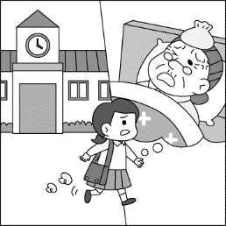 (B) 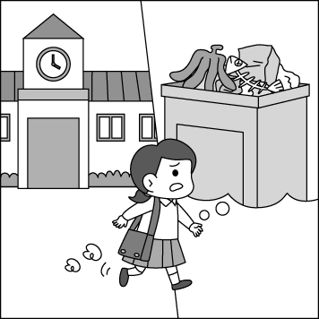 (C) 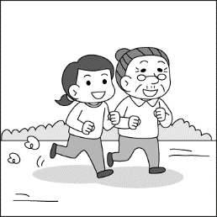
2. (A) 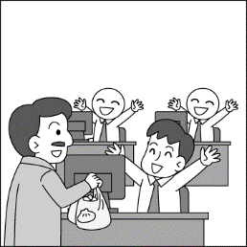 (B) 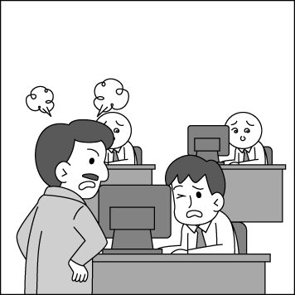 (C) 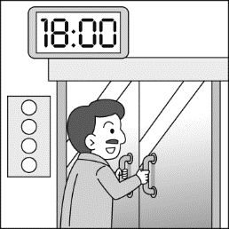
3. (A) 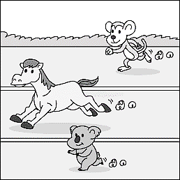 (B) 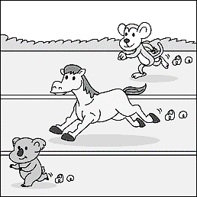 (C) 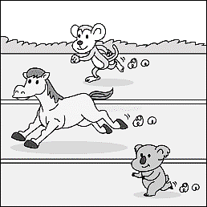
4. (A) 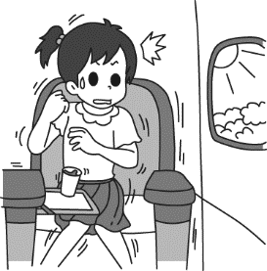 (B) 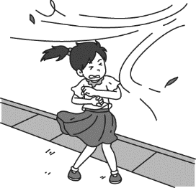 (C) 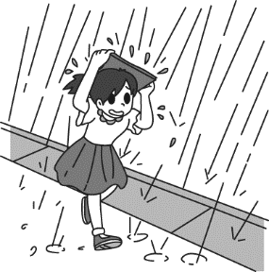
5. (A) 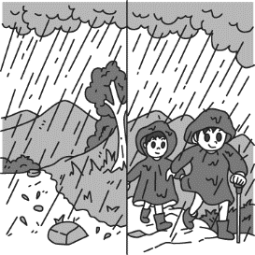 (B) 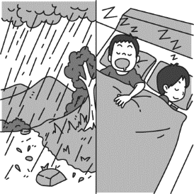 (C) 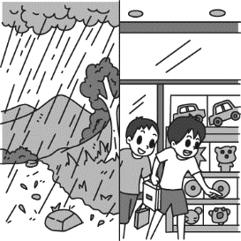
II. 基本問答：每題均有三個選項，請依據所聽到的內容，選出一個最適合的回應
6. (A) He has a lot of homework to do today.
(B) He did his homework carefully.
(C) He didn’t do his homework yesterday.
7. (A) She had me clean the windows.
(B) She has nothing to do.
(C) She was really busy this morning.
8. (A) No, he works really hard for his boss.
(B) Yes, he cares about us very much.
(C) Yes, he does. That’s why his boss likes him best.
【背面尚有試題】
9. (A) We should prepare some food, a flashlight and stay at home.
(B) The light went out an hour ago.
(C) No, we should train ourselves to face the problem.
10. (A) Yes, they save our lives.
(B) They made a sound to let their team know.
(C) They do their job bravely.
III. 言談理解：每題均有三個選項，請依據所聽到的對話與問題，選出一個最適當的答案
11. (A) The girl will not go to the party.
(B) Jack can help the girl finish her homework.
(C) The party starts at eight thirty.
12. (A) She can learn English in a different way.
(B) She can find a lawyer to protect her.
(C) She can report her boss to the Labor Department.
13. (A) She thinks it is easy and interesting.
(B) She thinks it is not easy because you must have many ideas.
(C) She thinks it is difficult but you can make a lot of money.
14. (A) It is dangerous to go out alone at night.
(B) The woman should pay for the man after dinner.
(C) People shouldn’t go to the beach during a typhoon.
15. (A) It is raining cats and dogs outside because of the typhoon.
(B) The man has to move the roses on the balcony inside because of the strong wind.
(C) The man and the woman are going shopping for some food.
二、請依題意選出最適當的答案：36%
16. The teacher asked John to stop _______ in class.
(A) talk (B) to talk (C) talking (D) talked
17. He treated us badly, so we chose _________.
(A) to take him down (B) to take down him (C) taking him down (D) taking down him
18. Jay studies _______ than his classmates. He studies _______ of all.
(A) hardlier; hardliest (B) more hardly; the most hardly (C) harder; hardest (D) hard; hardly
19. Jeff _______ his brother to do homework every day.
(A) lets (B) has (C) makes (D) helps
20. I like Jessica _________ of all because she is _______ friendly student in my class.
(A) most; most (B) more; most (C) most; the most (D) more; the most
21. My grandma raises _______ and ducks on the farm.
(A) vegetables (B) geese (C) sheeps (D) hen
22. I can’t see ________ my glasses.
(A) clear with (B) clearly with (C) clear without (D) clearly without
23. Some people choose not to buy the products, and _______ tell the sad stories.
(A) the other (B) the others (C) another (D) others
24. A: Today is April 22, Earth Day. Why don’t we ____________? B: Sure.
(A) take a break (B) do something good for the earth (C) eat more meat (D) save more money
25. It’ll take less time to get to the MRT if we walk ______ the park.
(A) through (B) by (C) without (D) between
26. He looked out of the window and saw a woman get in a car ______ away.
(A) drive (B) drove (C) and drive (D) and drove

27. Boy, can you stop making so much ______ while the baby is sleeping?
(A) space (B) noise (C) housework (D) radio
28. Don’t you smell something _________ in the kitchen? Let’s check it out.
(A) burned (B) burning (C) to burn (D) to burning
29. A: Must I finish the report before dinner? B: No, you _______.
(A) mustn’t (B) don’t have to (C) shouldn’t (D) must be
30. If you need any help in our hotel, _______ the front desk.
(A) to call (B) calling (C) and call (D) call
31. Suddenly, he felt the ground _________ and heard people _________ loudly.
(A) shook; shouted (B) to shake ; to shout (C) shaking; shouting (D) to shaking; to shouting
32. A: Before the typhoon comes, we should get some candles.
B: _________ We have flashlights.
(A) No worries. (B) Give me a break. (C) Turn it on. (D) Face the music.
33.We’ll have a typhoon holiday if the typhoon ______ stronger.
(A) is becoming (B) will become (C) became (D) becomes
三、克漏字選擇及閱讀測驗：22%
A: My boss is 34 to us. He makes us work 35 and seldom lets us take a break.
B: How many hours a day do you work?
A: Over ten hours. We work long hours 36 any extra pay.
B: The law protects everyone, so you can 37 your boss to the Labor Department.
A: Sounds great! That’s a wise thing 38 .
34. (A) mean (B) badly (C) friendly (D) nicely
35. (A) on the way (B) more and more (C) day and night (D) once again
36. (A) without getting (B) to get (C) for getting (D) and get
37. (A) leave (B) produce (C) share (D) report
38. (A) do (B) doing (C) to do (D) did

Natural disasters, like earthquakes, floods, hurricanes, and wildfires, happen because of natural processes on Earth. They can cause a lot of damage, like destroying homes and roads, and even hurting or killing people.
Earthquakes are sudden shakes in the ground caused by energy bursts in the Earth's crust. They can make buildings fall down and cause tsunamis near the sea.
Floods happen when a place gets too much water, often from heavy rain or rivers overflowing. Floods can ruin buildings, roads, and crops, and make people leave their homes.
Hurricanes, also called typhoons or cyclones, are strong storms with powerful winds and lots of rain. They can destroy things along coasts and inland, causing floods and damage.
Wildfires are dangerous fires that burn forests, buildings, and everything in their way. They usually happen in dry areas with lots of plants.
Even though natural disasters are scary, communities can get ready for them and have plans to help people if they happen.
＊burst 爆發 ＊ruin 毀壞
39. What are natural disasters?
(A) Events caused by people. (B) Events caused by aliens.
(C) Events caused by heavy rain. (D) Events caused by natural processes on Earth.
40. What can earthquakes cause according to the reading above?
(A) Buildings to collapse and tsunamis. (B) Volcanic eruptions.
(C) Strong storms. (D) Dangerous fires.
【背面尚有試題】
41. How can communities get ready for natural disasters?
(A) By preparing and making plans. (B) By causing more destruction.
(C) By ignoring the risks. (D) By destroying things along coasts and inland.

Easter Egg Hunt is a popular tradition during Easter. It involves hiding colorful eggs for children to find. The eggs are often filled with candies or small toys, making the hunt even more exciting. Families and communities organize Easter Egg Hunts in parks, gardens, or even in their own homes. It's a fun activity that brings people together to celebrate Easter and enjoy the spring season.
Besides Easter Egg Hunts, another common Easter activity is decorating eggs. People use various techniques like dyeing, painting, or using stickers to decorate eggs in beautiful patterns and designs. These decorated eggs are often displayed as decorations or given as gifts during Easter celebrations. It's a creative and enjoyable way to celebrate the holiday and express creativity.
Easter Sunday is also a time for religious observance for many people. It commemorates the resurrection of Jesus Christ from the dead, according to Christian belief. Churches hold special services and events to mark this occasion, including Easter sunrise services, musical performances, and community gatherings. For Christians, Easter is a time of joy and reflection, celebrating the hope and new life brought by Jesus' resurrection.
42. What is a popular tradition during Easter?
(A) Decorating houses with colorful eggs. (B) Trick-or-treating.
(C) Exchanging gifts. (D) Easter Egg Hunt.
43. How do people decorate eggs for Easter?
(A) By wrapping them in foil. (B) By throwing them in the air.
(C) By dyeing, painting, or using stickers. (D) By using a lot of paper and pens.
44. What do churches do to mark Easter Sunday?
(A) Hold special services and events. (B) Organize parades.
(C) Host sports competitions. (D) Invite people to dinner.

………………………………………………………………………………………………………………
※ 將以下的答案寫在答案欄中
四、翻譯：12%
1. 我們何不用一種不同的方式來爭取我們的權利呢？
2. 在可可果農場背後的巧克力公司必須停止使用童工。
3. 你真的應該要訓練自己面對你對黑暗的恐懼。
4. 牠們的嗅覺比我們的好上幾千倍。
【試題結束】

新北市立溪崑國民中學112學年度第二學期第二次定期評量 英語科 答案卷
八年級 班 座號 姓名
四、翻譯：12 %
1. ________________________________________________________________________
2. ________________________________________________________________________
3. ________________________________________________________________________
4. ________________________________________________________________________

112-2-2 八年級 英語科－解答
1 ~ 10 ABCAB BACAC
11~20 ACBCA CACDC
21~30 BDDBA CBBBD
31~40 CADAC ADCDA
41~44 ADCA

四、翻譯：12%
1. Why don’t we fight for our rights in a different way?
2. The chocolate companies behind the cocoa farms need to stop using child labor.
3. You really should train yourself to face your fear of the dark.
4. Their sense of smell is thousands of times better than ours.

新北市立溪崑國民中學112學年度第二學期第二次定期評量
八年級 英語科 聽力測驗稿

一、辨識句意：每題均有三張圖片，請依據所聽到的句子，選出符合描述的圖片
1. Mom has my sister take care of my grandma after school.
2. My boss makes us work day and night. That’s why we are often very tired after work.
3. Of all the animals in the zoo, the koala moves most slowly.
4. Gina feels the plane shaking badly now.
5. If it rains tomorrow, we will stay at home and get some rest.
二、基本問答：每題均有三個選項，請依據所聽到的內容，選出一個最適合的回應
6. How did the student do his homework?
7. What did your mom have you do this morning?
8. Does Jason work most carefully of all the workers?
9. The typhoon is coming. What should we do first, Dad?
10. How do rescue dogs do their job?

三、言談理解：每題均有三個選項，請依據所聽到的對話與問題，選出一個最適當的答案
11. W: What time does the party start, Jack?
M: Well... It begins at half past eight. Will you come?
W: I’m afraid not. I have to do my science homework tonight. It may take me a lot of time.
M: Well, why not do the homework this afternoon? I can come and help you finish it.
W: Really? That will be cool. Then I think I can finish it early and go to the party with you.
Q: Which is not true?
12. M: Emma, please listen to me. Why don’t we fight for our rights in a different way?
W: How?
M: The law protects everyone, so we can report your boss to the Labor Department.
He is so mean and treats all of you so badly. Then they will have him improve your lives.
W: Sounds like a good idea.
Q: What does the man tell Emma to do?
13. M: Did you watch the YouTube video from A-Di last night? He talked about his trip to New York
City. Being a famous Youtuber is so interesting and easy. You can make a lot of money and
travel at the same time.
W: Well, I don’t think so. You must have a lot of interesting ideas, or people don’t want to
watch your videos. You have to spend a lot of time thinking of different topics.
M: Yeah, it is true. It is not as easy as we think.
Q: What does the woman think of being a YouTuber?
14. M: Look at the latest news. Two students died at the beach again today.
W: Well, the beach is so dangerous when a typhoon comes. They shouldn’t go swimming there.
What’s the matter with them?
M: Yeah, but some people just don’t really care about it.
W: But their parents must feel very sad.
Q: What are the man and the woman talking about?
15. W: The typhoon is coming. I can see the trees on the street swaying.
M: I can hear the wind blow. I need to move the roses on the balcony inside, or the strong wind
might blow them away.
W: This is our first typhoon. We need to prepare some things. How about going shopping
with me later?
M: Good idea. We have to prepare some food at home.
Q: Which is not true?

