新北市立溪崑國民中學112學年度第二學期二次定期評量 英語科 試題卷
七年級 班 座號 姓名
第一部分:聽力測驗 30%
- 辨識句意：每題均有三張圖片，請依據所聽到的句子，選出符合描述的圖片
1. (A)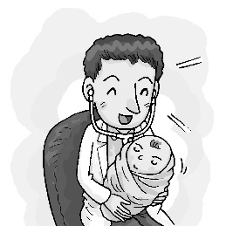 (B)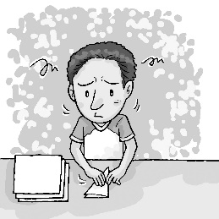 (C)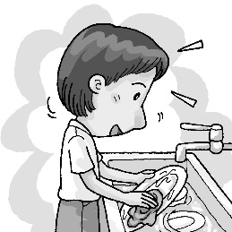
2. (A)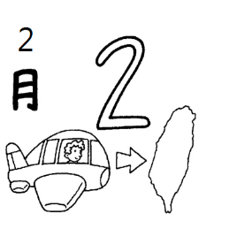 (B)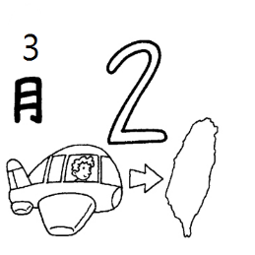 (C)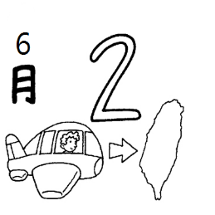
3. (A)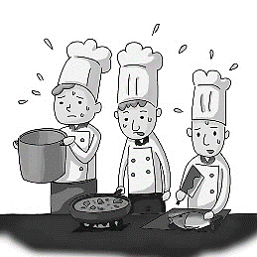 (B)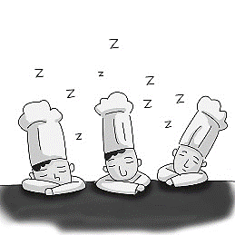 (C)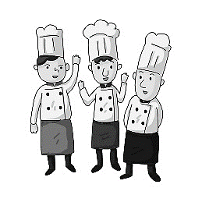
4. (A)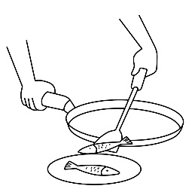 (B)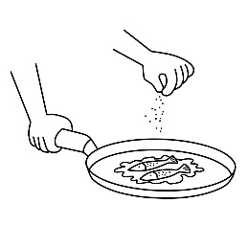 (C)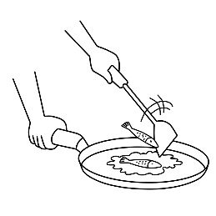
5. (A)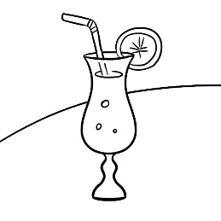 (B)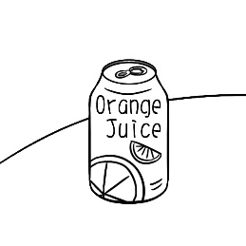 (C)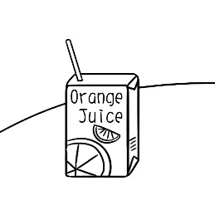

- 基本問答：每題均有三個選項，請依據所聽到的內容，選出一個最適合的回應
6. (A) It’s at the gym. (B) It’s three days away. (C) No, it’s still early.
7. (A) Yes, she talks about them all the time. (B) No, she really misses her brother. (C) No, she cares about them a lot.
8. (A) Too much. It’s bad. (B) Not much. It’s enough. (C) Very much. It’s delicious.
9. (A) Yes. I don’t like fruit. (B) Sure. It’s my favorite drink. (C) OK. Wait until both sides are brown.
10.(A) About six. (B) Six, please. (C) Six glasses are fine.

- 言談理解：每題均有三個選項，請依據所聽到的對話與問題，選出一個最適當的答案
11. (A) It’s the boy’s. (B) It’s the girl’s. (C) It’s the boy and the girl’s dad’s.
12. (A) She is the third child in her family. (B) She wants a big brother. (C) She has two brothers.
13. (A) To a station. (B) To a market. (C) To a library.
14. (A) It’s the woman’s birthday today. (B) The party is next weekend. (C) It’s on December tenth.
15. (A) Now, the fruit pie is ready. (B) First, put two cups of flour in the bowl. (C) Then put two cups of flour in the bowl.


第二部分: 單題:選擇正確或最佳的答案 30%
16. Look at the picture. The girl is _____________.
(A) doing the dishes (B) mopping the floor
(C) taking out the trash (D) writing a letter
17. My sister is good at badminton. She is ________ good at tennis.
(A) too (B) still (C) over (D) also
18. It’s May _______ today, ________ day of May.
(A) the third; the third (B) third; the third (C) third; third (D) the third; third
19. I’m not hungry now. One piece of pizza is ________ for me.
(A) enough (B) little (C) a few (D) easy
20. To build a bridge over this wide river is a very _______ job. Most people do not believe it can be done.
(A) popular (B) helpful (C) common (D) difficult
21. Jason: Is there any food on the table? Tracy: Yes, there are _________ apples and _______ juice.
(A) many; some (B) much; many (C) some; many (D) much; some
22. My parents are doctors, and ________________ junior high school teachers.
(A) your is (B) your are (C) yours are (D) yours is
23. This is __________ cellphone, and ________ is over there.
(A) Betty’s; my (B) Betty; mine (C) Betty’s; mine (D) Betty; he
24. Kevin: What time do you get up every morning?.
Tina: ____________.
(A) This Tuesday (B) On weekdays (C) At six o’clock (D) Every day
25. _________ orange juice in the fridge. You can have ________
(A) They’re; any (B) It’s; any (C) There are; some (D) There’s; some
26. _________ singer do you like, Taylor Swift ____ Miley Cyrus?
(A) Which; or (B) Which; and (C) Where; but (D) Whose; or
27. _________ glasses of water do you drink every day?
(A) What (B) How much (C) Whose (D) How many
28. Kevin: What floor do you live on?
Tina: ____________
(A) It’s on weekends. (B) It’s on the ninth floor. (C) It’s on January second. (D) It’s away from school.
29. Kevin: Tina, ___________?
Tina: Cookies for Leo’s birthday.
(A) can you teach me (B) what are you making
(C) how many cookies are there (D) what does Leo do
30. Kevin: I need one bag of flour, please. _____________
Tina: Sure. How much do you need?
- Do you have any plates? (B) By the way, do you have any salt?
- Are they two hundred dollars? (D) How many boxes do you have?

第三部分: 克漏字及閱讀測驗 20%
(31~33)
Vivian’s birthday is on April fourteenth. She is almost eighteen, just ten days to go until her birthday. She 31 . First, she will go to the cinema and 32 with her friends on Friday night. Then she will have a big dinner with her family at a nice restaurant on Saturday. Now , she 33 the movie tickets and 33 a table. She is very happy and can’t wait for her birthday.
31.(A) runs in the park (B) writes a letter (C) has some plans (D) makes cheese cake
32.(A) watch a movie (B) have a car race (C) play a soccer game (D) stay at home
33.(A) book; reserve (B) is booking; reserves (C) books; to reserve (D) is booking; reserving

(34~35)
Summer Camp for Teenagers July 20~August 8
 | Monday | Tuesday | Wednesday | Thursday | Friday
8:30~10:00 | volleyball | baseball | soccer | Frisbee | surf
10:30~12:00 | swim | cook | volleyball | group chat | swim
Lunch time
14:00~15:30 | baseball | gym | soccer | dodge ball | tennis
16:00~17:00 | basketball | basketball | computer | baseball | volleyball
Notice
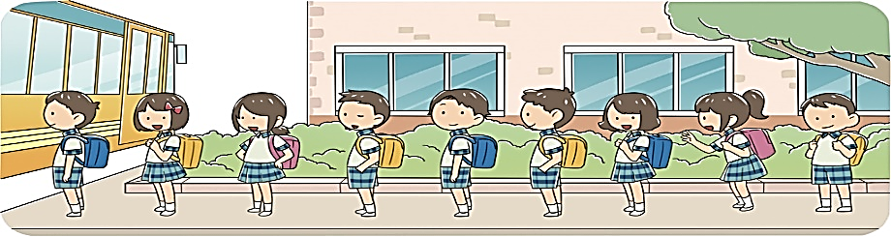
- The camp doesn’t prepare lunch unless you tell us the day before.
- Except swimwear, all the tools and equipment are prepared
and free for you here.
- Signing up before July tenth with three people
will get you a discount.
unless 除非 swimwear 永衣褲、帽 except 除.....之外 sign up 報名 discount 折扣 equipment 設備
34.Which is the best title for this camp?
(A) Let’s play sports. (B) How to dance.
(C) Sign up the camp together. (D) Cooking is fun.
35.Which is not true about the summer camp?
(A) There is a discount to the camp. (B) You have no other choice(選擇) but to bring your lunch.
(C) You don’t have to take your balls there. (D) There is no class on the weekend.
36.Read John’s diary(日記). He is talking about the _______ class.
This only happens once a week. The teacher said a pool is not big enough to learn, so she took us to the sea.
- swim (B) gym (C) surf (D) baseball

(37~38)
(On May 8th)
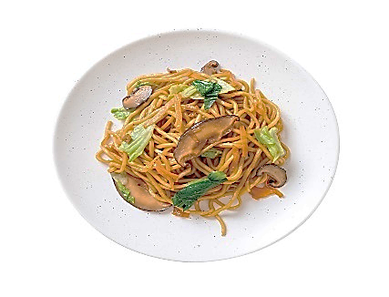
Hello, everyone. Welcome to James Lifestyles. I am your host James. Today we are making Taiwanese fried noodles, and we need:
* noodles
* meat
* vegetables
* one teaspoon of soy sauce
* 1/3 teaspoon of oil
* 1/2 teaspoon of salt
Now, let’s follow the steps and make Taiwanese fried noodles:
- Cut meat and vegetables into pieces.
- Put oil into the pan and heat it up.
- Put meat, noodles, and vegetables into the pan and fry them.
- Add the soy sauce and the salt, and then fry the dish for one minute. Now, we have a plate of delicious fried noodles.
Do you enjoy the show today? I’m James. See you next Wednesday.
- You ________ before you put oil into the pan.
- add soy sauce (B) fry noodles (C) cut meat (D) put salt into the pan
- When can we watch James Lifestyles next time?
- May 15th. (B) May 1st (C) May 17th. (D) May 22nd

(39~40)
In Taiwan, most young people are lucky to be able to go to school and learn from teachers and books. However, many people around the world still don’t have the chance to get a good education. So, when Salman Khan, an American educator, decided to start an online school, he knew that he could help these people and make the world a better place.
In 2004, Salman started to teach his cousin math by using some online tools. Then, more and more of his relatives asked him to teach their kids. In 2006, Salman decided to put his teaching videos online so that he could share them with more people. In 2009, Salman even gave up his job and built an online school which is called Khan Academy.
Now, Khan Academy has free videos that teach math, science, and even English. They can help students learn at their own pace.
There are also online teachers helping students around the world. Salman is happy because he can help many people. He believes that everyone can make a difference by learning new things.
education 教育 be able to 能夠 decide 決定 tools工具 relative 親戚 pace 步調 difference 差異
39. What is true according to the reading?
(A) The teachers in Khan Academy can go to people’s homes to teach them.
(B) Salman Khan started Khan Academy in 2004.
(C) Khan Academy helps people make teaching videos.
(D) Salman Khan is an American educator.
40. What does “They” mean?
(A) Teachers from Khan Academy.
(B) Salman Khan’s teaching videos.
(C) Students around the world.
(D) Salman Khan’s relatives.

第四部分: 看圖詳答 4%(每題2分)
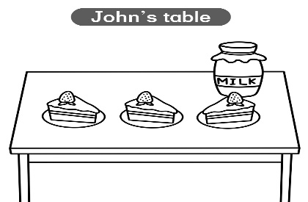
  - How much milk is there on John’s table? (請用單位量詞)

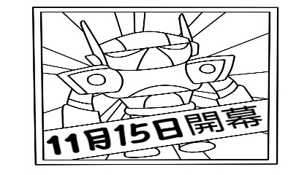
  - When is the robot museum open? (請用英文拼寫出日期)

第五部分: 翻譯 16%
- 一年有幾個月?
- 父親也可以扮演母親的角色。
- 我姐姐在糊狀物加入一些鹽巴以製作製作美味鬆餅。
- 加熱平底鍋並放一些奶油進去。
- Lisa 直到她媽媽回家才寫功課。
- 辦給學生和他們母親的賽跑，距離現在十天。

新北市立溪崑國民中學112學年度第二學期第二次定期評量 英語科 答案卷
七年級 班 座號 姓名
第四部分: 看圖詳答 4%
1.

2.

第五部份 翻譯16%
1.

2.

3.

4.

5.

6.

112學年度第二學期第二次英語科答案卷

- C | - A | - A | - A | - B
- B | - A | - C | - B | - A
- C | - B | - B | - C | - C
- B | - D | - A或B | - A | - D
- A | - C | - C | - C | - D
- A | - D | - B | - B | - B
- C | - A | - D | - A | - B
- C | - C | - A | - D | - B

第四部分: 看圖詳答 4%(每題2分)
- There is one bottle of milk on the table.
- It is open on November eleventh.

第五部分: 翻譯 16%
  - How many months are there in a year?
  - A father can also play the role of a mother.
  - My sister adds some salt to the batter to make delicious pancakes.
  - Heat up a pan and put some butter in it.
  - Lisa doesn’t do her homework until her mom goes home
  - The race for students and their mothers is ten days away.

溪崑國中 英語科 考試卷 ___年___班
一、辨識句意：每題均有三張圖片，請依據所聽到的句子，選出符合描述的圖片。
- CD: Hank is helping his mom with the dishes.
(A) (B) (C)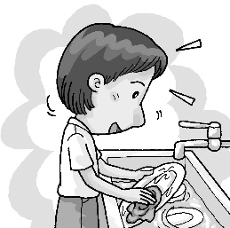
答案：C
- CD: It’s February second today. My cousin is on his way home.
(A) (B) (C)
答案：A
- CD: My cousin works as a cook. He’s busy at work.
(A)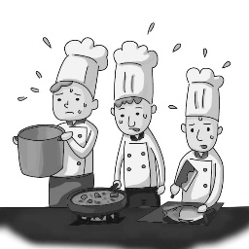 (B)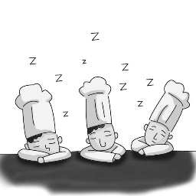 (C)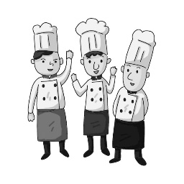
答案：A
- CD: You don’t need to add any salt to the fish. Just put the fish on the plate.
(A) (B)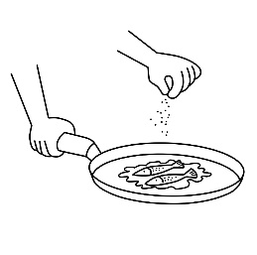 (C)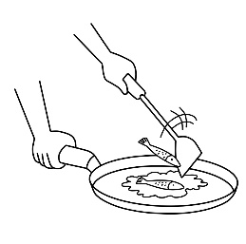
答案：A
- CD: Little Jimmy can’t use straws. Please give him a can of orange juice.
《題目區》
(A) (B) (C)
答案：B

二、基本問答：每題均有三個選項，請依據所聽到的內容，選出一個最適合的回應。
- CD: When is the meeting?
(A) It’s at the gym.
(B) It’s three days away.
(C) No, it’s still early.
答案：B
- CD: Does Emily miss her family in Japan?
(A) Yes, she talks about them all the time.
(B) No, she really misses her brother.
(C) No, she cares about them a lot.
答案：A
- CD: How do you like the fruit cake?
(A) Too much. It’s bad.
(B) Not much. It’s enough.
(C) Very much. It’s delicious.
答案：C
- CD: There are some papayas at home. Let’s make some papaya milk.
(A) Yes. I don’t like fruit.
(B) Sure. It’s my favorite drink.
(C) OK. Wait until both sides are brown.
答案：B
- CD: How many glasses of water do you drink every day?
(A) About six.
(B) Six, please.
(C) Six glasses are fine.
答案：A
三、言談理解：每題均有三個選項，請依據所聽到的對話與問題，選出一個最適當的答案。
- CD: G: This is not my letter.
B: This is not mine, either.
G: Is there a name on it?
B: Let me see. Oh, it’s for Dad.
Q: Whose letter is it?
(A) It’s the boy’s.
(B) It’s the girl’s.
(C) It’s the boy and the girl’s dad’s.
答案：C

- CD: G: Are you the first child in your family?
B: No, I’m the third. I have two big brothers.
G: That’s nice. I’m the only child in my family. I want a big brother, too.
Q: What do we know about the girl?
(A) She is the third child in her family.
(B) She wants a big brother.
(C) She has two brothers.
答案：B

- CD: W: We don’t have enough food for everyone.
B: How many people are there at the party?
W: About fifty. What can we do?
B: Well… I can go to the Farmer’s Market now.
W: Great. Please get two cakes and four bottles of black tea.
Q: Where is the boy going?
(A) To a station.
(B) To a market（市場）.
(C) To a library.
答案：B

14.CD: W: When can you get to the birthday party this afternoon?
M: Whose birthday is it?
W: Don’t you remember? It’s Mary’s!
M: Is today December tenth? Oh, no. I forgot about it.
Q: What do we know about the birthday party?
(A) It’s the woman’s birthday today.
(B) The party is next weekend.
(C) It’s on December tenth.
答案：C

15.CD: (W:) There are five steps to make a fruit pie. First, wash the apples and strawberries. Cut them into small pieces. Next, put them in a bowl, and mix them with some sugar and oil...[fade out]
Q: What’s the woman going to say next?
(A) Now, the fruit pie is ready.
(B) First, put two cups of flour in the bowl.
(C) Then put two cups of flour in the bowl.
答案：C

