新北市立溪崑國民中學112學年度第二學期第三次定期評量 英語科 試題卷
考試範圍: Unit 5-6 Review 3 （共50題劃卡題） 七年級 班 座號 姓名
（一）、聽力測驗 30% (每題2分)
一、辨識句意：每題均有三張圖片，請依據所聽到的句子，選出符合描述的圖片。
（ ）1. (A) 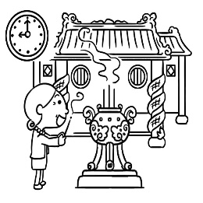 (B) 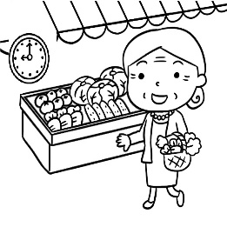 (C) 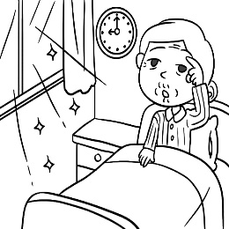
（ ）2. (A) 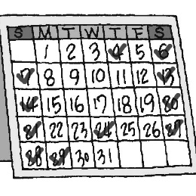 (B) 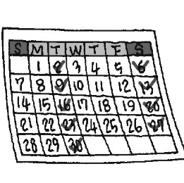 (C) 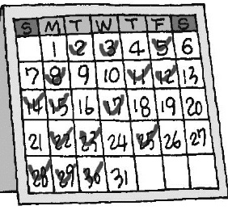
（ ）3. (A) 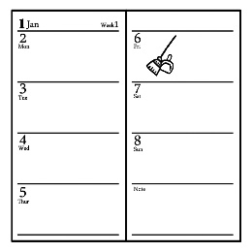 (B) 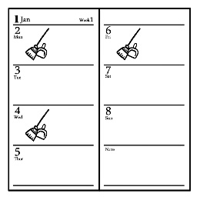 (C) 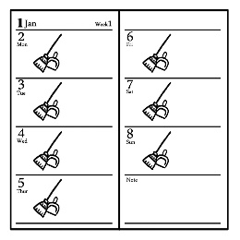
（ ）4. (A)  (B)  (C) 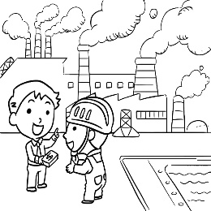
（ ）5. (A) 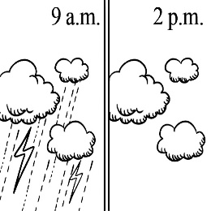 (B) 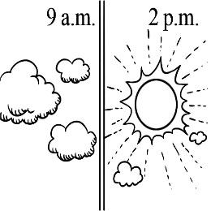 (C) 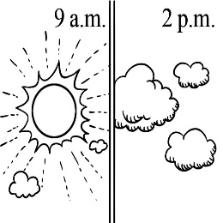
二、基本問答：每題均有三個選項，請依據所聽到的內容，選出一個最適合的回應。
（ ）6. (A) Sure. I clean it every day. (B) Don’t you have any toilet seats? (C) Yuck. It may have lots of germs on it.
（ ）7. (A) Yes, she never goes to the market on weekends. (B) Yes, she goes there once or twice a week.
(C) No, she only goes to the night market for its food.
（ ）8. (A) The river is very different now. (B) For example, there are many activities for visitors.
(C) That’s right. You can take a walk here after school.
（ ）9. (A) I’m busy today. Can we choose only one to visit? (B) That’s great. The restaurants are open today.
(C) Wow! Your shoes are dirty. Go wash them now.
（ ）10. (A) You can even see a lot of fish in the water. (B) There is a lot of trash in the river.
(C) There are many factories here, and the water is dirty.
三、言談理解：每題均有三個選項，請依據所聽到的對話與問題，選出一個最適當的答案。
（ ）11. (A) Every day. (B) Once a month. (C) Three times a week.
（ ）12. (A) It was hot and sunny. (B) It was cold and rainy. (C) It was cold and windy.
（ ）13. (A) No, she does it every day. (B) No, she does it three times a week. (C) No, she does it twice a week.
（ ）14. (A) The woman can finish the race. (B) The woman seldom goes jogging.
(C) The woman might say no to the man.
（ ）15. (A) She exercises three times a week, and she walks a lot every day. (B) She goes to the market every three days.
(C) She buys food at the same market three times a week.

（背面尚有試題）

（二）、綜合測驗 38% (每題2分)
( ) 16. Look at the picture. We can see a lot of _____ near the sea.
(A) fingers (B) fishermen (C) trash (D) space
( ) 17. I have a _____ of playing sports on weekends. I play volleyball with my son.
(A) habit (B) finger (C) market (D) plate
( ) 18. Don’t go jogging along that river. The _____ there is dirty. It’s not good to your health.
(A) fall (B) snow (C) wind (D) air
( ) 19. Helen: Where’s the restroom? I need to use the _____. Joe: It’s next to the teachers’ office.
(A) germ (B) toilet (C) market (D) answer
( ) 20. I don’t always do homework at home. I _____ do it in the library.
(A) seldom (B) usually (C) sometimes (D) never
( ) 21. Students like to play video games after school. It’s their favorite _____.
(A) fisherman (B) space (C) businessman (D) activity
( ) 22. Mr. Johnson works with some teachers from the UK. He has a big meeting with them _____.
(A) every four times (B) two every month (C) a month three times (D) every two months
( ) 23. Kelly: Does your dad often do the housework for your family? Rita: No, he _____.
(A) seldom does (B) always does (C) seldom is (D) does never
( ) 24. Daniel _____ a quiet boy. He likes to make a lot of noise in class. Few (很少) classmates like him.
(A) is always (B) is never (C) never is (D) always is
( ) 25. These beautiful T-shirts _____ mine last year, but now they _____ my sister’s. They are too small for me.
(A) were; are (B) are; are (C) are; were (D) were; were
( ) 26. Luisa is not here. She and her friends are _____ a trip to the US. She is very happy.
(A) on (B) over (C) in (D) under
( ) 27. Kent: _____ do you play baseball? Joe: Not very often. I am very busy every day.
(A) How much (B) How long (C) How often (D) How come
( ) 28. Does _____ often snow in London in winter? Ted: Yes, _____ does.
(A) we; we (B) there; it (C) there; there (D) it; it
( ) 29. Kenny and Lucy were Mrs. Brown’s students ten years _____.
(A) then (B) until (C) before (D) ago
( ) 30. I _____ make dinner with my mom. It’s not fun.
(A) twice (B) once (C) seldom (D) often
( ) 31. Suzie: Is _____ a lot of rain in Nantou in summer? Mike: Yes, _____ is.
(A) it; it (B) there; there (C) there; it (D) we; we
( ) 32. Gina: _____ Luke: It was great. I like swimming in the sea the most.  most最
(A) Was the party great?
(B) How was the trip?
(C) Was winter your favorite?
(D) How was the weather there?
( ) 33. Wilson: Vicky, there are some new books in the box on your desk.
Sarah: Really? _____
Wilson: Sure. They are your birthday gifts.
(A) Can I take a look now?
(B) Give me a break.
(C) Yes, that’s great
(D) What about you?
( ) 34. Kate: _____ Jenson: It’s warm and sunny. Let’s go to the park and play soccer.
(A) What’s the weather like today?
(B) What are they doing in the park?
(C) How was the weather this afternoon?
(D) Is it rainy and windy outside? （背面尚有試題）
（三）、克漏字 16% (每題2分)
(35~38) 請從文章下面的選項，選出最適合的答案並將選項代號劃在答案卡上
Let’s take a look 35 the two photos. Hong Kong 36 a fishing town with only small houses in the 1900s. A lot of people 37 fishermen. People didn’t have many activities in the town then.
Now, there 38 a lot of tall buildings in Hong Kong. Many people around the world visit this city. They even do lots of things there. They eat great food, watch shows, buy gifts, and visit old streets.
選項：(A) are (B) was (C) at (D) were
(39~42)
Hello, I’m the weather reporter, Bruce! I’m here to bring you the weather news at 7 p.m. every day. Here we go! We can see 39 a typhoon near Taiwan. We are going to have some rain and 40 in the next two or three days. The good thing is the weather will be great after the 41 . The sun will come out. 42 next week. See you next time. Have a nice day!  reporter記者 bring 帶來 news 新聞 typhoon 颱風 will 將會
選項：(A) typhoon (B) We can have some sunny days (C) there’s (D) wind
（四）閱讀測驗 16% (每題2分)
(43~45)
There are three messages on Mrs. Huang’s cellphone. They are from her husband, son and daughter.
  Mr. Huang 6/17 9:00 a.m. | Honey, thank you for the umbrella. Today is cloudy, but there is no rain here. I am going home at six this evening. Love you.
  Peter 6/17 10:00 a.m. | Mom, it was rainy near Andy’s place yesterday. Today is sunny and there is no rain here. I am going home at six thirty this evening. Love you.
  Jill 6/17 11:30 a.m. | Hi, Mom. The weather here is OK, but I really need a hat. It’s sunny and windy. I’m in NET now. Look at the photo. What do you think about it? Is red a good color for me?
 message訊息 umbrella雨傘 think about認為
( ) 43. Look at the chart. Where was Peter yesterday?  chart圖表
(A) Yilan (B) Taipei (C) Keelung (D) Taitung
 | Keelung | Yilan | Taipei | Taitung
6/16
6/17
( ) 44. What is “it” in Jill’s message?
(A) A shop. (B) A photo. (C) A red hat. (D) The color red.
( ) 45. Which is correct?
(A) Mrs. Huang is with Peter now.
(B) Jill is buying some food for lunch.
(C) Mr. Huang can get home for lunch today.
(D) Peter wasn’t home this morning.

（背面尚有試題）
(46~47)
Here is a table about Pearl City. Read it and answer the questions.
Season of the Year | Weather | What to do
Spring (September – November) | Cool & Wet | Whale (鯨魚) Season
Summer (December – February) | Warm & Clear | Butterfly Season
Fall (Mach – May) | Windy & Dry | Wind Surfing
Winter (June – August) | Cold & Snowy | Ice Skating
( ) 46. Nancy just spent the New Year holiday in Pearl City. Which picture was likely taken there?
 table表格 spent花費 taken照相
(A) 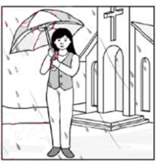 (B) 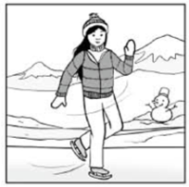 (C) 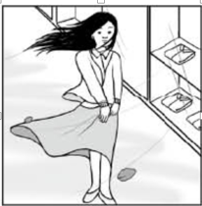 (D) 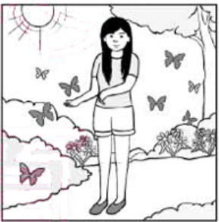
( ) 47. Tim wrote the following on his IG to his friends during his visit to Pearl City:
“…. I felt sick because the boat went up and down. But I was really lucky to see three of them. These large sea animals just didn’t mind our boat getting near them. They swam around the boat in a cute way. Everyone on the boat smiled….”  wrote寫 felt感覺 went（go過去式） mind在意 swam游泳 smiled微笑

In which season of the year did Tim most likely go to Pearl City?
(A) Summer (B) Spring (C) Fall (D) Winter
(48~50)
What kind of place do you stay for the night during a trip? Expensive hotels that may make you feel like you don’t get what you pay for? Or cheap hotels that put you and five other strangers in the same bedroom? If both choices sound terrible to you, here’s something new: holiday apartments.
In a holiday apartment, you have more space than what a hotel room can give you. Everything in the apartment is at your disposal. The living room, the kitchen, the study, and the bedrooms are all for your own use. Some apartments even have a lovely garden or a game room. You’ll feel at home in the holiday apartment. The best thing is that a holiday apartment is not expensive. The price for a holiday apartment is for two people, and the apartment is cheaper than a hotel room for two. You only need to pay a little money for the third or fourth person. If you travel with friends or your family, a holiday apartment will be your best choice.
 feel感覺 sound聽起來 swam游泳 apartment公寓 if如果

( ) 48. What is the reading mostly about?
- Where to find a nice holiday apartment.
(B) How to choose a nice holiday apartment.
(C) Why people should choose a holiday apartment.
(D) How people can change their house into a holiday apartment.
( ) 49. Who will like holiday apartments?
(A) Jason. He likes to take one-day trips.
(B) Irene. She likes to travel in a group of three or more.
(C) Judy. She wants to make new friends when she travels.
(D) Bill. He likes to spend his holidays in the country.  spend花費 country鄉下
( ) 50. What does it mean to say that something is at your disposal?
(A) You are free to use it.
(B) You can find it everywhere.
(C) You know everything about it.
(D) You can buy it at a big store.
試題結束
Wish everyone a happy summer vacation!
112-2-3 七年級 英語科－解答
1-38每題2分，39-46每題3分
1 | 2 | 3 | 4 | 5 | 6 | 7 | 8 | 9 | 10
B | C | A | C | B | C | B | C | A | A
11 | 12 | 13 | 14 | 15 | 16 | 17 | 18 | 19 | 20
A | B | B | A | C | C | A | D | B | C
21 | 22 | 23 | 24 | 25 | 26 | 27 | 28 | 29 | 30
D | D | A | B | A | A | C | D | D | C
31 | 32 | 33 | 34 | 35 | 36 | 37 | 38 | 39 | 40
B | B | A | A | C | B | D | A | C | D
41 | 42 | 43 | 44 | 45 | 46 | 47 | 48 | 49 | 50
A | B | A | C | D | D | B | C | B | A

新北市立溪崑國民中學112學年度第二學期第三次定期評量
七年級 英語科 聽力測驗稿

一、辨識句意：每題均有三張圖片，請依據所聽到的句子，選出符合描述的圖片。
1. My grandmother always goes to the market at nine a.m.
2. There is a nice gym near my house, and I go there three times a week.
3. Mr. Lin seldom cleans the house. He needs to make a change.
4. The people are talking in front of the factory.
5. It’s sunny in the afternoon, but it was cloudy in the morning.

二、基本問答：每題均有三個選項，請依據所聽到的內容，選出一個最適合的回應。
6. Look at the seat. It’s so dirty.
7. Does Irene only go to the market on weekends?
8. (B:) Wow. There are a lot of green spaces along the street.
9. Let’s visit some shoe factories today.
10. The river is clean, and the water is cool.

三、言談理解：每題均有三個選項，請依據所聽到的對話與問題，選出一個最適當的答案。
11.Do you clean your room every day?
M: No, I don’t. I clean it three times a week. What about you?
W: I clean it every day.
M: Great. Does Jerry clean his room every day, too?
W: No, he doesn’t. He only cleans it once a month.
M: Yuck!
Q: How often does the woman clean her room?
12. W: The weather here always changes a lot. It was cold and rainy yesterday, but it was hot and sunny the day before yesterday. The weather today is cold and windy.
Q: What was the weather like yesterday?
13. W: Judy is a nice girl. She helps her mom with the housework. She cleans her bedroom every day. On Mondays and Wednesdays, she mops the floor. On Tuesdays, Thursdays, and Saturdays, she takes out the trash.
Q: Does Judy take out the trash every day?
14. M: There is a 10K running race next month. My sister and I both jog very often. We’d like to join the race. What about you?
W: No, thanks. I don’t like running. I only jog once a month. I don’t believe I can do it.
M: Come on! Join the race with us. We can practice jogging together. I believe in you!
Q: The man says, “I believe in you.” What does he mean?
15. (M:) Aunt Gina goes to a market three times a week. The market is not near her home, but she still walks there and then takes a bus home with lots of food. She enjoys it. It’s her habit, and she doesn’t want to change it
Q: What can we know about the woman’s habit?

